DSM Report Template
-Open Session-
Overview
The DSM (Data and Safety Monitoring) report template is used to make periodic data and safety monitoring reports to the body providing study oversight (e.g., DSMB [Data and Safety Monitoring Board], SO [Safety Officer]). Investigators should consider using this template for clinical studies sponsored by the National Institute on Aging (NIA) in the Division of Behavioral and Social Research (BSR). The DSM report template (i.e., report format) should be approved by the study’s applicable study oversight body (e.g., SO, DSMB).
If the study team is not blinded, typically just an Open Session DSM Report is provided to present data, unless otherwise requested by study oversight.
Clinical Trials with Blinded Study Teams
If the study team is blinded, the study typically has two DSM report templates for reporting blinded (i.e., open session) and unblinded (i.e., closed session) data, unless otherwise requested by study oversight.
General Instructions
This DSM report template should be modified to reflect the study’s specific clinical trial documents (e.g., protocol, DSMP [Data and Safety Monitoring Plan], MOP [Manual of Operating Procedures]), reporting relevant study data and safety information. Table format may be updated if preferred, retaining relevant information. Throughout the report, please delete italicized instructions and example text as you modify the template for the specific study. For tables, blacked out cells typically have no listed values.
Please do not delete the footer noting which template version was used.
BSR DSM Report Template Open Session, updated 5/25
(Delete this page after the DSM Report is completed.)

Title of the Study
DSM Report – Open Session
Grant Number
Title of Grant (remove if same as study title)
PI Name(s)
Report Date: MM/DD/YYYY
DSM Report Template Revision History:
Briefly list revisions to the approved DSM report template (i.e., format changes approved by DSMB or SO). Changes should be approved prior to implementation.
Version Number | Version Date | Summary of DSM Report Template Revisions
1.0 | MM/DD/YYYY | Initial approved version.
2.0 | MM/DD/YYYY | E.g., Added … to reflect adverse events (AE) definition changes and reporting frequency in DSMP as approved by DSMB/SO.

Table of Contents
Study Summary 4
Protocol Synopsis 4
Project Organizational Chart, Personnel 6
CROMS Study Visualization 7
DSM Report Summary 8
Narrative Summary 8
Attachments 10
Recruitment and Participant Status: Figures and Tables 12
Figure 1: Overall Study Status 13
Figure 2: Cumulative Enrollment: Actual vs. Planned 14
Table 1: Participant Enrollment Status 15
Table 2: Demographic and Key Baseline Characteristics 16
Table 3: Reasons for Screen Failures 17
Table 4: Protocol Deviations 18
Table 5: Data Quality and Completeness 19
Safety Assessments for All Participants: Tables and Listing 20
Table 6: Incidence of Adverse Events by Body System and Preferred Term 21
Table 7: Severity of Adverse Events by Preferred Term 22
Listing 1: Unanticipated Problems 23
Listing 2: Serious Adverse Events 24
Listing 3: Deaths 25
Listing 4: Adverse Events 26
Table 8: Laboratory Test Results Summary 27
Listing 5: Clinically Significant Abnormal Lab Values 28

Study Summary
The information listed in this section should be consistent with the IRB approved clinical trial protocol and DSMP. This section does not change across periodic DSM reports, unless changes to the clinical trial are approved. If changes are approved (e.g., DSMB, SO, IRB) to these documents that are listed in this section, this section should be updated accordingly. Information provided in this section should be brief (e.g., typically a few sentences per item, list formats are encouraged as relevant).

Protocol Synopsis
Study Title | Full study title
Grant Number | Full grant number
CROMS Study ID | CROMS study ID (i.e., DBSR-XXXXX) for the clinical trial.
ClinicalTrials.Gov ID | ClinicalTrials.Gov Identifier Number (NCT #).
Study Design | Provide a short description of the protocol (e.g., how participants are enrolled, study arms, key procedures). This should only be a few sentences in length.
Specific Aims | Provide a brief list of the study Specific Aims. Do not include the entire Specific Aims section.  Example:  1. Aim 1  2. Aim 2  3. Aim 3
Endpoints | Include the primary and secondary endpoints.  Primary Endpoint:  Secondary Endpoints:
Sample Size | State target accrual and planned dropout rate.  Example:  300 participants will be enrolled to meet a final sample of 240 participants, estimating a 20% drop-out rate.
Study Population | Specify who is being recruited, providing key characteristics like general health status and demographics (e.g., age range, sex).
Inclusion Criteria | In list format
Exclusion Criteria | In list format
Stage of Behavioral Intervention Development | Stage 0, I, II, III, IV, or V
NIH Phase III Clinical Trial? | Yes/No
Multi-Site Trial? | Yes/No  A multi-site study uses the same protocol to conduct non-exempt human subjects research at more than one site.
Study Sites | List the name of each study site.
Intervention Description | Describe the study intervention. Include intervention type, length, frequency, and method of delivery (e.g., group vs. individual, web-based, etc.).  Example: The intervention is a 12-session psychoeducational program (4, 3-week modules), delivered over a 12-week period by community-based social workers to improve emotion regulation skills and mood in people with MCI. The modules are: 1), 2), 3), 4).
Blinded Design? | Yes/No  If yes, list who is blinded and their role (e.g., considering participant, care provider, PI, statistician, study team members, DSMB).  Example:  Study Team:  - PI (unblinded)  - Test administrators (blinded)  - ….  Participants:  - Caregivers (blinded)  - ….  DSMB: Unblinded
Study Duration | Estimated time (e.g., in months) from when the study opens to enrollment (e.g., begins recruitment) until completion of data collection (e.g., all participant procedures are complete).
Participant Duration | Time (e.g., in months) it will take for each individual participant to complete all study-related tasks after enrolling in the study.
Study Discontinuation and Closure Criteria | Provide in list format, as listed in the study’s IRB approved clinical trial protocol. See BSSR Clinical Trial’s protocol template Section 10.1.2 Study Discontinuation and Closure for an example.
DSM Report Frequency | The frequency of DSM reports as stated in the approved DSMP.  Example: This study will provide DSM reports every 6 months.

Project Organizational Chart, Personnel
Figure or table format is preferred. Include a brief description (e.g., 1 sentence) with each personnel to indicate their role and responsibilities, if they are blinded (if applicable), and institution. If applicable, indicate which personnel are responsible for the blinded and unblinded reporting activities (e.g., data, AEs).

CROMS Study Visualization
For all clinical trials: Confirm the accuracy of the CROMS study record and make any needed corrections prior to submitting the DSM report. Please review your Notice of Award, CROMS FAQ, and here for CROMS requirements.
- To retrieve the CROMS Study Visualization, access CROMS. Next to the CROMS Study ID for this clinical trial (e.g., DBSR-XXXXX), click on the graph icon. This will take you to the Study Visualization page, which shows graphs of total enrollment progress (actual vs. planned), demographic enrollment (actual vs. planned), and a summary of timelines.
- Save the CROMS Study Visualization web page as a PDF and attach it to this report by replacing this page with the CROMS Study Visualization PDF.

DSM Report Summary

Narrative Summary
The DSM narrative summary should be a brief overview of key considerations for study progress, safety, and data to provide sufficient information to study oversight (e.g., DSMB, SO) for reviewing study status, issues, and the study team’s planned actions. The narrative summary should focus on data, safety, and progress considerations since the prior DSM report. If issues are noted, a brief description of the study team’s actions to address the issue should be listed. If changes to approved clinical trial documents are requested, include it here. For measures reported in the below table, measures should be consistent with definitions in the approved clinical trial protocol and DSMP. The figures and tables included in this report support the narrative summary with additional detail and should be consistent with the information provided in the narrative summary. Bullet point and list formats are encouraged.
Study Status Overview | Provide a brief summary of study status, progress, major activities, and other pertinent information since the last DSM repot.  If the study team is requesting for study oversight to review changes to the approved clinical trial protocol or documents (e.g., consent, DSMP, MOP), a brief summary of requested changes and justification should be provided here. Attachments to this report should include clean and tracked changes versions of proposed changes to clinical trial documents.
Data as of Date | Date data was pulled for this report (MM/DD/YYYY).
Enrollment Status | Example:  - 420 participants have been screened for this study.  - 80 participants have been enrolled compared to the planned 100 (80%).
Participant Status | Briefly list number of active, randomized, and inactive participants (e.g., participants who enrolled but are no longer active in the study). For inactive participants, briefly summarize if they completed protocol, dropped out, or were discontinued.  Example:  - 30 participants of the 80 enrolled have been randomized.  - 10 participants are inactive. Of these, 8 completed the protocol.  - 2 participants dropped out for personal reasons prior to finishing study procedures, and one participant was discontinued because they had a stroke and became ineligible to participate.
Enrollment and Participant Status – Brief Narrative | Provide a brief description of key reasons for participant screen failures, dropout, or discontinuation. Briefly summarize any challenges or barriers to enrollment. If the study team is taking actions to address issues, summarize these actions here.  Example:  - Primary reasons participants have dropped out include participant burden from completing at-home daily logs. To reduce burden, we are taking these actions….  - Enrollment is limited by clinician time to recruit. To address this, we are requesting medical record access for our study team to enhance recruitment.
Demographic Status | Provide a brief summary of the demographic status of enrolled participants and how this compares to planned enrollment (based on the grant’s approved planned demographic tables, see HSS and the HSS Study Record).  Example:  - Compared to planned targets, (insert demographic group) are currently over-recruited (52 enrolled compared to planned 32).  - We are taking the following actions to improve recruitment of (insert demographic group) participants…
Progress Status | Has the study met planned timelines? If not, what actions are being taken to address progress?
Study Discontinuation and Closure Rules | Since the last DSM report, were any study discontinuation or closure (e.g., stopping) rules met?  Example:  No study discontinuation rules have been met since the previous DSM report.  Or  There are no new “Alerts” since the previous DSM report.
Safety Summary | Briefly state a summary of AE/SAEs that occurred since the last DSM report.  Example:  - 20 total adverse events have occurred in 7 participants. All were mild to moderate and unrelated to the study.  - There have been no additional serious adverse events since the last DSM report.
Protocol Deviations | Example:  - 8 protocol deviations associated with 5 participants occurred since the last DSM report.  - None of the deviations has impacted participant safety.
Data Quality and Completeness Monitoring | Brief summary of study monitoring and review of data quality and completeness measures (see approved DSMP for measures and frequency of monitoring).  Example:  - Data quality and completeness reviews are performed quarterly (last completed MM/DD/YYYY).  - Reviews indicate that missing data is acceptable (< 2%), however some issues in data entry accuracy compared to source documents were observed (6% of entries were inaccurate compared to source documents).  - The study team is taking the following actions to improve data entry accuracy…
Current Clinical Trial Protocol Version and IRB Approval Date | Example:  Version 2, approved by IRB MM/DD/YYYY
Approved Changes to Clinical Trial Documents since last DSM Report | List clinical trial documents that have been modified since the last report (e.g., clinical trial protocol, consent, DSMP, MOP). Briefly describe what the key changes to these documents are. Changes should be approved by study oversight prior to implementation.  Example:  Since our last DSM report:  - The IRB has approved a change to our protocol to permit addition of a new recruitment site. This was approved by the DSMB/SO at the last meeting.  - The DSMP was updated following DSMB/SO request to increase AE reporting frequency to quarterly.  Or  No document changes have been made since the last DSM report.

Attachments
Attach (unless otherwise requested by DSMB and SO):
- The previous DSMB or SO action items and recommendations from the last DSM report, along with the study team’s response.
- SAE (Serious Adverse Events) or UP (Unanticipated Problems) report forms since the last DSM report.
- Any clinical trial documents with changes approved since the last DSM report (e.g., protocol, consent, DSMP, MOP).
- If changes to clinical trial documents are proposed for review and approval, provide clean and tracked changes versions of these documents.
- If not included above, the current IRB approved clinical trial protocol.

Recruitment and Participant Status: Figures and Tables

Figure 1: Overall Study Status
Data as of Date:
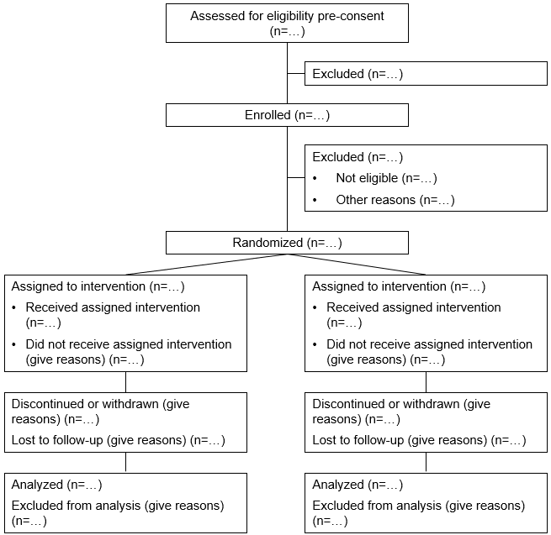
Figure 1 shows an example of a standard CONSORT diagram, showing an example of how the CONSRT diagram should reflect the study design and participant groups. When making the CONSORT, if the study team is blinded, please consider if CONSORT should be blinded or unblinded.
Figure modified from: Moher D, Schulz KF, Altman D, for the CONSORT Group. The CONSORT Statement: Revised Recommendations for Improving the Quality of Reports of Parallel-Group Randomized Trials. JAMA. 2001;285(15):1987–1991. doi:10.1001/jama.285.15.1987

Figure 2: Cumulative Enrollment: Actual vs. Planned
Data as of Date:

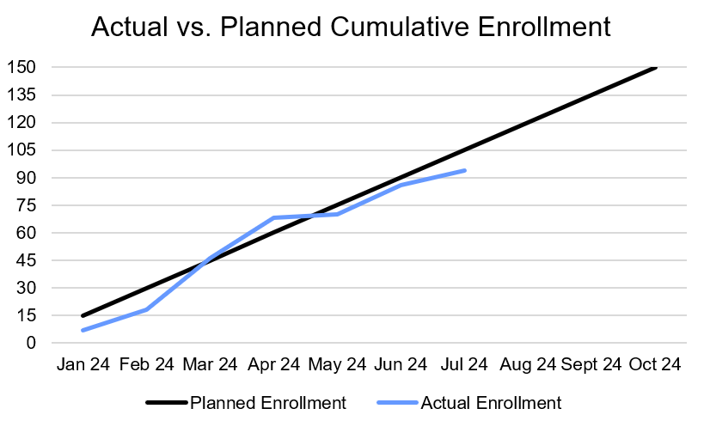
Anticipated Date to Complete Participant Procedures:
Approved Project End Date:
Figure 2 shows a graph of actual versus planned cumulative enrollment, reflecting how many participants the study needs to enroll over time (e.g., by month) to meet the target sample size within approved project timelines.
Recruitment timelines should be consistent with completing recruitment, participant procedures, and data analysis within approved project timelines. Any proposed changes to this should be discussed with NIA.

Table 1: Participant Enrollment Status
Data as of Date:
Participant Enrollment Status |  | N (%)*
 | Status
Participant Status | Enrolled
Participant Status | Active
Participant Status | Inactive
 | Activity Schedule
Activity Schedule for All Participants** | Randomization (Week 2)
Activity Schedule for All Participants** | Completed Study (Week 6)
 | Reason
Discontinued from Study Intervention***
Discontinued or Withdrawn from the Study***
Lost to Follow-Up***
Use categories as relevant to IRB approved clinical trial protocol.

Table 2: Demographic and Key Baseline Characteristics
Data as of Date:
Characteristics |  | Actual  N (%) | Planned  N (%)*
Sex
…
…
Clinical Features /  Stratification | BMI ≥ 30
 |  | Actual | Planned
Age | Mean
Age | Median
Age | Standard Deviation
Age | Minimum
Age | Maximum

Table 3: Reasons for Screen Failures
Data as of Date:
Screen Failure Reason | N | %*
TBI History
Total Screened
Total Screen Failures

Table 4: Protocol Deviations
Data as of Date:
Protocol Deviation* | Deviations N | Deviations Since Last DSM  Report N | Total Participants With Deviations  N (%)** | Participants With Deviations Since Last DSM Report N (%)**
Failure to obtain informed consent
Total
Participants Enrolled***
Report how many the protocol deviation affected in total and since the last DSM report. Total participants (last row) should reflect how many individual participants had at least one deviation.

Table 5: Data Quality and Completeness
Data as of Date:
Measure Category* | Measure
Missing Data | 5%
Data Entry Errors | 7%

Safety Assessments for All Participants: Tables and Listing

Table 6: Incidence of Adverse Events by Body System and Preferred Term
Data as of Date:
Body System | Preferred Term | Participants  N (%)* | Total AEs N
Overall
Cardiovascular | Myocardial Infarction
Cardiovascular | Increased Blood Pressure
Genitourinary | Yeast Infection
Genitourinary | Vaginal Bleeding
Gastrointestinal
This table should reflect the approved DSMP for adverse event reporting (e.g., categories and what AEs to report). For example, the table could present overall incidence of adverse events as shown above, adverse events related to the intervention as judged by the investigator, or treatment emergent events. This table may be sorted by body system and then descending order of incidence for each preferred term.
Consider providing an AE table for total number of events across the study and for events since the last DSM report, as requested by study oversight.

Table 7: Severity of Adverse Events by Preferred Term
Data as of Date:
Preferred Term* | Total Mild  N (%)* | Total Moderate  N (%)* | Total Severe  N (%)*
Headache
Pain
etc.
This table should reflect the approved DSMP for adverse event reporting.

Listing 1: Unanticipated Problems
Participant ID(s)* | Total  N (%)** | Date Identified*** | SAE (Y/N)**** | UP Description***** | Action(s) Taken****** | Resolved (Y/N) | Reported to what oversight bodies?
See OHRP guidance for reviewing and reporting unanticipated problems for UP definitions, including considerations for which unanticipated problems (UPs) are also considered SAEs.

Listing 2: Serious Adverse Events
Data as of Date:
Participant ID | Onset Date | Stop Date | Expected  (Y/N) | Relationship to Intervention*  (Y/N) | Outcome** | Description of SAE

Listing 3: Deaths
Data as of Date:
Participant ID | Date of Death | Cause of Death | Relationship to Intervention*

Listing 4: Adverse Events
Data as of Date:
Participant ID | Days on Intervention | Preferred Term | Relationship to Intervention* | Severity | Serious (Y/N) | Outcome**
This listing could be sorted by Preferred Term or sorted by Participant ID.

Table 8: Laboratory Test Results Summary
Data as of Date:

-Change from Baseline-
Laboratory Test | Study Timepoint | N | Mean | SD | Min | Median | Max | N | Mean | SD | Min | Median | Max
Test 1 | Screening
Test 1 | 6 Months
Test 1 | 12 Months
Test 1 | 24 Months
Test 1 | 36 Months
Test 2 | Screening
Test 2 | 6 Months
Test 2 | 12 Months
Test 2 | 24 Months
Test 2 | 36 Months
Test 3 | Screening
Test 3 | 6 Months
Test 3 | 12 Months
Test 3 | 24 Months
Test 3 | 36 Months
Table may include lab test results that are clinically significant, as defined by the IRB approved clinical trial protocol, or ALL lab test results. Final format is determined by the DSMB. This table may be removed if not relevant to the protocol.

Listing 5: Clinically Significant Abnormal Lab Values
Data as of Date:
Participant ID | Visit | Age | Sex | Lab Panel | Lab Test | Result
This table may be removed if not relevant to the protocol.

* Total number and percent of participants compared to number of enrolled participants.
** Activity schedule reflects the schedule of visits or activities participants complete during the study. Please note key procedures completed at relevant visits or activities (e.g., randomization, study completion), along with when the visit or activity occurs after enrollment (e.g., days, weeks, months).
*** For examples of participant discontinuation (e.g., AE/SAE, non-compliance, eligibility change, withdrew consent) and lost to follow-up reasons, see BSSR Clinical Trial’s protocol template Section 7 “Study Intervention/Experimental Manipulation Discontinuation and Participant Discontinuation/Withdrawal”.
* Planned N (%) must be consistent the approved sample and demographic characteristics for the study. Please ensure that the demographic characteristics listed here are consistent with the demographic characteristics listed in the HSS Study Record (i.e., please report actual and planned numbers for all demographic categories listed in your HSS enrollment tables).
* Percent is compared to the total number of screened potential participants.
* See BSSR Clinical Trial’s protocol template Section 10.1.10 “Protocol Deviations” for examples. Possible deviations may include: - Did not meet eligibility criteria - Visit noncompliance/incomplete visit - Participant taking concomitant drugs which are not allowed - Assessments outside protocol window - Failure to obtain informed consent
** Percent is number of participants with deviation (total or since last DSM report) compared to number of participants enrolled (total or since last DSM report).
*** Participants enrolled total or since last DSM report
* Update as relevant to report the data monitoring measures in the approved DSMP.
* Number of participants and percent of total enrolled participants experiencing an adverse event. Each participant should be counted only once for each adverse event (e.g., until the adverse event resolves). Recurrence of an adverse event should be counted as a new event.
* Number of participants and percent of total enrolled participants experiencing an adverse event. See Table 7 for how to count adverse events. Typically, adverse event severity is classified based on the greatest severity level.
* List participant IDs for all affected participants.
** Total number of participants affected compared to number of enrolled participants (N, %).
*** Date UP was identified.
**** Was the UP also an SAE?
***** UP descriptions should include when the event was identified relative to when it occurred, the harm or potential harm that occurred to participants, and the status of affected participants remain in the study.
****** Action taken as result of the UP to mitigate newly identified human subjects risks. Actions may involve, but are not limited to, a) clinical trial protocol, monitoring procedure, or eligibility criteria revisions, b) consent form modifications, c) suspension or pausing of study procedures (e.g., for new or currently enrolled participants), or d) notice to research participants.
* Definite, Possible, Not Related
** Outcome: Recovered, without treatment Recovered, with treatment Still Present, no treatment Still Present, being treated Residual effect(s) present – no treatment Residual effect(s) present- being treated Participant died
* Definite, Possible, Not Related
* Definite, Possible, Not Related
** Outcome: Recovered, without treatment Recovered, with treatment Still Present, no treatment Still Present, being treated Residual effect(s) present – no treatment Residual effect(s) present- being treated Participant died

