DSM Report Template
-Closed Session-
Overview
The DSM (Data and Safety Monitoring) report template is used to make periodic data and safety monitoring reports to the body providing study oversight (e.g., DSMB [Data and Safety Monitoring Board], SO [Safety Officer]). Investigators should consider using this template for clinical studies sponsored by the National Institute on Aging (NIA) in the Division of Behavioral and Social Research (BSR). The DSM report template (i.e., report format) should be approved by the study’s applicable study oversight body (e.g., SO, DSMB).
If the study team is not blinded, typically just an Open Session DSM Report is provided to present data, unless otherwise requested by study oversight.
Clinical Trials with Blinded Study Teams
If the study team is blinded, the study typically has two DSM report templates for reporting blinded (i.e., open session) and unblinded (i.e., closed session) data, unless otherwise requested by study oversight.
General Instructions
This DSM report template should be modified to reflect the study’s specific clinical trial documents (e.g., protocol, DSMP [Data and Safety Monitoring Plan], MOP [Manual of Operating Procedures]), reporting relevant study data and safety information. Table format may be updated if preferred, retaining relevant information. Throughout the report, please delete italicized instructions and example text as you modify the template for the specific study. For tables, blacked out cells typically have no listed values.
Please do not delete the footer noting which template version was used.
BSR DSM Report Template Closed Session, updated 5/25
(Delete this page after the DSM Report is completed.)

Title of the Study
DSM Report – Closed Session
Grant Number
Title of Grant (remove if same as study title)
PI Name(s)
Report Date: MM/DD/YYYY
DSM Report Template Revision History:
Briefly list revisions to the approved DSM report template (i.e., format changes approved by DSMB or SO). Changes should be approved prior to implementation.
Version Number | Version Date | Summary of DSM Report Template Revisions
1.0 | MM/DD/YYYY | Initial approved version.
2.0 | MM/DD/YYYY | E.g., Added … to reflect AE definition changes and reporting frequency in DSMP as approved by DSMB/SO.

Table of Contents
Recruitment and Participant Status: Figures and Tables 2
Figure 1: Overall Study Status by Intervention Group 3
Table 1: Participant Enrollment Status by Intervention Group 4
Table 2: Demographic and Key Baseline Characteristics by Intervention Group 5
Safety Assessments for All Participants: Tables and Listing 6
Table 3: Incidence of Adverse Events by Body System, Preferred Term, and Intervention Group 7
Table 4: Severity of Adverse Events by Preferred Term and Intervention Group 8
Listing 1: Serious Adverse Events by Intervention Group 9
Listing 2: Deaths by Intervention Group 10
Listing 3: Adverse Events by Intervention Group 11
Table 5: Laboratory Test Results Summary Intervention Group A 12
Table 6: Laboratory Test Results Summary Intervention Group B 13
Listing 4: Clinically Significant Abnormal Lab Values by Intervention Group 14

Recruitment and Participant Status: Figures and Tables

Figure 1: Overall Study Status by Intervention Group
Data as of Date:
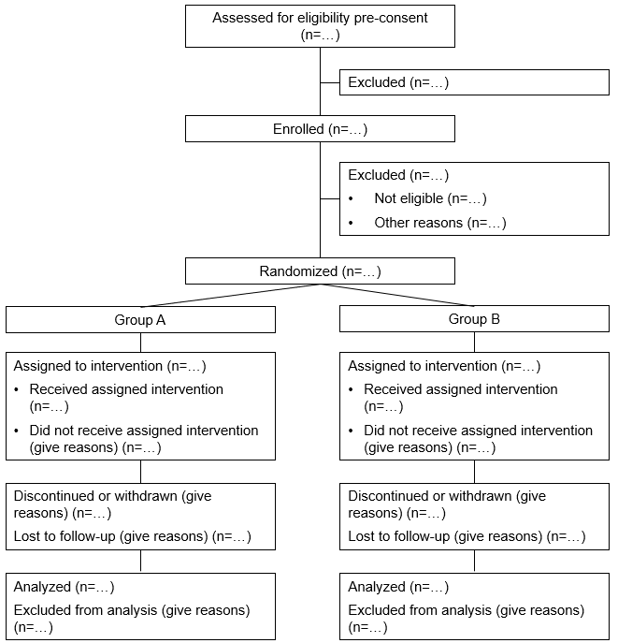
Figure 1 shows an example of a standard CONSORT diagram, showing an example of how the CONSRT diagram should reflect the study design and participant groups. When making the CONSORT, if the study team is blinded, please consider if CONSORT should be blinded or unblinded.
Figure modified from: Moher D, Schulz KF, Altman D, for the CONSORT Group. The CONSORT Statement: Revised Recommendations for Improving the Quality of Reports of Parallel-Group Randomized Trials. JAMA. 2001;285(15):1987–1991. doi:10.1001/jama.285.15.1987

Table 1: Participant Enrollment Status by Intervention Group
Data as of Date:
Participant Enrollment Status |  | Group A N (%)* | Group B  N (%)* | Total  N (%)*
 | Status
Participant Status | Enrolled
Participant Status | Active
Participant Status | Inactive
 | Activity Schedule
Activity Schedule for All Participants** | Randomization (Week 2)
Activity Schedule for All Participants** | Completed Study (Week 6)
 | Reason
Discontinued from Study Intervention***
Discontinued or Withdrawn from the Study***
Lost to Follow-Up***
Use categories as relevant to IRB approved clinical trial protocol.

Table 2: Demographic and Key Baseline Characteristics by Intervention Group
Data as of Date:
Characteristics |  | Group A  Actual  N (%) | Group B Actual  N (%)* | Planned Actual  N (%)
Sex
…
…
Clinical Features /  Stratification | BMI ≥ 30
 |  | Actual | Actual | Planned
Age | Mean
Age | Median
Age | Standard Deviation
Age | Minimum
Age | Maximum

Safety Assessments for All Participants: Tables and Listing

Table 3: Incidence of Adverse Events by Body System, Preferred Term, and Intervention Group
Data as of Date:
Body System | Preferred Term | Group A  Participants  N (%)* | Group B  Participants  N (%)* | Total AEs  N (%)
Overall
Cardiovascular | Myocardial Infarction
Cardiovascular | Increased Blood Pressure
Genitourinary | Yeast Infection
Genitourinary | Vaginal Bleeding
Gastrointestinal
This table should reflect the approved DSMP for adverse event reporting (e.g., categories and what AEs to report). For example, the table could present overall incidence of adverse events as shown above, adverse events related to the intervention as judged by the investigator, or treatment emergent events. This table may be sorted by body system and then descending order of incidence for each preferred term.
Consider providing an AE table for total number of events across the study and for events since the last DSM report, as requested by study oversight.

Table 4: Severity of Adverse Events by Preferred Term and Intervention Group
Data as of Date:
Preferred Term* | Group A  Total Mild  N (%)** | Group A  Total Moderate  N (%)** | Group A  Total Severe  N (%)** | Group B  Total Mild  N (%)** | Group B  Total Moderate  N (%)** | Group B  Total Severe  N (%)**
Headache
Pain
etc.
This table should reflect the approved DSMP for adverse event reporting.

Listing 1: Serious Adverse Events by Intervention Group
Data as of Date:
Intervention Group | Participant ID | Onset Date | Stop Date | Expected  (Y/N) | Relationship to Intervention*  (Y/N) | Outcome** | Description of SAE

Listing 2: Deaths by Intervention Group
Data as of Date:
Intervention Group | Participant ID | Date of Death | Cause of Death | Relationship to Intervention*

Listing 3: Adverse Events by Intervention Group
Data as of Date:
Intervention Group | Participant ID | Days on Intervention | Preferred Term | Relationship to Intervention* | Severity | Serious (Y/N) | Outcome**
This listing could be sorted by Preferred Term or sorted by Participant ID.

Table 5: Laboratory Test Results Summary Intervention Group A
Data as of Date:
-Change from Baseline-
Laboratory Test | Study Timepoint | N | Mean | SD | Min | Median | Max | N | Mean | SD | Min | Median | Max
Test 1 | Screening
Test 1 | 6 Months
Test 1 | 12 Months
Test 1 | 24 Months
Test 1 | 36 Months
Test 2 | Screening
Test 2 | 6 Months
Test 2 | 12 Months
Test 2 | 24 Months
Test 2 | 36 Months
Test 3 | Screening
Test 3 | 6 Months
Test 3 | 12 Months
Test 3 | 24 Months
Test 3 | 36 Months
Table may include lab test results that are clinically significant, as defined by the IRB approved clinical trial protocol, or ALL lab test results. Final format is determined by the DSMB. This table may be removed if not relevant to the protocol.

Table 6: Laboratory Test Results Summary Intervention Group B
Data as of Date:
-Change from Baseline-
Laboratory Test | Study Timepoint | N | Mean | SD | Min | Median | Max | N | Mean | SD | Min | Median | Max
Test 1 | Screening
Test 1 | 6 Months
Test 1 | 12 Months
Test 1 | 24 Months
Test 1 | 36 Months
Test 2 | Screening
Test 2 | 6 Months
Test 2 | 12 Months
Test 2 | 24 Months
Test 2 | 36 Months
Test 3 | Screening
Test 3 | 6 Months
Test 3 | 12 Months
Test 3 | 24 Months
Test 3 | 36 Months
Table may include lab test results that are clinically significant, as defined by the IRB approved clinical trial protocol, or ALL lab test results. Final format is determined by the DSMB. This table may be removed if not relevant to the protocol.

Listing 4: Clinically Significant Abnormal Lab Values by Intervention Group
Data as of Date:
Intervention Group | Participant ID | Visit | Age | Sex | Lab Panel | Lab Test | Result
This table may be removed if not relevant to the protocol.

* Total number and percent of participants compared to number of enrolled participants in each category.
** Activity schedule reflects the schedule of visits or activities participants complete during the study. Please note key procedures completed at relevant visits or activities (e.g., randomization, study completion), along with when the visit or activity occurs after enrollment (e.g., days, weeks, months).
*** For examples of participant discontinuation (e.g., AE [Adverse Events] /SAE [Serious Adverse Events], non-compliance, eligibility change, withdrew consent) and lost to follow-up reasons, see BSSR Clinical Trial’s protocol template Section 7 “Study Intervention/Experimental Manipulation Discontinuation and Participant Discontinuation/Withdrawal”.
* Planned N (%) must be consistent the approved sample and demographic characteristics for the study. Please ensure that the demographic characteristics listed here are consistent with the demographic characteristics listed in the HSS Study Record (i.e., please report actual and planned numbers for all demographic categories listed in your HSS enrollment tables).
* Number of participants and percent of total enrolled participants in each intervention group experiencing an adverse event. Each participant should be counted only once for each adverse event (e.g., until the adverse event resolves). Recurrence of an adverse event should be counted as a new event.
* For each preferred term, sort by most common event in descending order of incidence.
** Number of participants and percent of total enrolled participants in each intervention group experiencing a certain severity adverse event. See Table 7 for how to count adverse events. Typically, adverse event severity is classified based on the greatest severity level.
* Definite, Possible, Not Related
** Outcome: Recovered, without treatment Recovered, with treatment Still Present, no treatment Still Present, being treated Residual effect(s) present – no treatment Residual effect(s) present- being treated Participant died
* Definite, Possible, Not Related
* Definite, Possible, Not Related
** Outcome: Recovered, without treatment Recovered, with treatment Still Present, no treatment Still Present, being treated Residual effect(s) present – no treatment Residual effect(s) present- being treated Participant died

