Printing Multi-Paged Documents

1. Open any Word document, click “File” from the menu bar, and select “Print.”
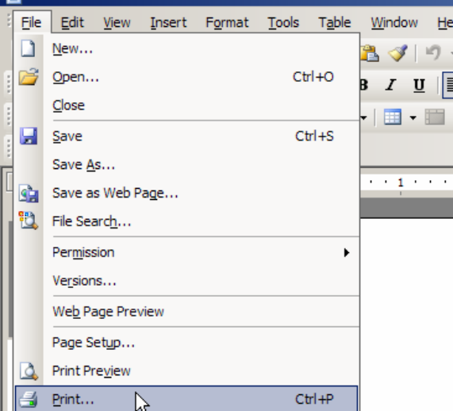

2. Click on the “Properties” box.
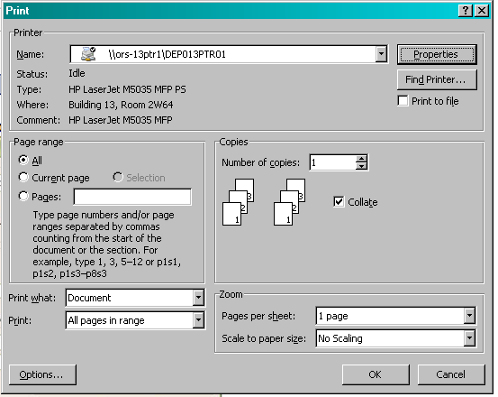

3. The location of the multi-page feature varies between printers. A few common examples are shown below.
