Print Documents in Draft/EconoMode Format

1. Open any Word document, click “File” from the menu bar, and select “Print”
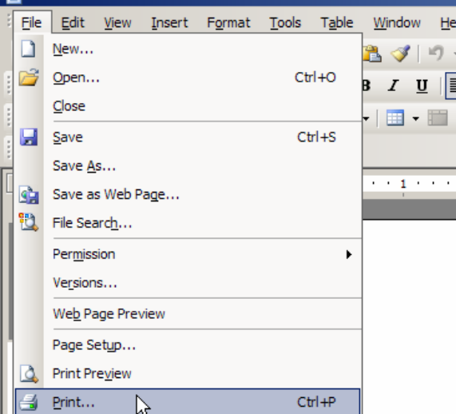

2. Click on the “Properties” box.
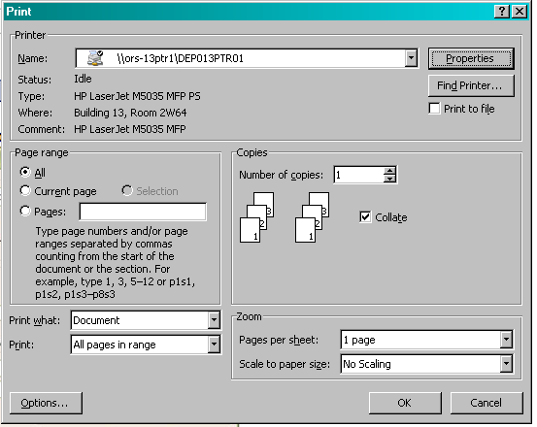

3. The location of the draft format varies by printer. A few examples are shown below.
