Default Printing to Double-Sided Documents

1. Click on “Start” and find “Settings.” In “Settings” click on “Printers and Faxes.”
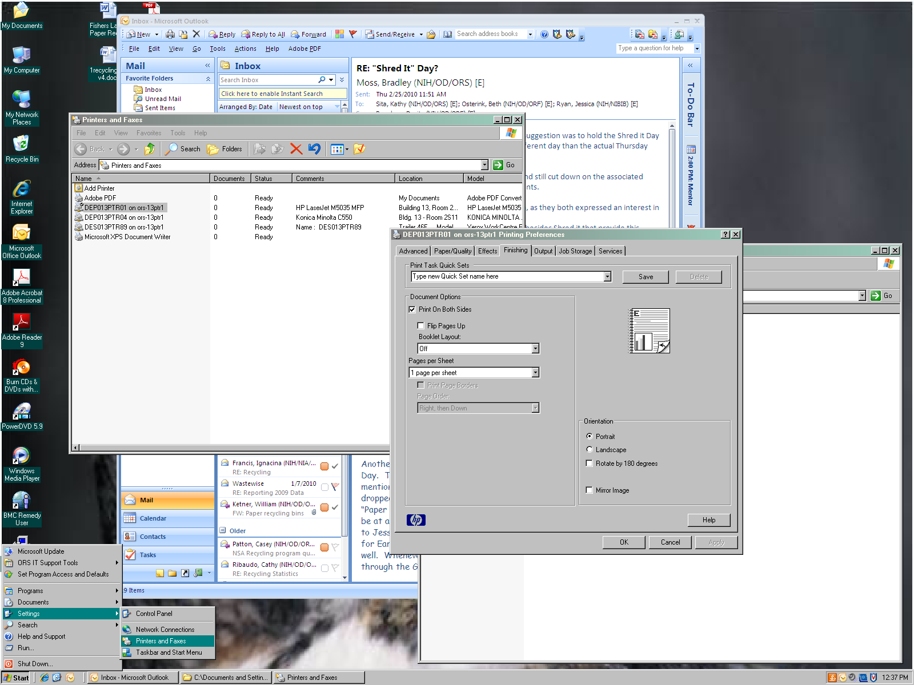

2. Right click on the printer you want to change the default settings on. Then select “Printing Preferences.”
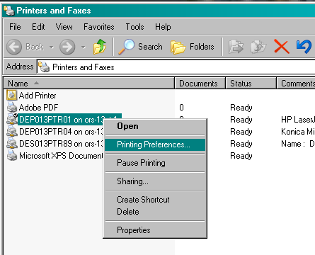

3. Select double-sided/duplex and then select “Apply” or “OK” if there is no “Apply” button. The location of the double-sided (duplex) setting features may vary. Common locations of the duplex features are illustrated below.
