Print Double-Sided Documents

1. Open any document, click “File” from the menu bar, and select “Print”
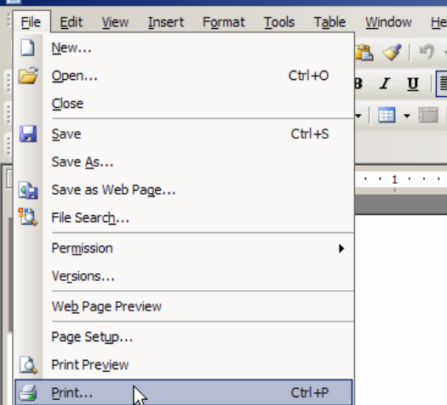

2. Click on the “Properties” box.
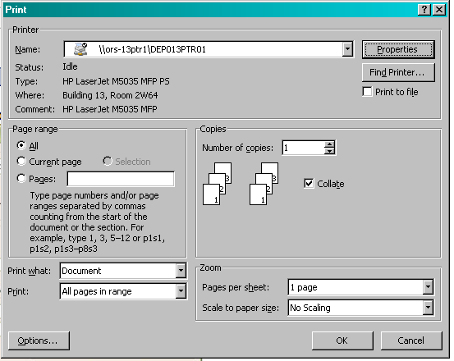

3. The location of the double-sided (duplex) setting features within the printer’s properties may vary. Common locations of the duplex features are illustrated below.
