U. S. DEPARTMENT OF HEALTH AND HUMAN SERVICES
National Institutes of Health

IC Animal Program
Disaster Plan
Templates

FINAL VERSION - 04/08/2024

Blank Page

Table of Contents

Introduction……………………………………………………………………………………..Pg 1

Preparedness Templates:
Incident-Specific Response……………………………………………….……………..Pg 5
- Animal Activism Event
- Biohazard Spill or Exposure
- Bite, Scratch, and Splash
- Bomb Threat
- Chemical Hazard Spill or Exposure
- Civil Disturbance (Disgruntled Employee, Intruder/Trespasser)
- Critical Animal Room Temperatures (Building Automation Systems and HVAC Failure)
- Earthquake
- Facilities Access Control Failure (FACNet, Andover Card Readers, Security)
- Fire
- Flood/High Water
- High Wind (Tornado, Hurricane, Derecho)
- Medical Emergency
- Radiation Spill or Exposure
- Storms
- Strange Odor
- Structural Damage
- Telecommunications Failure
- Utility Failure – Electric Power, HVAC
- Utility Failure - Sewer, Water

General Emergency Guidance………….……………………………….……………..Pg 29
- Communication during Emergency/Disaster Event
- Euthanasia Guidance for Disaster Events
- Evacuation from Large Animal Surgery, Imaging, and Special Techniques Areas
- Information Technology Systems Failure
- Staffing Shortage Planning Guidance
- Transportation Emergencies & Supply Failure (Weather, Road Blocks, Public Transportation Outage)
- Triage Guidance for Disaster Events

IC Specific Information to be Included in IC Animal Program Disaster Plan ………………...Pg 39

Disaster Planning Resources: …………………………………………………………………,..Pg 43
- Acronyms & Definitions
- Animal Program Staff Preparedness Information
- Animal Program Status Report Information
- Animal Program After-Action Report
- Calculating Minimum Water Requirements
- Emergency Alert Notification Systems
- Emergency Animal Care Resources
- Instructions for Updating NED Information & AlertNIH Status
- Media & FOIA Inquiries
- NIH Animal Facility Alarm Set Points (& tiered response system)
- NIH APD Critical Concerns following an Animal Facility Closure Chart
- NIH Emergency Response Contact Information
- NIH Guidelines for Designating Emergency, Mission Critical, and Mission Services & Support Employees for All Hazards/Contingencies
- Telecommunications Systems
- Online Resources & Links
- Operating Instructions for the MovinCool® Office Pro Spot Cooler

Introduction

The Overview and Template documents are designed as reference guides for individuals writing and implementing animal facility and program disaster plans. Although it is impossible to thoroughly address every conceivable emergency situation, IC animal program emergency plans should, at a minimum, address the topics presented in the Template document. Identification of potential situations and courses of action are critical and essential.

The Template is facility non-specific, and is intended to serve as a format around which specific IC animal program emergency plans can be structured. Each IC should conduct an individual vulnerability assessment for each of its animal facilities to identify the impact of potential hazards, threats, and adverse events on facility operations before issuing an individual facility plan. It may be necessary to develop individual plans for each IC primary and satellite animal facility.

Additional IC-specific instructions must be added to ensure coverage of those issues unique to the IC. Specific instructions may be added to the pages of the Template, or additional sections may be added. Any emergency response plan should first address personnel injury and safety; animal care should always be considered secondary issue. Adequate preparation and appropriate training is the cornerstone to successful mitigation of potential disasters. Therefore, the Template should not be used as a substitute for training, experience, or good judgment.

In addition to basic emergency preparedness and response information provided within the Template document, additional information specific to your IC program should be included. While the following is not a comprehensive list, it is suggested that at a minimum the following IC-specific items be included in your plan as reference materials:
- IC Organizational Chart
- IC Crisis Response Team Structure
- IC Crisis Response Team Emergency Coordinator Contact Info
- IC Animal Program Roster (all key IC info)
- IC Animal Facility Roster(s) (AF specific contact info)
- IC Animal Facility Floor Plans
- IC Animal Program Euthanasia Plan
- IC Animal Program Staging/Evacuation/Relocation Plan
- IC Animal Program Preparedness Training Program
- IC Animal Program Standard Operating Procedures for Emergency/Disaster Response
- IC Animal Program Triage Plan

Once the IC Animal Program Disaster Response, Euthanasia, Staging/Evacuation/Relocation, and Triage Plans have been developed, they should be reviewed and updated annually. As part of this annual review, requirements and needs for a large-scale disaster and euthanasia activity should be assessed and modified as necessary. Program requirements to consider include, but are not limited to, personnel, training, equipment, drugs, supplies, transportation, and carcass disposal.

Blank Page

IC Animal Program Emergency Response Planning

Preparedness Templates
Incident Specific

Blank Page

Animal Activism Event
Preparedness:
Do not place yourself or others at risk. Contact the Police immediately if a situation appears to be escalating.
Prevent crimes through employee awareness and securing offices, facilities, and property. Verify staff training on security and response procedures.
Employees should wear government-issued identification badges at all times.
Change cipher lock codes semi-annually, and check doors semi-annually for proper locking function.
Secure all movable/portable equipment.
NIH Police will provide safety escorts on campus upon request: 301-496-5685 or 311.

Response:
Do NOT confront the individual(s).
Check to see if anyone was injured and seek medical care, if needed.
Immediately notify Police - on-campus 911; or off-campus 9-911. If off campus, also call the NIH Police at 301-496-5685, and ask that the on-duty supervisor be notified.
If this is a hit and run type attack, let the Police know that the activists have left and report any injuries &/or damage.
Use the following list to assist in gathering specific details for the Police:
-Identify yourself as a person working at an animal research facility
-Location of the activity - including building, floor, room number(s), etc.
-Number of people involved
-Characteristics of the people i.e. gender, type of clothing, distinctive features, etc.
-Type of activities being conducted, i.e. picketing, yelling, vandalism, releasing animals,…
-Type and number of weapons visible
-Type and number of other tools and equipment, i.e. bullhorns, rope, spray paint cans, electrical wiring, backpacks, gym bags, signs, etc.
Remain at your general location until the Police arrive. If necessary, move to a safe place or exit the facility (if this is occurring inside).
Take photographs of the activists and their activities, but only if this can be done safely.
Observe the route and means the activists use to leave the area, but only if this can be done safely.
Note the exit path and vehicle information, including license plate numbers.
Note any items or places physically touched by activists and protect those items/areas. If activists were not wearing gloves, law enforcement may attempt to get the activists fingerprints.
Carefully examine the entire work area for damage, missing items, and any items left behind by activist. Do not touch any items left behind or anything suspicious. Point these items out to law enforcement officials.
Things to look for include the following:
Noise makers: devices designed to make painfully loud noise, either immediately or later when activated by a timer
Stink bombs: these may be devices that are ignited by a flame immediately or later from a timer
Stinky fruit: activists may leave frozen pieces of type of fruit that smells of rotting flesh. Once thawed it can make a facility uninhabitable for some time.
Flyers or other printed information
Packages, boxes, backpacks, or other containers that could contain dangerous items (e.g., toxic/caustic chemicals, incendiary devices, bombs, etc.)
Notify supervisor as soon as possible.

Recovery:
Re-enter the area only upon clearance by Emergency Responder, Facility Management, or Supervisory personnel.
Report the animal program status to your supervisor and APD.
Assess program elements contributing to the occurrence of the event and program areas impacted.
Consider implementing barriers or procedures to prevent or lessen the effects of a future similar event.
Debrief with staff after the event. For staff who are distressed, seek professional assistance through the NIH Employee Assistance Program at 301-496-3164.
Biohazard Spill or Exposure

Preparedness
Ensure proper signage is posted in biohazard areas and lists PPE, handling, containment, and emergency response instructions.
Ensure biohazards are properly handled, and stored or contained.
Verify staff training on the biohazard’s risks in accordance with NIH Division of Occupational Health & Safety guidance.
Verify staff training on pertinent emergency response and first aid procedures.
Response:
Large Spill (>200ml):
Call NIH Fire Department (On-campus 911; Off-campus 9-911).
Immediately administer first aid to contaminated area or wound. (See below)
Advise personnel in the room/area of the spill to evacuate immediately.
Close windows and doors to the room/area of the spill and evacuate.
To minimize spreading contamination, exposed personnel should report to and remain in one safe location until the arrival of the Fire Department.
Do not re-enter the room/area until the appropriate safety officials have cleared the area for re-entry.

Small Spill (<200 ml):
Put on protective clothing (gloves, safety goggles or glasses, and lab coat).
Immediately administer first aid to contaminated area or wound. (See below)
Flush spilled material with a freshly made 1:10 dilution of bleach or povidine-iodine, and allow to sit for 30 minutes.
Wipe down all equipment and surfaces potentially contaminated.
Dispose of contaminated material as biohazardous waste.
Wash hands with soap and warm water.
Notify the immediate supervisor and the area Health and Safety Specialist @ 301-496-2346.

First Aid: Immediately begin first aid to contaminated area.
Eye exposure: Flush exposed eyes or face immediately. Remove contacts. Hold eyelids open with thumb & fingers. Flush continuously with eyewash for 15 minutes. Roll eyes to thoroughly rinse.
Mouth exposure: Rinse mouth with plain water for at least 15 minutes.
Skin exposure: Remove contaminated clothing & place in biohazard bag. Flush exposed skin with large amounts of water for 15 minutes.
Seek medical attention - Following the application of first aid:
If the incident occurs during NIH business hours (Monday thru Friday between 7:30am–5pm):
Report immediately to NIH OMS. (Building 10/Room 6C306; Phone#: 301-496-4411)
If the incident occurs outside NIH business hours:
Report immediately to Suburban Hospital (Bethesda) or Shady Grove Hospital (Poolesville).
Call the NIH Page Operator at 301-496-1211 & ask the Operator to page the OMS on-call physician.
Emergency Patient Transportation: On-campus 911; Off-campus 9-911. Notify the immediate supervisor.
Recovery:
Re-enter the area only upon clearance by Emergency Responder, DOHS, Facility Management, or Supervisory personnel.
Assess program elements contributing to the occurrence of the event and program areas impacted.
Report the animal program status to your supervisor and APD.
Re-establish pertinent biohazard control procedures.
Re-establish all animal care programs and services.
File an Emergency Event After Action Report.
Bite, Scratch, & Splash
Preparedness:
All staff working with animals should be trained in how to administer first aid to wounds that occur in the facility; especially bite-scratch wounds and animal fluid splash events resulting from contact with research animals. Any wound resulting from being bitten or scratched by a research animal should receive immediate/urgent medical care, but the following wounds should be treated as medical emergencies:
- Bites, scratches, and animal body fluid splashes arising from contact with an Old World Macaque monkey.
- Bites, scratches, and animal body fluid splashes arising from objects (cages, restraint devices, needles, etc.) exposed to an Old World Macaque monkey.
- Wounds or mucous membranes contaminated or splashed by a known or suspected pathogen.
Each facility should have an internal SOP addressing proper action to be taken following an animal related injury or splash. Procedures should be developed in accordance with the APD Guideline on Nonhuman Primate and Other Research Animal Bite, Scratch, Splash, and Exposure (BSSE) Guidelines . A Quick Guide for immediate action following injury or splash related to an Old World Macaque should be posted in all facilities housing Macaques. Conduct frequent training to ensure all personnel know the location of the Bite/Scratch/Splash/Exposure (BSSE) Kits and procedures for an animal-related injury or splash. Inventory Bite/Scratch/Splash/Exposure (BSSE) Kits on a monthly basis and ensure the kits do not contain expired items. Verify staff training on SOP and first aid response procedures.

Response:
- A. First aid after BSSE to any Old World NHP:
  - 1.) Initiate immediate first aid (within the first 5 minutes of exposure): a. Contaminated skin and wounds should be washed thoroughly for 15 minutes with clean running water or normal saline solution, a sponge, and a cleansing agent such as povidone-iodine or chlorhexidine, provided on-site in the NHP bite/scratch (BSSE) kit.
  - b. Contaminated eyes and mucous membranes should be irrigated at an eyewash station for 15 minutes using normal saline solution or clean running water.

  - 2.) After administration of first aid, immediately report the incident to the Main Campus OMS, or have someone report on your behalf while administering first aid, if possible. Ask to speak with the OMS provider-on-duty, and state: “I have had a nonhuman primate-related injury or incident.” Notify Main Campus regardless of geographic location. a. OMS will assess the injury or exposure by phone and provide further guidance.
  - b. IF indicated, OMS will direct you to initiate immediate B virus post-exposure prophylaxis (PEP), found within the BSSE kit.

→ Call 301-496-4411 (Main Campus Clinic), 7:30 am – 5:00 pm ET, Monday – Friday
→ After-hours, or if there is no answer at the OMS clinic during business hours, call 301-496-1211 (NIH Operator), 5:00 pm – 7:30 am ET, Monday – Friday, and on weekends & holidays

If the local OMS clinic is called, they will contact the Main Campus Clinic for approval of post-exposure prophylaxis administration.

- B. First aid after BSSE to other research animals including New World NHPs, rodents, fish, etc.:
  - 1.) Initiate immediate first aid (within the first 5 minutes of exposure): a. Contaminated skin and wounds should be washed thoroughly for 15 minutes with clean running water or normal saline, a sponge, and a cleansing agent such as povidone-iodine or chlorhexidine.
  - b. Contaminated eyes and mucous membranes should be irrigated at an eyewash station for 15 minutes using normal saline or water.

  - 2.) After administration of first aid, report incident to OMS.
Seek medical attention - Following the application of first aid:
If the incident occurs during NIH business hours (Monday thru Friday between 7:30am–5pm): Report immediately to NIH OMS. (Building 10/Room 6C306; Phone#: 301-496-4411)
If the incident occurs outside NIH business hours: Report immediately to Suburban Hospital (Bethesda) or Shady Grove Hospital (Poolesville).
Call the NIH Page Operator at 301-496-1211 & ask the Operator to page the OMS on-call physician.
Emergency Patient Transportation: If transport to a hospital is required, call On-campus 911; Off-campus 9-911
Follow-up: Complete Macaque Information Request Form. Submit Part A to OMS as soon as possible. Collect samples from animal involved in injury, and submit samples and Part B to OMS for testing.
Emergency Patient Transportation: Call (On-campus 911; Off-campus 9-911). Notify immediate supervisor.
Recovery:
Assess program elements contributing to the occurrence of the event and program areas impacted.
Consider implementing barriers or procedures to prevent or lessen the effects of a future similar event.
Ensure the incident is reported to NIH DOHS/OMS as per program SOP.

Bomb Threat
Preparedness:
Do not place yourself or others at risk. Call Police immediately if a situation appears to be escalating.
Verify animal care staff training on security and response procedures.
Employees should wear government-issued identification badges at all times.
Change cipher lock codes semi-annually, and check doors semi-annually for proper locking function.

Response:
Suspicious Letter or Package:
Never touch a suspected bomb/explosive device.
Evacuate everyone in the vicinity to a safe distance.
Turn off all radios and transceiver equipment near the suspected area.
Call the NIH Police (On-campus 911; Off-campus 9-911).
Examine suspicious mail gently - Touching Triggers Tragedy!
Look for suspicious packaging, unrequested delivery.
Place of Origin - Note the delivery postmark.
Writing - Treat with caution if unusual type of writing not normally received on the address.
Balance - Has loose contents, or is heavier on one side than the other.
Weight - Excessively heavy for its volume.
Feel - Springiness at the top, bottom, or sides, but it does not bend or flex.
Protruding Wires, holes, grease marks, smell, etc.
Letter Stiffness. Presence of stiff cardboard, metal, or plastic.
Inner Sealed Enclosures.

Threatening Call:
Do not hang up. Remain calm. Take the caller seriously. Assume the threat is real.
Engage caller in conversation. Obtain as much information as possible from the caller - type of device, what it looks like, where it's located, what time it will go off, etc. If possible, have someone listen in on the call.
Be calm and take notes of the conversation. Jot down exact words as soon as possible. Use Bomb Threat Checklist to gather information about the caller and the threat.
If the threat is left on voicemail, do not delete it.
Have a coworker call the Police (On-campus 911; Off-campus 9-911) on another line. If you are alone, after the call is disconnected by the caller, do not hang up the phone. Press *57 first and then hang up the phone. (This procedure will "capture" the phone line so that the phone company can trace it), then call the Police (On-campus 911; Off-campus 9-911) to report the threat.
Do not use cell phone, two-way radio, or any wireless communication device, as it can act as a trigger for an explosive device.
Notify supervisor.
Do not discuss the situation with news media or other outsiders. Inquiries should be courteously and tactfully directed to the IC Information Officer. http://www.nih.gov/news/media_contacts.htm

Recovery:
Re-enter the area only upon clearance by Emergency Responder, Facility Management, or Supervisory personnel.
Refer to Structural Damage template, if necessary.
Assess program elements contributing to the occurrence of the event and program areas impacted.
Consider implementing barriers or procedures to prevent or lessen the effects of a future similar event.
Debrief with staff after the event. For staff who are distressed, seek professional assistance through the NIH Employee Assistance Program at 301-496-3164.

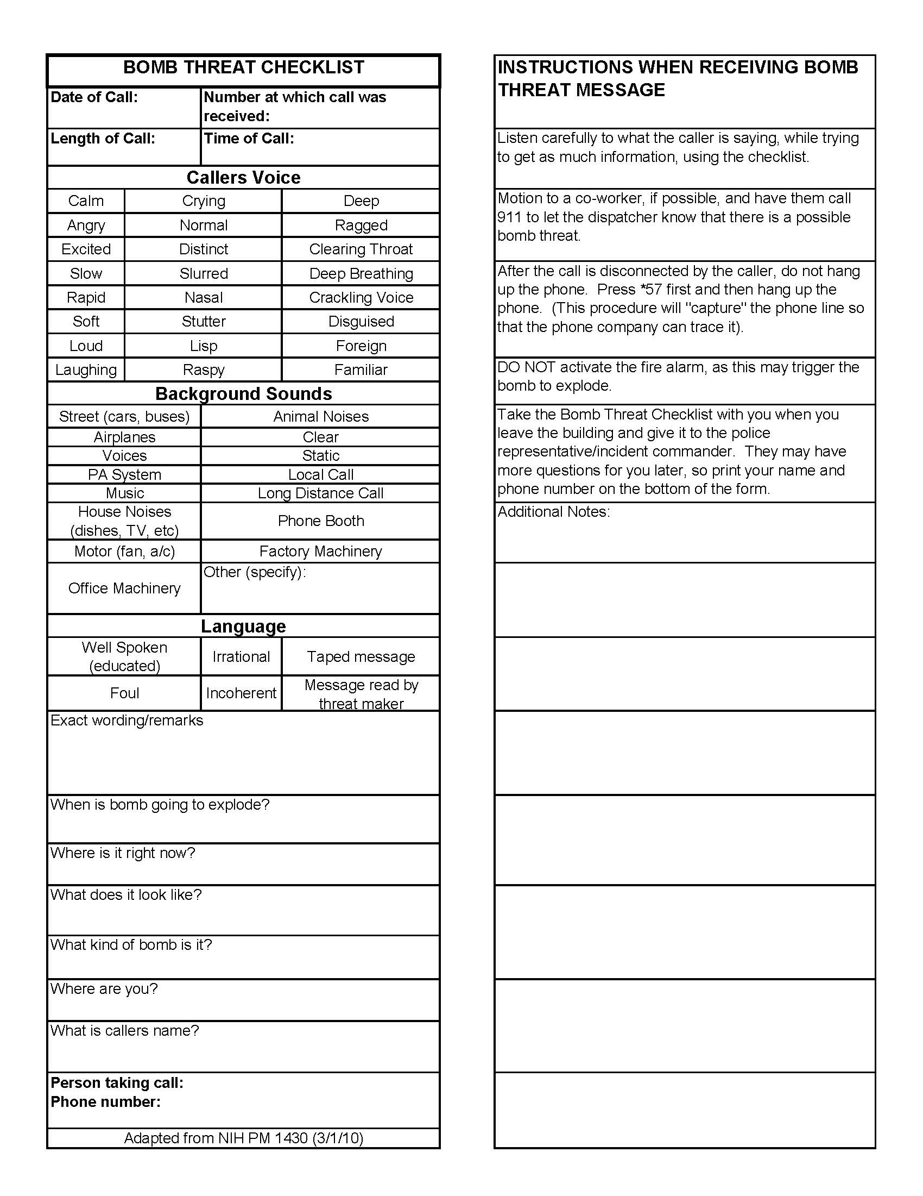

Chemical Hazard Spill or Exposure

Preparedness:
Ensure proper signage is clearly posted in chemical hazard areas, including required PPE, handling, containment, and emergency instructions.
Verify staff training on working with and around the chemical hazards on the risks of the particular hazard in accordance with NIH Division of Occupational Health and Safety guidance.
Verify staff training on pertinent emergency response and first aid procedures.
Maintain copy of the NIH Chemical Hygiene Plan: http://www.ors.od.nih.gov/sr/dohs/Documents/NIH-CHP.pdf and Material Safety Data Sheets (MSDS) for all chemicals present in facility.
Response:
Large Spill (>200ml)

Turn off gas burners.
Evacuate personnel in the room/area of the spill, & close doors upon exit.
Exposed personnel should report to and remain in one safe location until the arrival of the Fire Department.
Call Fire Department (On-campus 911; Off-campus 9-911).
Administer first aid if needed as per instructions below.
Do not re-enter the room/area until the appropriate safety officials have cleared the area for re-entry.
Small Spill (<200 ml):
Turn off gas burners.
Put on appropriate protective clothing (gloves, safety goggles or glasses, and lab coat).
Administer first aid if needed as per instructions below.
Cover small spills with absorbent towels or sheets to minimize volatilization.
Clean spill area working from outside toward the center until there is no more removable contamination.
Wipe down all equipment and surfaces potentially contaminated.
Dispose of contaminated material as biohazardous waste.
Wash hands with soap and warm water.
For medical emergencies, call On-campus 911; Off-campus 9-911.
Notify the immediate supervisor and the area Health and Safety Specialist @ 301-496-2346.
First Aid: Personal safety is the first consideration. Avoid contact with blood or body fluids.
Immediately begin first aid to contaminated area: Person assisting should wear gloves.
Eye exposure: Flush exposed eyes or face immediately. Remove contacts. Hold eyelids open with thumb & fingers. Flush continuously with eyewash for 15 minutes. Roll eyes to thoroughly rinse.
Mouth exposure: Rinse mouth with plain water for at least 15 minutes.
Skin exposure: Remove contaminated clothing. Flush exposed skin with large amounts of water for 15 minutes.
Seek medical attention - Following the application of first aid:
If the incident occurs during NIH business hours (Monday through Friday between 7:30am–5pm): Report immediately to NIH OMS. (Building 10/Room 6C306; Phone#: 301-496-4411)
If the incident occurs outside NIH business hours:
Report immediately to Suburban Hospital (Bethesda) or Shady Grove Hospital (Poolesville), and call the NIH Page Operator at 301-496-1211 & ask the Operator to page the OMS on-call physician.
Emergency Patient Transportation: Call (On-campus 911; Off-campus 9-911). Notify immediate supervisor.
If Animal Resources Team assistance is needed contact the ART via OACU (301-496-5424—during working hours), or contact Dr. Evan Shukan (shukanet@mail.nih.gov, 413-427-9448) or Hana Bao (hana.bao@nih.gov, 781-929-2836) directly.
Recovery:
Re-enter the work area upon clearance by NIH DOHS, Facility Management, or Supervisory personnel.
Assess program elements contributing to the occurrence of the event and program areas impacted.
Consider implementing barriers or procedures to prevent or lessen the effects of a future similar event.
Ensure the incident is reported to NIH DOHS at 301-496-2346 as per program SOP.

Civil Disturbance
(Disgruntled Employee, Intruder/Trespasser)

Preparedness:
Do not place yourself or others at risk. Contact the Police immediately if a situation appears to be escalating.
Verify staff training on security and response procedures.
Prevent crimes through employee awareness and securing offices, facilities, and property.
Employees should wear government-issued identification badges at all times.
Change cipher lock codes semi-annually, and check doors semi-annually for proper locking function.
Secure all movable/portable equipment.
NIH Police will provide safety escorts upon request: 301-496-5685.

Response:
Disgruntled Employee:
Be sympathetic and make an effort to understand their concerns. Remain calm and do not become confrontational.
If unable to interact in positive manner, attempt to establish the magnitude of the problem and manage the complaint in a progressive fashion through referral of the employee to one of the following individuals:

NIH Employee Assistance Program (EAP) (Building 31, Room B2B57, (301) 496-3164)
NIH Civil (301-402-4845)
Anti-Harassment toll-free line (833-224-3829)
Animal Program Director
Chair, IC Animal Care & Use Committee (ACUC)
Office of Animal Care and Use (Phone: 301-496-5424)
Deputy Director for Intramural Research (Phone: 301-496-1921)
If necessary, call the NIH Police by dialing On-campus 911; Off-campus 9-911.

Intruder/Trespasser:
Suspicious persons and/or behavior should be reported to the NIH Police at 301-496-5685.
Use caution when approaching an individual that appears to be trespassing. Do not put yourself or others at risk.
Inquire in a non-confrontational manner if the person needs assistance.
If the Police need to be called, try to detain the person until they arrive.
If they cannot be detained, write down any characteristics that you can recall – hair color, height, clothing, accent, items being carried, etc.

Reporting Theft, Crimes, & Security Breaches:
Personal injury/property damage – Call Police On-campus 911; Off-campus 9-911
Theft of property - to the NIH Police at 301-496-5685 or 311. Off campus incidents should be reported to local police as well.
Threats (to person and/or personal property) – Call NIH Police at 301-496-5685 or 311.
Unauthorized entrance into an NIH facility - Call NIH Police at 301-496-5685 or 311.
Criminal act - Call Police On-campus 911; Off-campus 9-911
Suspicious persons and/or behavior, and other security-related incidents – Call NIH Police at 301-496-5685 or 311.

Recovery:
Re-enter the area only upon clearance by Emergency Responder, Facility Management, or Supervisory personnel.
Assess program elements contributing to the occurrence of the event and program areas impacted.
Consider implementing barriers or procedures to prevent or lessen the effects of a future similar event.
Debrief with staff after the event. For staff who are distressed, seek professional assistance through the NIH Employee Assistance Program at 301-496-3164.

Critical Animal Room Temperatures
(Building Automation Systems and HVAC Failure)

Preparedness:
Prepare and maintain a plan for manual animal room temperature monitoring. Verify staff training on plan critical elements, such as: frequency of room temperature checks; documentation requirements; acceptable temperature ranges per species; appropriate response procedures; location of room temperature displays; and, use and location of manual temperature monitoring equipment.
Post step-by-step instructions for reporting abnormal high or low animal room temperatures to the Office of Research Facilities (ORF) Help Desk [301-435-8000 (24 hours/7days a week)] near a central facility telephone or staff entrance.
Review staff responses to BAS failures (temperature emergencies) using table top exercises that practice BAS Failure reporting and response procedures to Animal Program Managers and the ORF Help Desk.
Periodically review animal relocation plans related to room temperature emergencies.
Determine number of portable chillers and heaters required to maintain animal room temperatures during an HVAC emergency event, and incorporate into IC Triage Standard Operating Procedure (SOP). If possible, keep portable chillers/heaters on-site or meet with ORF personnel to determine what is readily available in the event of a temperature emergency.
Response:
Notify the Animal Facility Manager immediately, when:
-Animal room temp is outside the acceptable range. The Facility Manager or designee can validate actual room parameters using a handheld Vailsala monitoring device.
-The Environmental Monitoring (EM) system is not working properly or is in alarm status.
Notify the Office of Research Facilities (301-435-8000: 24 hours/7 days a week):
-Report that the Animal Room Environmental Monitoring system is not working correctly or the animal rooms are in alarm status and animal lives are at risk.
-Ask the ORF Help Desk if the BAS failure is due to a scheduled utility shutdown. If the answer is “yes”, contact the ORF Building Facility Manager to help coordinate a response.
If an animal room temperature is elevated or falls to a critical Tier 2 temperature;
-If the animal rooms contain Hazardous Agents (Infectious, Chemical, Radiological, etc.), contact the NIH Division of Occupational Health & Safety at (301) 496-2346 or NIH Division of Radiation Safety (301)496-5774.
-Implement IC Triage SOP. Place portable fans, chillers, or heaters in the room, &/or prop open the animal room doors, if the animal room contains microisolators, open racks, and/or conventionally housed animals.
-If temperature rises due to HVAC malfunction, consult with Animal Facility Manager & ORF regarding shutting off room supply to conserve temperature. Evaluate ABSL, animal and air quality issues before making air handler changes
Initiate manual animal room temperature monitoring procedures:
-Check and record room temperatures and humidity levels hourly or more often as necessary.
-Report the status of the animal rooms to supervisor at least once every hour until the room temperatures are in the normal range. Continue manual animal room temperature monitoring until supervisor announces the BAS problem is resolved.
If Animal Resources Team assistance is needed contact the ART via OACU (301-496-5424—during working hours), or contact Dr. Evan Shukan (shukanet@mail.nih.gov, 413-427-9448) or Hana Bao (hana.bao@nih.gov, 781-929-2836) directly.

Recovery:
Report the program status to immediate supervisor and APD.
Review anticipated disaster event concerns listed in NIH APD Critical Concerns following an Animal Facility Closure chart (Resources Section).
If temperatures remain critical for a prolonged period, consult IC Staging/Evacuation/Relocation procedures and implement as needed.

Reestablish hazard control procedures; and reestablish animal care programs and services.
Assess program elements contributing to the occurrence of the event and program areas impacted.
Consider implementing barriers or procedures to prevent or lessen the effects of a future similar event.
File an Emergency Event After Action Report, if necessary.

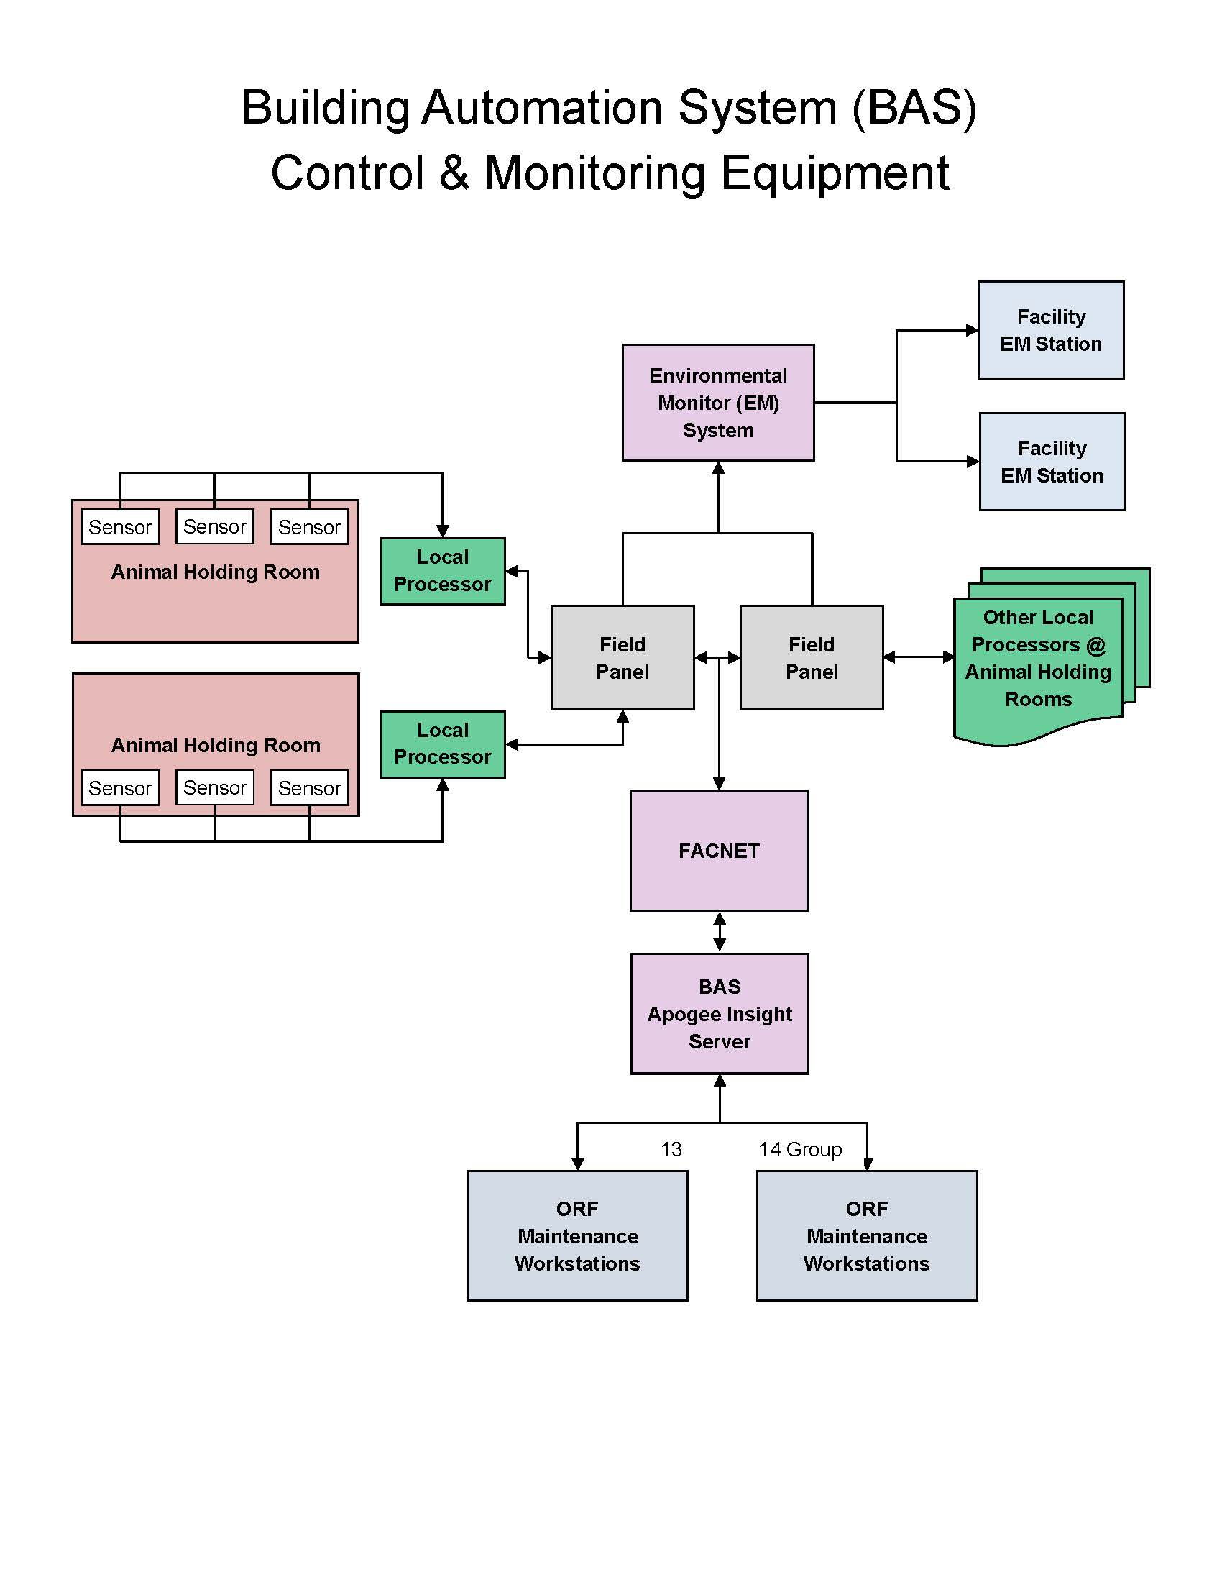

Earthquake
Preparedness:
Ensure personnel can find building exits even if directional signs are obscured by smoke or power outage.
Identify Occupant Emergency Coordinators (OEC) that will be responsible for personnel evacuation. OEC may designate Floor Team Coordinators (FTC) as necessary to facilitate rapid evacuation. Notify OEC if there are personnel with a disability that may limit or impede their ability to evacuate the building.
Identify at least two building evacuation routes. Verify staff training on facility evacuation and rallying procedures and perform practice drills twice per year with the Emergency Planning Coordinator.
Staff orientation procedures should include review of facility emergency equipment (type and location) and building exit routes.
Keep all egress routes and hallways clear. Keep flammables in appropriate storage cabinets.

Response:
Indoors:
If time permits, turn off power to equipment and/or close off any gas supplies.
Get to the ground, and stay away from external walls and windows.
Find cover under a desk, table, or sturdy piece of furniture; if furniture is unavailable, crouch down against an interior wall and protect your neck and head with your arms. Hold on to the desk, table, or furniture until shaking stops. Then evacuate the building by the stairway checking for hazards along the way.
Do not use elevators. Do not pull fire alarm unless Fire Department response is required.
Move away from the building to avoid falling objects.
Go to the rally area and wait for instructions. Supervisors account for personnel.
If dangerous to evacuate, move to a safe location interior to the building. Call Fire Department (On-campus 911; Off-campus 9-911).
Outdoors:
Remain outdoors. Move away from the building to avoid falling objects. If in a safe open area (away from buildings, trees, streetlights, & overhead utility wires), drop to your knees and cover your head until shaking stops.
Go to the rally area and wait for instructions. Supervisors account for personnel.
If you are injured or witness structural damage, call the Fire Department from a cell phone (On-campus 301-496-9911; Off-campus 911).
Meet Emergency Responders, and follow their directions. Do not re-enter the building until it is determined safe for occupancy by the Fire Marshal, Fire Department or ORF.
If Animal Resources Team assistance is needed contact the ART via OACU (301-496-5424—during working hours), or contact Dr. Evan Shukan (shukanet@mail.nih.gov, 413-427-9448) or Hana Bao (hana.bao@nih.gov, 781-929-2836) directly.

Recovery:
Do not re-enter the building until it is determined safe for occupancy by the Fire Marshal, Fire Department or ORF.
Review anticipated disaster event concerns listed in NIH APD Critical Concerns following an Animal Facility Closure chart (Resources Section). Assess timeline, potential animal status, and identify resources needed. If applicable, refer to Structural Damage Template.
Perform triage of animals to determine most appropriate course of action (i.e., relocation within facility, euthanasia, evacuation,…).
Re-establish pertinent biohazard control procedures.
Re-establish all animal care programs and services.
Assess program elements contributing to the occurrence of the event and program areas impacted.
Consider implementing barriers or procedures to prevent or lessen the effects of a future similar event.
File an Emergency Event After Action Report.

Facility Access Control Failure
(FACNet, Andover Card Readers, & Security)
Background:
The electronic Facilities Network (FACNet) supports a variety of building support and building automation systems (BAS) to include building: access, security, lighting, elevators, HVAC (heating, ventilation, air conditioning) control systems. The FACNet comprises: electronic hosting of various building automation system programs, redundant offsite servers, and electronic connections to environmental sensors, building equipment, operator control monitors, etc.
--Building Access Control Systems enable Animal Facility (AF) staff members to control who enters a building or building section through ID badges.
--Building HVAC Control Systems (Siemens, etc.) electronically monitor animal room environmental conditions and adjust air handler components to maintain the animal room environments according to established setpoints. Normally, when a building’s FACNet connection is down (fails), the building’s HVAC components will continue to run according to the last instructions it received from the FACNet.
--Building HVAC Monitoring Systems enable Animal Facility staff and ORF engineers to monitor room conditions, and initiate corrective actions when room environmental parameters deviate from acceptable ranges. If a FACNet HVAC monitoring component fails, ORF will not be able to monitor or influence animal room environmental conditions.
---FACNet Electronic Connections are illustrated in the Building Automation System Control & Monitoring Equipment schematic (see Critical Animal Room Temperatures template). The FACNet Server is the central point for linking the ORF Operator Desk to the HVAC Field Controller Panels/Server, Building (HVAC, Security, Access, Lighting) Components, and Animal Room (HVAC, Security, Access, Lighting) Sensors.
Preparedness:
Identify critical rooms and ensure doors remain locked or unlocked (as appropriate) in the event the FACNet system fails. Ensure the facility staff has keys or other methods to access locked doors in the event of card key system failure.
Annually conduct a program risk-analysis of FACNet-dependent animal facility programs. Annually review FACNet component failure response procedures with key Animal Program staff members.
Ensure staff members are familiar with the AF’s FACNet-dependent BAS monitoring systems.
Annually discuss FACNet disaster or failure response plans with the organizations managing the FACNet hosted BAS programs:
Central Information Technology (CIT) - facility access
NIH Division of Physical Security and Access Control – facility security
Office of Research Facilities – HVAC & lighting
Response:
If a BAS program hosted by the FACNet fails:
- Verify the FACNet controlled function/parameter is failed or out of bounds.
- Notify your supervisor of the incident/situation.
- Immediately report the problem to the host/lead of the BAS program.
- Initiate actions to maintain or re-establish the correct animal room conditions.
Check the status of all other FACNet hosted BAS systems in the Animal Facility.
Report the status of FACNet hosted BAS systems to the Animal Facility Manager.
If Animal Resources Team assistance is needed contact the ART via OACU (301-496-5424—during working hours), or contact Dr. Evan Shukan (shukanet@mail.nih.gov, 413-427-9448) or Hana Bao (hana.bao@nih.gov, 781-929-2836) directly.
Recovery:
Review anticipated disaster event concerns listed in NIH APD Critical Concerns following an Animal Facility Closure chart (Resources Section). If applicable, refer to Critical Animal Room Temperatures Template.
Liaison with the manager of the BAS system until the function/parameter is corrected.
Assess program elements contributing to the occurrence of the event and program areas impacted.
Consider implementing barriers or procedures to prevent or lessen the effects of a future similar event.
Fire

Preparedness:
Smoke, heat, and toxic gases from a fire are the most common cause of fire related deaths & injuries. Smoke, heat, and gases rise and collect at ceiling levels, pushing cooler, cleaner air toward the floor.
Ensure personnel can find building exits even if directional signs are obscured by smoke or power outage.
Identify Occupant Emergency Coordinators (OEC) that will be responsible for personnel evacuation. OEC may designate Floor Team Coordinators (FTC) as necessary to facilitate rapid evacuation. Notify OEC if there are personnel with a disability that may limit or impede their ability to evacuate the building.
Identify at least two building evacuation routes. Verify staff training on facility evacuation and rallying procedures and perform practice drills twice per year with the Emergency Planning Coordinator.
Staff orientation procedures should include review of facility emergency equipment (type and location) and building exit routes.
Keep all egress routes and hallways clear. Keep flammables in appropriate storage cabinets.
Response:
Notify Fire Department immediately.
Pull/Activate the nearest fire alarm.
If a telephone is closer than alarm, call the Fire Department (On-campus 911; Off-campus 9-911.) then pull fire alarm to evacuate others.
Evacuate personnel.
If clothing catches fire - "Stop, Drop, and Roll".
Avoid smoke-filled air - "Get Low and Go"
Notify personnel in the room/area of the fire to evacuate immediately.
Do not use elevators. Walk to the nearest stairwell/exit & follow designated fire exit route to evacuate building.
Complete safety actions as time permits.
Turn off any gas being used.
Return flammables to safety cabinet.
Close all doors.
OEC/FTC duties:
Ensure all personnel have evacuated, and doors are closed in vacated areas.
Secure flammables
Exit building and go to rally point.
Report to Fire Officer in Charge, and notify them of any trapped or injured personnel that could not be reached.
If Animal Resources Team assistance is needed contact the ART via OACU (301-496-5424—during working hours), or contact Dr. Evan Shukan (shukanet@mail.nih.gov, 413-427-9448) or Hana Bao (hana.bao@nih.gov, 781-929-2836) directly.
Recovery:
Do not re-enter the building until it is determined safe for occupancy by the Fire Marshal, Fire Department or ORF.
Report the animal program status to supervisor and APD.
Review anticipated disaster event concerns listed in NIH APD Critical Concerns following an Animal Facility Closure chart (Resources Section). Assess timeline, potential animal status, and identify resources needed. If applicable, refer to Structural Damage Template.
Perform triage of animals to determine most appropriate course of action (i.e., relocation within facility, euthanasia, evacuation,…).
Re-establish pertinent biohazard control procedures.
Re-establish all animal care programs and services.
Assess program elements contributing to the occurrence of the event and program areas impacted.
Consider implementing barriers or procedures to prevent or lessen the effects of a future similar event.
File an Emergency Event After Action Report.

Flood/High Water
Preparedness:
Flooding water has tremendous force. Locate and identify low-lying areas that could be impacted by flood waters. Keep all floor drains unobstructed. Do not enter floors or rooms that have water present. Even a small amount of water can increase the risk of electrical hazards.
Identify Occupant Emergency Coordinators (OEC) that will be responsible for personnel evacuation. OEC may designate Floor Team Coordinators (FTC) as necessary to facilitate rapid evacuation. Notify OEC if there are personnel with a disability that may limit or impede their ability to evacuate the building.
Identify at least two building evacuation routes. Verify staff training on facility evacuation and rallying procedures and perform practice drills twice per year with the Emergency Planning Coordinator.
Staff orientation procedures should include review of facility emergency equipment (type and location) and building exit routes.
Keep all egress routes and hallways clear. Keep flammables in appropriate storage cabinets.
Maintain equipment list of items such as extension cords, wet-dry vacuums, flashlights, light trees, batteries, generators, walkie-talkies, portable space chillers, heaters, and fans.
Response:
Large water leak or flood:
Notify Fire Department immediately - Call Fire Department (On-campus 911; Off-campus 9-911), then pull fire alarm to evacuate personnel.
Evacuate personnel - Notify personnel to evacuate immediately. Do not use elevators. Use stairs & follow designated exit route. Walk to the nearest stairwell/exit and evacuate the building.
Complete safety actions as time permits - Turn off all electrical equipment & power disconnects, and close all doors.
OEC/FTC duties:
Ensure all personnel have evacuated and doors are closed in vacated areas.
Exit building and go to rally point.
Report to Fire Officer in Charge (OIC), and notify them of any trapped or injured personnel that could not be reached.
Small/contained water leak:
Notify Office of Research Facilities (301-435-8000: 24 hours/7 days a week). Provide building(s), room number(s), and degree of water damage (volume, size of area, source of water).
Evacuate personnel from compromised areas.
Notify personnel to evacuate from impacted area immediately.
Do not use elevators. Use stairs & follow designated exit route.
Complete safety actions as time permits - Turn off main water valves & close all doors.
If Animal Resources Team assistance is needed contact the ART via OACU (301-496-5424—during working hours), or contact Dr. Evan Shukan (shukanet@mail.nih.gov, 413-427-9448) or Hana Bao (hana.bao@nih.gov, 781-929-2836) directly.
Recovery:
Do not re-enter the building until it is determined safe for occupancy by the Fire Marshal, Fire Department or ORF.
Review anticipated disaster event concerns listed in NIH APD Critical Concerns following an Animal Facility Closure chart (Resources Section). Assess timeline, potential animal status, and identify resources needed.
Perform triage of animals to determine most appropriate course of action (i.e., relocation within facility, euthanasia, evacuation,…). Animals may be temporarily relocated from low-level areas to laboratories or other animal facilities on upper floors of the same or other IC buildings, especially if flooding is highly probable.
Re-establish pertinent biohazard control procedures.
Re-establish all animal care programs and services.
Assess program elements contributing to the occurrence of the event and program areas impacted.
Consider implementing barriers or procedures to prevent or lessen the effects of a future similar event.
File an Emergency Event After Action Report.

High Wind
(Tornado, Hurricane, Derecho)
Preparedness:
Human life safety is the primary concern.
Ensure personnel can find building exits even if directional signs are obscured by smoke or power outage.
Identify Occupant Emergency Coordinators (OEC) that will be responsible for personnel evacuation. OEC may designate Floor Team Coordinators (FTC) as necessary to facilitate rapid evacuation. Notify OEC if there are personnel with a disability that may limit or impede their ability to evacuate the building.
Identify at least two building evacuation routes. Verify staff training on facility evacuation and rallying procedures and perform practice drills twice per year with the Emergency Planning Coordinator.
Staff orientation procedures should include review of facility emergency equipment (type and location) and building exit routes.
Keep all egress routes and hallways clear. Keep flammables in appropriate storage cabinets.
Keep daily supplies of drugs and drug administration items on hand. Crash cart should be stocked with 24-hour supply of euthanasia solution and necessary analgesics.
Keep an emergency weather radio for listening to weather reports.
Develop plans for personnel to shelter-in-place and for disruption to utilities and animal care supply chain.
Fully stock supply and crash-carts in preparation for forecasted adverse weather events.
Response:
If time permits, move animals to indoor/sheltered facilities.
Remain inside or move to first floor or basement location until the storm has passed.
Expect shattered glass/debris and electrical outages. Protect cages as possible from potentially shattering glass.
Do not use elevators, use stairs only.
Account for personnel and identify missing or injured staff.
Perform first aid as necessary, and as the situation allows. If necessary, call the NIH Fire Department for further medical treatment. (On-campus 911; Off-campus 9-911)
Report building structure and service problems to the Office of Research Facilities (301-435-8000: 24 hours/7 days a week).
Notify supervisor of current facility status and any personnel injuries.
If Animal Resources Team assistance is needed contact the ART via OACU (301-496-5424—during working hours), or contact Dr. Evan Shukan (shukanet@mail.nih.gov, 413-427-9448) or Hana Bao (hana.bao@nih.gov, 781-929-2836) directly.
Recovery
Do not re-enter the building until it is determined safe for occupancy by the Fire Marshal, Fire Department or ORF.
Report the animal program status to supervisor and APD.

Review anticipated disaster event concerns listed in NIH APD Critical Concerns following an Animal Facility Closure chart (Resources Section). Assess timeline, potential animal status, and identify resources needed. If applicable, refer to Structural Damage Template.
Inventory animal population and account for any potentially escaped animals. Alert NIH Police (301-496-5685 or 311) if there are escaped animals.
Perform triage of animals to determine most appropriate course of action (i.e., relocation within facility, euthanasia, evacuation,…). Consider evacuation of animals if adverse weather is forecasted and subsequent structural damage of the building may threaten the animal colony. Animals may be temporarily relocated from low-level areas to laboratories or other animal facilities on upper floors of the same or other IC buildings, especially if flooding is highly probable.
Re-establish pertinent biohazard control procedures.
Re-establish all animal care programs and services.
Assess program elements contributing to the occurrence of the event and program areas impacted.
Consider implementing barriers or procedures to prevent or lessen the effects of a future similar event.
File an Emergency Event After Action Report.

Medical Emergency

Preparedness:
Ensure first aid kits are fully stocked and all materials are in date.
Verify staff training on contents and location of first-aid kits, and maintain map or list of the locations.
Identify which staff members are certified in first aid administration.
Maintain current “In Case of Emergency” contact list for personnel.
Verify staff training on difference between a major and minor medical emergency:
Major Medical Emergency: Severe illness or injury that requires immediate hospital care. Victim is in severe pain or distress and/or has life-threatening condition such as: severe bleeding, head injury, broken/dislocated joints or bones, heart attack or severe chest pains, unconscious and/or not breathing , anaphylaxis, severe chemical burn, etc.
Minor Medical Emergency: Minor illness or injury that does not require immediate hospital care. Victim not in severe pain or distress and does not have life-threatening condition, such as minor strains/sprains, allergic reaction (other than anaphylaxis), minor burns, etc.
Personnel should be aware of locations of Automated External Defibrillator (AED) units. Further information can be found at the following NIH websites:

NIH AED Locations & Cardiopulmonary Resuscitation (CPR) Training:
https://www.ors.od.nih.gov/sr/dohs/safety/Training/Pages/aedlocations.aspx

How to Use an Automated External Defibrillator (AED) – NHLBI:
http://www.nhlbi.nih.gov/health/health-topics/topics/aed/

Response:
First Aid: Personal safety is the first consideration. Do not enter an unsafe accident scene at the risk of your own safety. Avoid contact with blood or body fluids. Person assisting should wear gloves.
Administer first aid: Personnel certified to provide first aid or CPR may give emergency care. Untrained staff may render support at the direction of the emergency operator.
Seek medical attention - Following the application of first aid:

Minor Medical Emergencies:
If the incident occurs during NIH business hours (Monday through Friday between 7:30am–5pm):
Report to NIH OMS. (Building 10/Room 6C306; Phone#: 301-496-4411)
If the incident occurs outside NIH business hours:
Report to Suburban Hospital (Bethesda) or Shady Grove Hospital (Poolesville),

Major Medical Emergencies & Emergency Patient Transportation: Call (On-campus 911; Off-campus 9-911). Notify immediate supervisor.

Recovery:
Assess program elements contributing to the occurrence of the event and program areas impacted.
Consider implementing barriers or procedures to prevent or lessen the effects of a future similar event.
Ensure the incident is reported to NIH Occupational Medical Service (OMS) at 301-496-4411.

Radiation Spill or Exposure

Preparedness:
Ensure proper signage is clearly posted in radiation hazard areas, including required PPE, handling, containment, and emergency instructions. Verify training of staff working with and around the hazards. Training should include the risks of the particular hazard, and on emergency response and first aid procedures.
Response:
Large Spill (>500 microcuries):
Check for exposure.
Administer first aid if needed as described below.
Evacuate personnel in the room/area of the spill, & close doors upon exit. Post person by door to prevent re-entry.
Exposed personnel should report to and remain in one safe location until the arrival of the Fire Department.
Shield large spills if possible without contaminating yourself or creating an exposure.
Call Fire Department (On-campus 911; Off-campus 9-911).
Call Division of Radiation Safety to triage @ 301-496-5774.
Do not re-enter the room/area until the appropriate safety officials have cleared the area for re-entry.
Small Spill (<500 microcuries):
Check for exposure.
Administer first aid if needed as described below.
Evacuate personnel in the room/area of the spill, & close doors upon exit.
Exposed personnel should report to and remain in one safe location until the arrival of the Fire Department.
Confine the contamination by laying absorbent material over spill without splashing it.
Collect absorbent material into radioactive waste container using gloves and appropriate tools to collect material. Dispose of contaminated material as waste.
Clean spill area with soap and water working from the outside toward the center.
Test for contamination repeatedly using survey meter or wipe test. Continue to clean area until there is no removable contamination.
Notify Division of Radiation Safety @ 301-496-5774.
First Aid: Personal safety is the first consideration. Do not enter an unsafe accident scene at the risk of your own safety. Avoid contact with blood or body fluids.
Administer first aid: Person assisting should wear protective gloves. Change gloves after clothing removal and before handling contaminated person again. Remove contaminated clothing and shoes before going to a clean area. Wash affected skin with soap and water.
Call: The Fire Department (On-campus 911; Off-campus 9-911).
Seek medical attention - Following the application of first aid:
If the incident occurs during NIH business hours (Monday through Friday between 7:30am–5pm):
Report immediately to NIH OMS. (Building 10/Room 6C306; Phone#: 301-496-4411)
If the incident occurs outside NIH business hours:
Report immediately to Suburban Hospital (Bethesda) or Shady Grove Hospital (Poolesville), and call the NIH Page Operator at 301-496-1211 & ask the Operator to page the OMS on-call physician.
Emergency Patient Transportation: Call (On-campus 911; Off-campus 9-911). Notify immediate supervisor.
Monitor: As per NIH Division of Radiation Safety approved protocol for radiation use.
Recovery:
Re-enter the work area upon clearance by Division of Radiation Safety or Supervisory personnel.
Assess program elements contributing to the occurrence of the event.
Consider implementing barriers or procedures to prevent or lessen the effects of a future similar event.
Ensure the incident is reported to NIH Division of Radiation Safety at 301-496-5774.

Storms
Preparedness:
Winter Storms: Most winter storms are predictable. Severe storms can produce “white out" conditions where visibility is near zero. Do not travel in "white out" conditions.
Summer Storms: Thunderstorms often generate severe winds, rain, hail and lightning. Power fluctuations or outages, and flash floods are common. Stay indoors and monitor local weather forecasts for thunderstorm, tornado, and other severe weather warnings.
Essential Personnel: Designate qualified FTE individuals as “Emergency” and assign them the responsibility to provide required animal care services during a severe storm. Essential contract staff should be identified by their contract company, and a staffing plan in place for situations that may result in staffing shortages. Periodically review the responsibilities and expectations of essential personnel with all individuals. Establish SOPs for relieving and rotating essential personnel during prolonged storms.
Overnight Personnel Housing: Identify and prepare administrative areas in the animal facility for essential government personnel to sleep and prepare food if weather conditions warrant they overnight in the facility. Advise contract project managers to make similar arrangements for their essential personnel. Review the financial and contractual provisions authorizing essential personnel sleeping in or near the facility during a storm or disaster.
Food Supplies for Personnel: Stock adequate food and water supplies in the facility for at least three essential personnel to eat for least three days. NIH cafeterias may or may not be open during emergency events.
Communications: Maintain at least one type of alternative communication capability, such as walkie-talkies and/or cellular. Distribute home and work phone numbers for key car pool teams. Prepare response plans for communication system failures. Make wallet cards with key facility contacts and ART team numbers each essential person designee.
Review anticipated disaster event concerns listed in NIH APD Critical Concerns following an Animal Facility Closure chart (Resources Section).
Response:
Before the storm:
Monitor Local Weather: Appoint a weather watcher among facility staff to monitor local weather developments throughout the storm period. Weather updates: www.weather.com or www.wtop.com. News/weather radio stations: WTOP 107.7 FM or 1500 AM.
Emergency Personnel: Notify emergency personnel to report to the facility prior to the storm. Confirm adequate food, water, emergency, and lodging arrangements are in place. Survey emergency personnel supplies: flashlights, walkie-talkies, batteries, contact lists, cell phones, etc. Coordinate with the APDs of shared facilities to maximize use of key and essential personnel.
Animal Husbandry: If possible, move outside animals to indoor or sheltered housing. Ensure adequate amounts of food and water are available to support the animal colony for the duration of the storm. Pre-stage husbandry supplies.
Research: Notify investigators of potential support modifications predicated by the storm.
During the storm: Monitor animal room environmental parameters on a periodic basis. Walk the animal facility and report any storm-related facility damage to the supervisor.
Provide essential animal husbandry services as directed by your supervisor.
Report building structure and service problems to the Office of Research Facilities (301-435-8000: 24 hours/7 days a week). Notify your supervisor and APD.
Prepare to relocate or evacuate animals or animal colony rooms facing life-threatening environmental conditions consequent to the storm (flood, HVAC failure, electricity failure, structural damage, etc.)
If Animal Resources Team assistance is needed contact the ART via OACU (301-496-5424—during working hours), or contact Dr. Evan Shukan (shukanet@mail.nih.gov, 413-427-9448) or Hana Bao (hana.bao@nih.gov, 781-929-2836) directly.
Recovery:
Review anticipated disaster event concerns listed in NIH APD Critical Concerns following an Animal Facility Closure chart (Resources Section). Assess timeline, potential animal status, and identify resources needed. If applicable, refer to Structural Damage Template.
Assess program elements contributing to the occurrence of the event and program areas impacted.
Consider implementing barriers or procedures to prevent or lessen the effects of a future similar event.

Strange Odor

Preparedness:
Do not assume that odors are non-hazardous material. Strange odors could be from a fire or a hazardous materials spill in a nearby lab. Never assume someone else has reported it or that it is not an urgent event - call the Fire Department for assistance (On-campus 911; Off-campus 9-911).
Identify at least two evacuation routes that lead safely outside the building.
Identify Occupant Emergency Coordinators (OEC) that will be responsible for personnel evacuation. OEC may designate Floor Team Coordinators (FTC) as necessary to facilitate rapid evacuation.
Notify OEC if there are personnel that have a disability that may limit or impede their ability to evacuate the building.
Verify staff training on facility evacuation and rallying procedures, and perform practice drills twice per year with the Emergency Planning Coordinator.
Staff orientation procedures should include review of facility emergency equipment (type and location) and building exit routes.
Keep all egress routes and hallways clear.
Keep flammables in appropriate storage cabinets.

Response:
Don't spend time looking for the source - report it - and, if necessary, evacuate.
Report the odor to the Fire Department, even if you know the cause of it.
Call the Fire Department - (On-campus 911; Off-campus 9-911).
Odors Causing Physical Effects:
Noxious odors may cause watery and burning eyes, coughing, nausea, etc. Immediately advise the people near the area of the odor to evacuate.
Evacuate the area.
Call the Fire Department – (On-campus 911; Off-campus 9-911)
Electrical Odor or Burning Odor with No Sign of Smoke:
Call the Fire Department - (On-campus 911; Off-campus 9-911)
If Animal Resources Team assistance is needed contact the ART via OACU (301-496-5424—during working hours), or contact Dr. Evan Shukan (shukanet@mail.nih.gov, 413-427-9448) or Hana Bao (hana.bao@nih.gov, 781-929-2836) directly.

Recovery:
Re-enter the area only upon clearance by Fire Officer in Charge (OIC).
Perform triage of animals to determine most appropriate course of action (i.e., relocation within facility, euthanasia, evacuation,…)
Re-establish pertinent biohazard control procedures.
Re-establish all animal care programs and services.
Assess program elements contributing to the occurrence of the event and program areas impacted.
Consider implementing barriers or procedures to prevent or lessen the effects of a future similar event.
File an Emergency Event After Action Report.

Structural Damage
Preparedness:
Inspect work and animal areas for heavy objects stored overhead that could fall due to inadvertent movement of the supporting structure. Secure these items to a floor, wall, or ceiling if possible. Relocate tall cabinets and bookshelves away from doorways and out of hallways to prevent them from blocking exits. Identify "Safety Spots" in your work areas that will provide protection from falling objects. Safety Spots include areas near sturdy tables, desks, inside walls, securely anchored tall pieces of furniture or equipment and hallways. Prepare staffing plans or have staff members available at the onsite emergency command center location for at least 72 hours. Keep a flashlight, contact numbers, family emergency contact telephone numbers, first aid kit, battery operated radio and other emergency supplies in a readily accessible area.

Response:
Collapsing, Damaged, or Shaking Building:
Protect yourself from falling objects or loose debris. Move to a safe location such as near a sturdy table or desk in your work areas that will provide protection from falling objects. If no furniture is available: move to an inside wall, securely anchored piece of furniture or equipment (higher than your head) or hallway.
Evacuate personnel from the building as soon as the movement stops.
Building Evacuation Procedures-Personnel:
Notify Fire Department immediately - Call Fire Department (On-campus 911; Off-campus 9-911), then pull fire alarm to evacuate personnel.
Evacuate personnel - Notify personnel to evacuate immediately. Do not use elevators. Use stairs & follow designated exit route. Walk to the nearest stairwell/exit and evacuate the building.
OEC/FTC duties:
Ensure all personnel have evacuated and doors are closed in vacated areas.
Exit building and go to rally point.
Report to Fire Officer in Charge (OIC), and notify them of any trapped or injured personnel that could not be reached.
If Animal Resources Team assistance is needed contact the ART via OACU (301-496-5424—during working hours), or contact Dr. Evan Shukan (shukanet@mail.nih.gov, 413-427-9448) or Hana Bao (hana.bao@nih.gov, 781-929-2836) directly.

Recovery:
Do not re-enter the building until it is determined safe for occupancy by the Fire Marshal, Fire Department or ORF.
Review anticipated disaster event concerns listed in NIH APD Critical Concerns following an Animal Facility Closure chart (Resources Section). Assess timeline, potential animal status, and identify resources needed.
Assess building damage and initiate alternative operating procedures to accomplish the research animal support mission consistent with animal program SOPs and supervisor approvals. Initiate plans to staff the facility without services (water, power, telephone) for at least 72 hours.
Perform triage of animals to determine most appropriate course of action (i.e., relocation within facility, euthanasia, evacuation,…). Consider evacuation of animals if adverse weather is forecasted and subsequent structural damage of the building may threaten the animal colony. Animals may be temporarily relocated from low-level areas to laboratories or other animal facilities on upper floors of the same or other IC buildings, especially if flooding is highly probable. Inventory animal population and account for any potentially escaped animals. Alert NIH Police (301-496-5685 or 311) if there are escaped animals.
Coordinate immediate animal facility needs with ORF, DOHS, DEM and ART-C personnel.
Re-establish pertinent biohazard control procedures.
Re-establish all animal care programs and services.
Assess program elements contributing to the occurrence of the event and program areas impacted.
Consider implementing barriers or procedures to prevent or lessen the effects of a future similar event.
File an Emergency Event After Action Report.
Telecommunications Failure
Preparedness:
Telecommunication outages may be isolated or regional events. The NIH Center for Information Technology (CIT) repairs events isolated to the NIH campus.
During large or regional disaster/emergency events, the landline and cell phone systems may be impacted due to damage or overwhelming call volume. These outages cannot be remedied by CIT.
The National Communications Systems provides two telecommunication systems called GETS and WPS that can be used by national security and emergency response personnel to make priority landline and cellular calls. Key emergency response personnel within the IC should be registered for these services. For further information on these systems, see the Telecommunications Systems page in the Resources section of this document.
The NIH Integrated Services Digital Network (ISDN) telephones require electricity to function, therefore electrical outages may impact them.
The NIH Analog Phone Systems do not require electricity and are on a different system than the ISDN phones. There are two NIH analog phone systems that should still work in the event that the main NIH digital phone system is down. The nearest locations of these phones should be listed in the IC animal program disaster plan.
- NIH Red Emergency Phones (http://cit.nih.gov/ServiceCatalog/BackupSystem.htm) are to be used only in the event that the NIH telephone system is not working. These phones are located throughout the NIH campus, and additional phones may be requested for key NIH emergency response personnel by their IC Administrative Officers. Red Phones are on a separate analog network with a “214” exchange. To reach other NIH phone numbers, 9 must be dialed first.
- NIH Emergency Blue Light Phones (http://cit.nih.gov/ServiceCatalog/BlueLight.htm) call directly to the NIH Dispatcher at the Emergency Communications Center. These phones can be used to report emergency and non-emergency events.
Ensure staff contact lists are up to date and available.
Consider a secondary method of communication, such as walkie-talkies, analog phones, cell phones, intercom systems, etc.). Keep these secondary communication devices charged and ready for use. Verify staff training on secondary device location, use, and response procedures.
Response:
Localized Event:
Report telecommunication failure to NIH Center for Information Technology (CIT):
NIH CIT Service Desk: (301)496-4357 or 1-866-319-4357
Online Service Request: http://itservicedesk.nih.gov/
If voicemail function is working, change greeting message to indicate there is an outage and provide information for contacting the facility (i.e. cell phone numbers, email, etc.). Voicemail Access: (301)435-5000 or 1-888-447-6747
Check voicemail often for messages. This can be done online, and email notifications can also be activated: http://cit.nih.gov/NR/exeres/F760492F-36BA-418C-8688-6C62F5B43EAD,frameless.htm
Email staff and animal users to notify them of the outage, and provide interim contact information.
In the event of an emergency that requires NIH Police, Fire, or other first responder, use an Emergency Blue Light Phone.
If Animal Resources Team assistance is needed contact the ART via OACU (301-496-5424—during working hours), or contact Dr. Evan Shukan (shukanet@mail.nih.gov, 413-427-9448) or Hana Bao (hana.bao@nih.gov, 781-929-2836) directly.
Regional Event:
Minimize use of cellular and landline calls.
Implement use of secondary communication devices.
Use services that require use of minimal bandwidth, such as Short Message Service (SMS text), Blackberry PIN, Instant Messaging, email, etc.
Staff registered with the National Communications Systems may be able to make urgent phone calls using their cell phones or landlines.
Recovery:
Assess program elements contributing to the occurrence of the event and program areas impacted.
Consider implementing barriers or procedures to prevent or lessen the effects of a future similar event.

Utility Failure – Electric Power, HVAC

Preparedness:
Verify all animal care staff training on acceptable temperature ranges, reporting environmental fluctuations, and appropriate response procedures.
Maintain contingency plans to ensure animals receive adequate care in the event of power loss or abnormal temperatures.
Maintain list or location map of breakers, emergency power outlet locations, and equipment and animal housing that may be impacted by power loss.
Determine number of portable chillers and heaters required to maintain animal room temperatures during an HVAC emergency event.
Identify critical rooms and ensure that they remain locked or unlocked (as appropriate) in the event the Facilities Access Network (FACNet) or other security systems fail. Ensure that facility staff has keys or other methods to access locked doors in the event of card key system failure.
Maintain equipment list of items such as extension cords, flashlights, light trees, batteries, generators, walkie-talkies, portable space chillers, heaters, and fans. Verify animal care staff training on location and use of equipment.

Response:
Manually check room temperature and humidity.
Call the Office of Research Facilities (301-435-8000: 24 hours/7 days a week). Inform them that animal lives are at risk due to abnormal environmental conditions.
Notify the Animal Facility Manager immediately.
Check to see if the failure/fluctuation may be due to a scheduled utility shutdown.
If animal room temperature is elevated to a critical temperature (i.e. animal lives are at risk), use portable fans, use portable chillers, &/or open doors.
If animal room temperature falls to a critical temperature (i.e. animal lives are at risk), place portable space heaters in the room.
If biohazard agents are used in a room, contact NIH Division of Occupational Health & Safety at 301-496-2346 before using portable fans or leaving animal room doors.
Shut off the main breaker switches to equipment such as cage washer, autoclave, ventilated racks, etc.
Close sash on all hoods that are in use during power failure.
If power outage impacts animal room temps, refer to “Critical Temperature” procedures.
Once normal power is restored or emergency generators are functioning:
Turn on light switches and ventilated racks first, then other equipment as needed.
Check each animal room temperature and humidity.
Check safety cabinets in each procedure room.
Check alarm panels for any alarms and repair if possible.
Turn on Siemens (Landis & Staefa) monitoring equipment.
Report facility environmental status to Supervisor.

If Animal Resources Team assistance is needed contact the ART via OACU (301-496-5424—during working hours), or contact Dr. Evan Shukan (shukanet@mail.nih.gov, 413-427-9448) or Hana Bao (hana.bao@nih.gov, 781-929-2836) directly.

Recovery:
Review anticipated disaster event concerns listed in NIH APD Critical Concerns following an Animal Facility Closure chart (Resources Section). If applicable, refer to Critical Animal Room Temperatures Template.
Re-establish pertinent biohazard control procedures.
Re-establish all animal care programs and services.
Assess program elements contributing to the occurrence of the event and program areas impacted.
Consider implementing barriers or procedures to prevent or lessen the effects of a future similar event.
File an Emergency Event After Action Report.

Utility Failure – Sewer, Water

Preparedness:
Ensure contingency plans are in place to ensure animals receive adequate care in the event of water loss or sewer failure. This may include relocating animals/cages, moving them to another room, moving them to another facility, etc.
Ensure adequate emergency water supplies are readily available (See “Calculating Minimum Water Requirements” for additional information.)
Maintain list or location map of main water valves.
Label all water valves, and verify staff training on location and operation of the valves, including valves on cage wash equipment.
Verify animal care staff training on respond to water failure or sewer stoppage and associated problems.
Establish an SOP that explains how to conserve water. Include procedures for hand cleaning cages by dumping and replacing bedding over short periods of time.

Response:
Restrict access to flooded areas. Even areas with small amounts of standing water should be avoided if at all possible due to the risk of electrical shock.
Turn off water valves.
Call the Office of Research Facilities (301-435-8000: 24 hours/7 days a week).
Notify the Animal Facility Manager immediately.
Observe animal rooms for flooding or for potential of flooding. Take appropriate action to ensure cages/animals will not be exposed to contaminated and/or rising water.
Stop all use of water.
Do not flush toilets.
Do not dump any fluids down the drains.

Recovery:
Review anticipated disaster event concerns listed in NIH APD Critical Concerns following an Animal Facility Closure chart (Resources Section). If applicable, refer to Flood/High Water Template.
Re-enter the area only upon clearance by Emergency Responder, DOHS, Facility Management, or Supervisory personnel.
Assess program elements contributing to the occurrence of the event and program areas impacted.
Consider implementing barriers or procedures to prevent or lessen the effects of a future similar event.

Preparedness Templates
General Emergency Guidance

Blank Page

Communication during an Emergency/Disaster Event

The objective of First Responders, such as the Fire Department and Police, is to resolve the immediate problem which resulted in the disaster/emergency.

First Responders will request the following information from the animal facility Occupant Emergency Coordinator (OEC) or other senior facility staff member upon arrival:

- Location of the emergency (room, floor, or building)
- Status of personnel in the facility (numbers present and their location)
- Special hazards in the building (name of hazards and their locations)
- Species of animals in the facility (nonhuman primates, aquatics, rodents, large animals)
- Location of animals not in home cages (‘Loose Animals’ or ‘Animals in Surgery’)
- PPE requirements to enter the facility/room
- Decontamination requirements for fire/rescue equipment entering and leaving the building/room

Communications to the IC Animal Program Director should flow according to the IC Animal Program Emergency and Disaster Plan and the IC’s Crisis Response Team’s (IC CRT) Communication SOPs.

Animal Resources Team (the ART)
-The ART is the Emergency Support Team (EST) representing the NIH IRP animal programs in the NIH Emergency Operations Plans (EO). The ART functions to facilitate communication among the animal programs and to coordinate resource requests, when needed, to the other ESTs in the NIH EOP.

-The ART is activated during any incident of NIH-wide concern. During such incidents the ART conducts daily 10am conference calls (more often if needed):

866-703-2103
Passcode: 3364863

If Animal Resources Team assistance is needed contact the ART via OACU (301-496-5424—during working hours), or contact Dr. Evan Shukan (shukanet@mail.nih.gov, 413-427-9448) or Hana Bao (hana.bao@nih.gov, 781-929-2836) directly.

EUTHANASIA GUIDANCE FOR DISASTER EVENTS

The decision to euthanize animals and selection of appropriate euthanasia methods require careful consideration of many factors, but the urgency of these decisions is heightened during an emergency. Emergencies in a research animal setting can lead to the loss of room access, environmental control, or unsafe working conditions which limit animal care and veterinary service support options. Euthanizing injured or distressed research animals may be the only way to relieve animal pain and suffering under these conditions, as noted in the 8th Edition of the Guide for Laboratory Animal Care and Use which states “[a]nimals that cannot be relocated or protected from the consequences of the disaster must be humanely euthanized.” These recommendations align with those found in the AVMA Guidelines on Euthanasia, which state “[u]nder unusual conditions, such as disease eradication and natural disasters, euthanasia options may be limited,” and “the most appropriate technique that minimizes human and animal health concerns must be used.”

Identification, selection, and application of a method of euthanasia that ensures the welfare of animals and safety of personnel rests in the professional judgment of the IC Animal Program Director or his/her designee e.g., a Facility Veterinarian. In accordance with NIH Policy Manual 3040-2, the IC Animal Program Director (APD) is the veterinarian with delegated authority for all activities involving animals within their program, including emergencies and disasters. The ORS APD in the case of DVR Central Animal Facilities or Shared Animal Facilities, or the lead IC APD in the case of a Shared Animal Facility, must be delegated equivalent authority by their user ICs to ensure the delivery of adequate veterinary care for all animals in the facilities they oversee. This includes the delegated authority to euthanize IC research animals for health and welfare issues during emergency conditions.

The APD, working closely with the Facility Veterinarian and IC Scientific Director, has the authority to assess circumstances and exercise professional judgment regarding the safest and most humane options for managing the health and welfare of affected animals. This includes selection and implementation of euthanasia methods that may deviate from those described in the approved protocol but are considered the most safe and humane under emergency conditions. Decisions involving euthanasia should be coordinated with the Institute Scientific Director, Institute Emergency Coordinator, NIH EOC or COOP Disaster Recovery Coordinator, and the NIH Animal Resources Team. Euthanasia of animals in containment (i.e., ABSL-2 or ABSL-3) or that have been exposed to radiation must also involve the NIH Division of Occupational Health and Safety and the Division of Radiation Safety respectively.

Resources required for emergency euthanasia procedures include (1) personnel proficient or trained in the selected euthanasia method; (2) specialized equipment; (3) specific euthanasia drugs and materials; (4) approved carcass disposal methods and carcass storage locations; and (5) approved animal and carcass transportation assets. If needed, the IC APD may request additional supplies from the NIH EOC or COOP and the Animal Resources Team (ART) or through the IC Emergency Coordinator (IC-EC). These requests should be communicated directly to a member of the ART or by attending an ART response call coordinated by the NIH Office of Animal Care and Use (OACU). The NIH EOC or COOP and ART will attempt to marshal the needed resources through external partners.

Disaster euthanasia plans must be included in the IC Animal Program’s Disaster Plan. These plans should outline trained personnel, equipment, drug, supply, transportation, and carcass disposal items required to support various requirements (i.e., small scale/selective euthanasia to large scale or mass depopulation). Euthanasia plans should be reviewed, and equipment inventoried annually by the IC
Animal Program leadership and updated as necessary.

References:
- Guide for Laboratory Animal Care and Use, 8th Edition, NAS Press, 2011.
- AVMA Guidelines for the Euthanasia of Animals: 2020 Edition, AVMA Press, 2020.
- Guidelines for Euthanasia of Rodents Using Carbon Dioxide, ARAC, Revised 12 Dec 2020.

Accepted: NIH Animal Program Directors Committee, 25 June 2012.
Reviewed and accepted: NIH Animal Program Directors Committee, 10 July 2023.

Evacuation from Large Animal Surgery, Imaging and
Special Techniques Areas

Preparedness:
The safety of humans shall be the primary concern; and secondarily, the safety of the animals during any emergency or disaster response event.
Practice facility clearance, evacuation, marshalling, and personnel accountability procedures as approved by the Division of Emergency Preparedness and Coordination.
Discuss with the staff members from the Large Animal Surgery, Imaging and Special Techniques Areas their animal management responsibilities in a scenario where a facility evacuation is directed and animals are undergoing special procedures in these areas.
Discuss animal facility plan to evacuate and account for personnel with an NIH Division of Fire and Rescue Services (DFRS) official.
Response:
The surgical team and all personnel must evacuate the surgical area and building immediately, if fire or smoke is detected in or near the surgery suite.
If there is imminent danger to the surgical staff, the surgical team should evacuate immediately. If time permits, the animal should be euthanized with an overdose of an appropriate injectable anesthetic or euthanasia agent.
If a surgical team evacuation is required, there is not an immediate danger present, and a surgical incision:
- Has not been made at the time of the alarm: the surgeon should not proceed any further with the planned procedure. The animal will be disconnected from anesthesia and any monitoring equipment and relocated to an empty ICU cage. The cuff on the endotracheal tube will be deflated and the tube removed. (Alternatively, the surgical team may decide to evacuate the animal when they evacuate from the building)
- Has been made or if the procedure is well under way: The surgical team should halt the procedure and begin an emergency closure or protection of the surgical site affected to ready the animal for relocation. The following animal management options are recommended:
- The Surgical Team Leader will decide if the animal shall be taken off gas anesthesia and given an appropriate injectable anesthetic.
- The surgical site should be covered with saline moistened sterile gauze, and an appropriate antibiotic should be given if not already administered.
- The animal should be placed in an appropriate transport cart and evacuated out of the building with the surgical staff.
- Appropriate emergency supplies and a wound closure kit should accompany the animal.
When an evacuation is announced:
Non-essential personnel should immediately evacuate the building through the nearest exit if fire or smoke is detected in the building and move to their pre-determined assembly area.
The Floor Team Coordinators (FTC)/ Area Team Coordinators (ATC)/ Facility Managers (FM) will conduct a brief search of all assigned areas, and then report the evacuation status of their area(s) to the Occupant Emergency Coordinator (OEC).
If applicable, the FTC/ATC/FMs should report the location and the number of persons remaining in the surgery suite to the OEC.
The Occupancy Emergency Coordinator (OEC) will be the point-of-contact to give status reports to the DFRS Incident Commander.
If possible, the ATC/FTC/FM will interface with the OEC and provide situation updates to the Surgical Team Leader if the surgical team is remaining in the surgery suite.
Recovery:
Prepare an After-Action Report immediately after the incident describing the issues facing the surgery team during the event. Review and discuss the AAR with the facility, surgery, and DFRS staffs.

Information Technology Systems Failure
(Computer, Email, Inter/Intranet, Servers)

Preparedness:
Information Technology (IT) failure can be due to various reasons – loss of electrical power, server outage, cyber-attack, etc.
Verify staff completion of the Annual Computer Security Training. Verify staff training on protecting IT resources and appropriate response to IT systems failure.
Identify any critical applications that may be needed and ensure that those applications are hosted in a Data Center that is operated on generator power.
Ensure that facility staff has keys or other methods to access locked doors in the event of card key system failure.
Identify critical rooms and ensure that they remain locked or unlocked (as appropriate) in the event the Facilities Access Network (FACNet) system fails.
Ensure staff have chargers and or batteries for mobile computing (cell phones, Blackberries, IPads, Androids, etc.) devices readily available.
Identify staff that need remote access accounts during emergency events, and establish accounts.
Ensure staff routinely accesses the network using the Virtual Private Network remote access process to ensure they remember passwords.
Ensure NIH ID badge is readily available (ID is required for remote access with card reader).
NIH CIT Useful Resources:
E-Fax: Send faxes to NIH computer desktops (https://emib.cit.nih.gov/services/Pages/E-Fax.aspx)
Email Best Practices: https://emib.cit.nih.gov/services/Pages/EmailBestPractices.aspx
IForgotMyPassword: Reset forgotten passwords; Call CIT HelpDesk (301-496-4357) to register.
NIH Email Web Access: https://mail.nih.gov/
NIH Instant Messaging: http://cit.nih.gov/ServiceCatalog/Services.htm?ServiceID=137
NIH IT Security Policies, Guidelines, & Regulations: https://ocio.nih.gov/ITGovPolicy/Pages/spec_policy.aspx
NIH IT Security Training & Awareness: https://ocio.nih.gov/aboutus/publicinfosecurity/securitytraining/Pages/default.aspx
NIH 102 Paging Network: http://cit.nih.gov/ServiceCatalog/Services.htm?Service=102+Paging+Network+Support

Response:
In the event that a suspicious email is received, do not open any links or files associated with the file. Forward any suspicious emails to: NIHAV@mail.nih.gov.
If a cyber attack or virus infection is suspected, report immediately to NIH CIT at 301-496-4357. Shut the suspected workstation(s) off, and do not email or transfer any files.
NIH Center for Information Technology:
Homepage: http://www.cit.nih.gov/
Online Ticket Submission: http://itservicedesk.nih.gov/Support/
301-496-4357 (HELP)
301-496-8294 (TTY)
866-319-4357 (HELP)

CIT Normal Hours of Operation: Mon–Fri: 6am–6pm

CIT Limited Support After–Hours: Sat–Sun: 8.30am–5pm; Mon–Fri: 6pm–midnight
Alternate modes of communication such as, fax machines, scanners, phone calls, instant messages, and texting may need to be utilized to transmit information until the issue is resolved.

If Animal Resources Team assistance is needed contact the ART via OACU (301-496-5424—during working hours), or contact Dr. Evan Shukan (shukanet@mail.nih.gov, 413-427-9448) or Hana Bao (hana.bao@nih.gov, 781-929-2836) directly.

Recovery:
Re-establish all animal care programs and services.
File an Emergency Event After Action Report.
Assess all elements contributing to the occurrence of the event.
Consider implementing procedures to prevent or lessen the effects of a future similar event.

Staffing Shortage Planning Guidance

Animal Program Mission during a Staffing Shortage: Maintain the integrity of NIH animal research through the provision of humane animal care, regulatory compliance, and responsible stewardship of government property.

Animal Program Services during a Staffing Shortage:
Essential Services
1. Basic husbandry.
2. Veterinary Care including:
- Intensive Care
- Veterinary Pathology Services
- Veterinary Clinical Diagnostic Laboratory Services
- Pharmacy Services
- Sentinel Animal Testing
3. Rodent Weaning and Genotyping
4. Technical and Logistical Support Services for selected, ongoing animal research activities.

Non-essential Services (0-3 weeks)
1. Animal procurement including standing orders.
2. Transport of animals except for humane care emergencies.
3. Phenotyping services

Animal Program Staffing Requirements during a Staffing Shortage:
Staffing Shortage From Day 1 to Indefinite (Essential Personnel):
1. Husbandry and cage-wash staff–fully staffed.
2. Veterinary Technicians for animal observations and treatments–fully staffed.
3. Facility and Clinical Veterinarians–partially staffed.
4. Animal Program Directors and Animal Program Managers–oversee contract and facility operations.
5. NIH/ORF Facility Managers – monitor and manage facility capabilities and operations.
6. Clinical Laboratory Staff - conduct diagnostic and disease testing.

Staffing Shortage > 7 days to Indefinite (>7 days = Essential Personnel):
- Administrative staff – Animal Care & Use Committee functions, purchasing and contracting.

Staffing Shortage 1-21 days (Non-Essential Personnel): [May become essential after 21 days]
1. Behavior and Environmental Enrichment Staff
2. Nutrition Staff

Animal Program Supply Requirements during a Staffing Shortage:
- Campus and loading dock access to trucks delivering supplies.
- Personnel at receiving docks, for receiving and managing supplies.
- A mechanism to pay supply vendors during the staffing shortage period.
- A system to communicate supply needs and resources between programs.
- Trucks and drivers available to move supplies between facilities.

Equipment and Facility Repair Requirements during a Staffing Shortage:
1. Purchase and receipt procedures for procuring essential parts, equipment, maintenance, and contract services.
2. NIH campus access to vendors and contractors working on critical equipment or facility projects.

Contractor Continuity Requirements during a Staffing Shortage:
- Contract monitors to verify receipt of appropriate contracted staffing levels, services and products.
- Contractor payment program to ensure timely payment for contracted services or products.

Transportation Emergencies & Supply Failure
(Weather, Road Blocks, Public Transportation Outage)

Preparedness:
Road closures and inclement weather can prevent transportation of staff and supplies. Maintain a current inventory list of supplies. Ensure adequate amounts of food and water are available to support the animal colony for the 5 – 7 days. Pre-stage husbandry supplies when possible.
In preparation for adverse events that may close roads and impact public transportation, all essential employees should be advised in advance of their essential status and counseled on their role and responsibility within the animal program during these events. Consideration of altered work schedules comprised of shifts or teams to ensure continuation of mission critical activities may be necessary.
Considerations need to be made in the event that essential personnel are required to shelter in place during the event. Overnight accommodations may be needed. In the event that local restaurants, food delivery services, and Clinical Center cafeterias are not accessible, food and water for up to a 3-day period should be kept on-hand for essential personnel.
Personnel that utilize public transportation should have alternate transportation plans in place in the event that public transportation is impacted or shut down. Carpooling options should be considered.

If a weather-related or other emergency arises before the workday begins, the Office of Personnel Management (OPM) will issue an announcement regarding the Operating Status of the Federal Government to the media, whenever possible. The current status is posted on the OPM homepage (http://www.opm.gov/), and OPM Office of Communications at 202-606-1900. See the following OPM Websites for additional information:
Current Operating Status: http://www.opm.gov/status/index.aspx

Washington, DC Area Dismissal & Closure Procedures: http://www.opm.gov/oca/compmemo/dismissal.pdf

OPM Email Notifications:
http://apps.opm.gov/listserv_apps/list-sub.cfm?targetlist=operatingstatus

Emergency Radio Stations:
NIH 1660 AM – broadcasts emergency and traffic-related information to the NIH community.
WTOP 103.5 FM - broadcasts emergency and traffic-related information to the public in the Washington DC metropolitan area.

Alert Montgomery Notification System: https://member.everbridge.net/index/1332612387832009#/login

A list of additional local Alert Systems can be found in the Resources Section of this document.

Response:
Implement staffing plans to maintain mission critical activities and monitor supply levels throughout event.
If necessary, coordinate with other ICs to maximize use of essential personnel.
If supply stockpile is low or inadequate, notify IC APD so they can coordinate with ART-C or another IC animal program to obtain necessary supplies in a timely manner.
If Animal Resources Team assistance is needed contact the ART via OACU (301-496-5424—during working hours), or contact Dr. Evan Shukan (shukanet@mail.nih.gov, 413-427-9448) or Hana Bao (hana.bao@nih.gov, 781-929-2836) directly.

Recovery:
Resume normal operations.
Meet with essential personnel and key staff members to identify problems experienced during the storm and potential corrective actions to strengthen future readiness and response efforts.
Implement corrective actions.

Triage Guidance for Disaster Events

(‘The determination of priorities for action in an emergency’; i.e., treatment, evacuation, husbandry)

Preparation:
Establish a clear chain of decision-making authority for the triage of animal support activities during an emergency response.
Establish emergency action (treatment, evacuation, husbandry) priority lists. The triage lists may be based on: program services, animal species, animal ages, injury types, studies, animal health and infection status, and/or facility functions.
Discuss the facility’s triage priorities with the facility’s supervisors and emergency response coordinators.
Incorporate the facility’s triage plan in day-to-day operational activities by the utilization of distinct color schemes or markers to signify the triage status of processes, equipment items or animals.
Review the facility’s emergency support priorities during the facility’s annual disaster plan review.
Identify alternative housing and transportation options.

Response:
Assess the situation: facility damage, facility support capability, emergency equipment availability, animal colony status,
Focus emergency support to ensuring personnel safety, maintaining study integrity, conserving resources, and protecting animal life and well-being,
Provide emergency support to the animal colony utilizing the facility’s emergency support triage plan until directed otherwise by your supervisor.
If Animal Resources Team assistance is needed contact the ART via OACU (301-496-5424—during working hours), or contact Dr. Evan Shukan (shukanet@mail.nih.gov, 413-427-9448) or Hana Bao (hana.bao@nih.gov, 781-929-2836) directly.

Recovery:
Re-establish stable animal environments.
Re-establish pre-emergency food, medications, equipment, and supply levels.
Review the effectiveness of the triage plan during the emergency response with the facility supervisors and leadership, and incorporate these findings in the Emergency Response After Action Report.
Adjust the triage plan as needed.

IC Specific Information

Blank Page

IC Specific Information to be Included in IC Animal Program Disaster Plan

As recommended in the Introduction of this document, the IC Animal Program Disaster Plan should include IC specific information that may be need to be referenced during an emergency event. It is suggested that at a minimum, the following information be inserted into this document:

- IC Organizational Chart
- IC Crisis Response Team Structure
- IC Crisis Response Team Emergency Coordinator Contact Info
- IC Animal Program Roster (all key IC info)
- IC Animal Facility Roster(s) (AF specific contact info)
- IC Animal Facility Floor Plans
- IC Animal Program Euthanasia Plan
- IC Animal Program Staging/Evacuation/Relocation Plan
- IC Animal Program Preparedness Training Program
- IC Animal Program Standard Operating Procedures for Emergency/Disaster Response
- IC Animal Program Triage Plan

Additionally, the NIH Emergency Preparedness Handbook should be inserted as a required reference for the IC Animal Program response plan.
(https://www.ors.od.nih.gov/ser/dem/info/Documents/NIH%20DEM%20Emergency%20Preparedness%20Handbook.pdf )

Blank Page

Disaster Planning Resources

Blank Page

Acronyms & Definitions

AlertNIH - The NIH emergency alert notification system. Messages are distributed through SendWordNow, and the contact information is pulled from the NIH Enterprise Directory (NED). Employees must opt-in to this system to receive messages.

Animal Facility (AF)

Animal Program (AP)

Animal Program Director (APD)

Animal Resources Team (ART) - Animal Resources Team (ART), one of the twelve Emergency Sipport Teams (ESTs) in the NIH Emergency Operations Plans (EOP), staffed by NIH OACU members and led by the OACU Associate Director for Emergency Preparedness (the ART-L)). The ART convenes daily at 10:00 am through conference calls (866)703-2103, Participant Passcode: 336-4863 whenever an incident or event of NIH-wide concern occurs, and/or urgent communication and coordination among IC animal programs is needed. Its main purpose is to organize and coordinate animal program resource requests/needs, coordinate communications between animal programs, and provide IC animal program updates and status reports.

Animal Resources Team Leader (ART-L) - The OACU Associate Director for Emergency Preparedness leads the ART.

Animal Research Facility Emergency Points of Contact Roster - This is a list of emergency points of contact for each NIH animal facility. The list is maintained on a secured SharePoint site. Each IC animal program is responsible for updating and maintaining the information maintained on the site. For more information on access or making roster changes, contact Keith Johnson, OACU at keith.johnson2@nih.gov.

Automated External Defibrillator (AED)

Blue Light Emergency Phone System - An analog phone system for reporting emergency and non-emergency events to the NIH Emergency Communications Center. These phones are located outside and near entrances to NIH buildings.

Building Automation Systems (BAS)

Cardiopulmonary Resuscitation (CPR)

Center for Information Technology (CIT)

Continuity of Operations (COOP) Plan - The NIH COOP is designed to ensure continuity of the NIH mission essential functions during and following incidents that threaten NIH’s ability to perform basic (I.e., mission critical) functions. ONLY THE NIH DIRECTOR OR SECRETARY OF DHHS MAY ACTIVATE THE COOP. In most incidents up to and excluding the activation of the COOP, the NIH Emergency Operations Plan (EOP) will be in effect.

Crisis Management Center (CMC) – This is the predetermined location where the IC Crisis Response Team and IC Leadership Team will convene to assess the event, determine the best immediate action plan, and coordinate the execution of the plan.

Crisis Response Team (CRT) - Each IC CRT is comprised of the IC Emergency Coordinator (EC), IC Leadership Team, IC Support Section, and IC Functional Section. The IC CRTs become operational during emergencies that directly affect an IC. The EC is the main IC point of contact when an emergency event occurs.
Division of Emergency Management (DEM) - DEM is responsible for coordinating NIH resources essential to emergency planning and preparedness functions.

Division of Occupational Health & Safety (DOHS)

Division of Personnel Security & Access Control (DPSAC) - Division responsible for issuing NIH Identification Badges.

Disaster Recovery Coordinator (DRC) - The DRC coordinates the activities and communications of the EOP. This role resides within the DEPC.

Disaster Response Animal Advisory Committee (DRAAC) – The NIH DRAAC develops information, tools, and other resources to enable each animal program to have an effective emergency response and recovery plan. The DRAAC is comprised of representative personnel from each IC animal program.

Division of Radiation Safety (DRS)

Emergency Coordinator (EC) - Each IC has at least one Emergency Coordinator appointed as the primary IC point of contact for emergency response and recovery. The IC EC coordinates the activities of the IC Crisis Response Team (CRT). The CRT is composed of a Leadership Section, Support Section, and Functional Section.

Emergency Communications Center (ECC) - The ECC is the NIH dispatcher for the Emergency Responders (NIH Police, Fire, Rescue).

Emergency Operations Center (EOC) - The EOC is a centralized location for the DRC, EST, and other EOP operational personnel to meet during an emergency situation. The ECC is outfitted with NIH computer access, various communication devices, and other resources for each EOP EST.

Emergency Operations Plan (EOP) - The NIH Emergency Operations Plan is a scalable emergency response plan for any size incident at NIH. Any number, including only one or two, of Emergency Support Teams (ESTs) may be engaged in an incident, depending on the scale and needs of the incident. For larger scale incidents where more coordination is needed the director of DEM may activate the Emergency Operations Center (EOC) out of which the ESTs may physically or virtually operate. When the EOC is activated the director of DEM or his designee serve as the NIH Disaster Recovery Coordinator (DRC) and director of the EOC.

Emergency Preparedness Handbook – A resource that assists NIH employees to increase their awareness and improve emergency preparedness both at work and at home.

Emergency Responders - Police, Fire Department, and other emergency services that respond to an emergency situation.

Emergency Support Teams (ESTs) - The ESTs become operational during emergencies that impact multiple ICs or areas. There are twelve ESTs: Animal Resources Team (ART), Clinical Center Team, Facilities Team, Information Technology Team, Logistics Team, Public Information Team, Public Safety Team, Safety Team, Contracts Team (OLAO), Procurement Team (OFM), HR Team (OHR), and Extramural Team.

Environmental Monitoring (EM)

Facility Access Control Network (FACNet) - An integral component within the Building Automation Systems, including card key access, lighting, elevators, and HVAC control systems.

Federal Emergency Management Agency (FEMA)

Floor Team Coordinator (FTC) – Assists Occupant Evacuation Coordinator (OEC) with staff evacuation of a floor within a building.

Freedom of Information Act (FOIA) – For more info see: NIH FOIA Office

Government Emergency Telecommunications Service (GETS) – A National Communications System that can be used by national security and emergency response personnel to make priority cellular calls.

Guide for the Care & Use of Laboratory Animals (Guide)

Heating, Ventilation, Air Conditioning (HVAC)

IC Animal Program Disaster Plan Templates (Template) - An NIH Animal Program document that provides a proposed structure for IC animal programs to develop their individual emergency response and recovery plans.

Institute/Center (IC) - The 30 individual components that make up the National Institutes of Health. Twenty-four of the 30 ICs use animals in their intramural research programs.

Integrated Services Digital Network (ISDN) - The NIH digital telephone system.

Intramural Research Program (IRP)

Maryland Emergency Management Agency (MEMA)

Material Safety Data Sheets (MSDS)

National Terrorism Advisory System (NTAS) - Homeland Security alert system for potential terrorist threats.

NIH Enterprise Directory (NED) - The NIH employee directory. This system is also used for “opting-in” to the SendWordNow AlertNIH system.

NIH Intramural Research Program Animal Program Disaster Plan Overview (Overview) - An NIH Animal Program document that discusses the communication flow during an emergency event, the components and structure of the NIH Continuity of Operations (COOP) Plan, the Animal Resources Team, and IC Crisis Response Teams (CRT), and also provides general information and guidance for developing a plan.

NIH Radio Station – AM 1660 - The NIH radio station is utilized to broadcast emergency and traffic-related information to the NIH community.

Occupational Medical Service (OMS)

Occupant Emergency Coordinator (OEC) - Coordinates staff evacuation from an assigned building.

Office of Animal Care & Use (OACU) - The NIH office with authority to act on behalf of the Institutional Official to ensure that NIH animal programs and facilities for animal care and use are in compliance with the Guide for the Care and Use of Laboratory Animals, the PHS Policy, and the Animal Welfare Act Regulations. This authority is exercised by the Director, OACU. The Associate Director for Emergency Preparedness, OACU serves as the ART-Lead.

Office of Laboratory Animal Welfare (OLAW) - NIH Office of Extramural Research regulatory office that provides guidance and interpretation of the Public Health Service Policy, and monitors compliance of PHS Assured institutions.

Office of Personnel Management (OPM)

Office of Personnel Management Operating Status – Current federal government operating status (i.e., early dismissal, closure, etc.).

Office of Research Facilities (ORF)

Office of Research Services (ORS)

Officer in Charge (OIC)

Pandemic Flu Resources – Resources for planning for an pandemic influenza event.

Personal Protective Equipment (PPE)

Red Emergency Phone System – These phones are to be used in the event that the NIH telephone system is not working. The phones are located throughout the NIH campus, and phones may be requested for key NIH emergency response personnel by their IC Administrative Officers. Red Phones are on a separate analog (POTS) network with a 214 exchange and should not require electrical power to operate. To reach other NIH phone numbers, 9 must be dialed first.

AlertNIH - is a web-based system that NIH utilizes to disseminate information to various emergency response groups such as the NIH Emergency Support Teams, (including the Animal Resources Team), and other key animal program staff. The AlertNIH NIH Animal Contact (NIH-AC) list is used to promptly notify key IC animal program staff of emergency events. Messages are disseminated via email and phone. Individuals must be added to a AlertNIH list and also opt-in through the NIH Enterprise Directory (NED) in order to receive messages on their personal devices. Submit membership changes to the NIH-AC list to Keith Johnson, OACU keith.johnson2@nih.gov or email secoacu@od31em1.od.nih.gov.

Alert NIH Animal Contact List (NIH-AC) - This AlertNIH list is used to promptly notify key IC animal program staff of emergency events. Messages are disseminated via email, text, and phone. Individuals must be added to a AlertNIH list and also opt-in their personal devices through the NIH Enterprise Directory (NED). Submit membership changes to the NIH-AC list to OACU.

Short Message Service (SMS)

Standard Operating Procedure (SOP)

Tier 1 Warning Range (Temperature, Humidity, Air Changes) - An environmental parameter alarm outside of the normal range (but not yet critical) in an NIH animal holding area. ORF personnel will respond within 15 minutes, and contact the appropriate animal facility personnel within 2-hours of the event and resolution.

Tier 2 Critical Response Alarm (Temperature, Humidity, Air Changes) – An environmental parameter alarm within a critical range in an NIH animal holding area. ORF will be on-site within 15 minutes, and to notify the appropriate animal facility personnel within 15 minutes.

Wireless Priority Service (WPS) – A National Communications Systems telecommunication system that can be used by national security and emergency response personnel to make priority landline and cellular calls.

Animal Program Staff Preparedness Information

Sufficient preparation is critical to successful mitigation of emergencies. Each individual should review and be familiar with workplace evacuation routes, emergency response procedures, equipment, and supplies before an actual emergency occurs.

A personnel training program using the IC response and recovery plan is critical to the outcome of specific situations. Subtle changes in routine operations may necessitate changes in the plan and require additional training of personnel.

It is also important for staff to develop their own personal response plans at home so that they are assured that their family and loved ones know how to respond and are safe during an emergency situation. Information on developing a personal plan can be found under Preparedness at Home in the Other References section of this document.

- Read and understand the IC Animal Program Emergency Response and Recovery Plan.

- Be familiar with your building’s floor plans, evacuation routes, rally location, and the NIH Emergency Preparedness Handbook.

- Participate in practice scenarios - fire drills, power failure, animal escape, human-animal bite, chemical spill, eye splash, etc.

- Prepare yourself and your family so they know and understand what to do, where to go, and how to cope if you are unable to return home immediately.

- Read and familiarize yourself with the applicable IC SOPs, NIH Waste Disposal Guide, emergency phone numbers, and applicable emergency procedures.

- Know the location of the following:
Emergency information (guides, manuals, SOPs, telephone numbers)
Telephones
Stairwells (avoid elevators)
Fire alarms and extinguishers
First Aid and Bite Kits
Eyewash stations

- Keep the following items on hand and in a location known to all employees:
Flashlights and fresh batteries
Portable radio and fresh batteries
Personal emergency telephone numbers, e.g. children’s schools, next-of-kin, significant other, doctor, etc.

- Keep the following items on hand and in a location known to appropriate supervisory staff:
Personal information that may be required by emergency response personnel, e.g. drug allergies, current medications, etc.

- In preparation for a prolonged evacuation event, each staff member should have a prepared “Go-Bag” that contains items that they may need for an extended evacuation period. It may contain items such as medication, drinking water, warm clothing, umbrella, etc. Re-entry may be delayed, so employees should also take personal items such as car keys, wallets, purses, and identification badges.

Animal Program Status Report Information

When making a report to the ART during an emergency event, the following information should be included:

IC/Animal facility location
Sender name
Sender contact information (provide best way to contact sender: email, Fax#, text, or phone#)
Date/time of report
Facility status - structural damage, HVAC, water, steam, electricity, etc.?
Personnel status - appropriate staffing level, injuries, shelter-in-place status, etc.?
Animals - no issues, injured, compromised biosecurity, deaths, unknown, etc.?
Does IC need ART support? Food, bedding, water, veterinary care, relocation, personnel, etc.?
Other comments/updates:

Animal Program After-Action Report

The After-Action Report should be generated after any extensive emergency or disaster. The report should fully describe the incident, immediate effects, methods used to resolve the situation and how the problem may be averted in the future. These reports are intended for internal IC use, and should be tailored to fit the needs of the IC disaster response program.

Include the following descriptions:
- Record the circumstances resulting in the disruption of normal operations.
- Date
- Time
- Location
- Personnel affected - Animals/species involved
- Physical plant damaged
- Equipment affected
- Did the incident compromise the health, safety or welfare of any animals or personnel?
- Were any animals relocated or evacuated?
- Was this reported to the Animal Resources Team – Leader (ART-L) (Dr. Evan Shukan, shukanet@mail.nih.gov, 413-427-9448 or Hana Bao hana.bao@nih.gov, 781-929-2836 in OACU? (after the incident, providing ART assistance is not needed, this may be reported to anyone in OACU)
- Describe how operations were restored. If only temporary or partial, when will operations be fully restored?
- Describe any loss of holding space for animals and how it was replaced.
- Describe any loss of equipment and how it is expected to be replaced.
- Describe how the incident impacted the research mission.
- Was there permanent loss of data; must experiments be repeated; was there loss of founder animals with/without offspring, or loss of strains that must be imported or derived from embryos?
- If there was a compromise of health status, are the animals to be rederived or the facility restocked?
- Estimate the costs to your organization.
- Personnel
- Animals
- Facility
- Equipment
- Were there any premonitory signs that could have forewarned of the impending emergency? Were these premonitory signs reported to or discussed by the facility management and was some action taken prior to the incident?
- Were there some preparations for this type of emergency (mitigation) that could have prevented or lessened the detrimental effects on the operations of the facility?
- Was the disaster management plan consulted to resolve issues associated with the emergency?
- Was the personnel evacuation plan needed during this emergency, was it followed, and did it work appropriately?
- What other preparations would be useful to ensure the health and safety of personnel and animals?

                - Calculating Minimum Water Requirements

                - Preparedness:
                - Animal drinking water estimation should be performed periodically.
                - Use the average facility census to allow management to conduct proactive planning for water supplies and logistics.
                - Adjustments up or down can then be made after an actual water emergency has occurred.

                - Calculations:
                - To figure the daily drinking water needs for gravity or pump administered water:
- Count the number of animals in the building for each species.
- Multiply by the approximate total number of each species by the approximate average daily water consumption by that species.
Average daily water consumption by species:
Mice - 6.7 ml per adult (225 ml/kg)
Rat - 45 ml per adult (80 – 110 ml/kg)
Hamster - approximately 15 ml per adult (14 ml/100 gm)
Rabbit - 400ml per adult (100 ml/kg)
Guinea Pigs - 90 ml per adult (100ml/kg)
Cats - 300 ml per adult
Primate - 600 ml per adult
Dog (beagle size) - 1000 ml per adult
Dog (Fox hound size) - 2000 ml per adult
Other large animals (rule of thumb - 30 ml or 1 oz per pound per day)
- Add the total average daily water by species. This equals the total volume of water in milliliters required per day for the entire facility.
Example:
                - • There are 1,000 cages of mice (5 per cage), and 100 cages of rats (3 per cage) in the facility.
                - • (5 mice/cage x 1,000 cages x 6.7 ml/mouse) + (3 rats/cage x 100 cages x 45 ml/rat) = 47,000 ml = 47 liters = 12.41 gallons (There are 3,785 ml/gallon.)
- The volume of the water in the supply lines must be determined if the water failure results in facility supply lines being drained. This volume must be calculated and adequate water made available to fill the lines. This volume would usually be needed to add to the total needed only one time in emergency situations.
Note: One cubic centimeter equals the same volume as 1 ml of water, 3,785 ml = 1 Gallon, Pi = 3.14, and radius = diameter divided by 2
The formula for calculating volume for a water line = Pi x radius of the pipe squared x length of the pipe. Remember 1 cubic centimeter (cc) = 1 ml so working in centimeters will make for easy conversion. For example, to determine the volume in a water line 1.6 cm in diameter 100 meters long: Pi = 3.14, the radius would be ½ the diameter or .8cm, and the length is 10,000 cm. Therefore, the calculations are: 3.14 x (0.8cm) x (0.8 cm) x 10,000 cm = 10,096 cc or 5.3 gallons.
- Add to this amount, the value from number 3.
- It may be useful to multiply the total amount calculate by 2 to account for varying rates of use and waste.

Reference: Laboratory Animal Medicine 2nd edition; Fox, J.G., et al

Emergency Alert Notification Systems
NIH Emergency Alert Systems
AlertNIH - https://ors.od.nih.gov/ser/alert/Pages/default.aspx
- An NIH communications service that is used to disseminate urgent information to NIH staff via cell phones, home phones, work phones, email, or pagers.
- Updating your AlertNIH Contact Information - http://www.ors.od.nih.gov/ser/alert/Pages/NED-Update-Instructions.aspx#personal
- Managing your AlertNIH Notifications - http://www.ors.od.nih.gov/ser/alert/Pages/NED-Update-Instructions.aspx#alertNIH

AlertNIH NIH Animal Contacts List
- This is the contact list used to promptly notify key IC animal program staff of emergency events through AlertNIH. Messages are disseminated via email, text, and phone. Individuals must be added to a SWN list by OACU and also “opt-in” their personal devices through the NIH Enterprise Directory (NED). Submit membership changes to the NIH-AC list to OACU.

Local Emergency Alert Systems
Washington DC: https://textalert.ema.dc.gov/index.php?CCheck=1
Maryland Counties & Towns:
- Charles - http://www.charlescountycns.com/
- Frederick - http://frederickcountymd.gov/index.aspx?NID=4727
- Gaithersburg - https://alert.gaithersburgmd.gov/index.php?CCheck=1
- Montgomeryhttps://alert.montgomerycountymd.gov
- Prince George's County MD - https://notifyme.princegeorgescountymd.gov/index.php?CCheck=1
- Rockville - https://alert.rockvillemd.gov/index.php?CCheck=1
- Takoma Park - http://aviso.takomagov.org/index.php?CCheck=1
Virginia Counties:
- Arlington - https://www.arlingtonalert.com/index.php?CCheck=1
- Fairfax - https://www.fairfaxcounty.gov/cean/
- Fauquier - http://www.emergencyemail.org/add.asp?lc=61510
- Loudon - https://alert.loudoun.gov/index.php?CCheck=1
- Prince William - https://alert1.alert.pwcgov.org/index.php?CCheck=1
National Emergency Alert Systems
US Office of Personnel Management – Operating Status & Schedules http://apps.opm.gov/listserv_apps/list-sub.cfm?targetlist=operatingstatus

National Terrorism Advisory System (NTAS)

http://www.dhs.gov/files/publications/ntas-public-guide.shtm#content

Emergency Radio Stations:
NIH 1660 AM – broadcasts emergency and traffic-related information to the NIH community.
WTOP 103.5 FM - broadcasts emergency and traffic-related information to the public in the Washington DC metropolitan area.
Emergency Animal Care Resources

It is recommended that each IC assemble and maintain a list of resources that are used regular used. This serves two functions: it allows animal programs to keep track of rates of usage in anticipation of supply chain shortages or stoppages, and it allows animal programs to clearly articulate resource requests when they requests for help become necessary.

ICs are responsible for entering and maintaining the information for their program. These lists should be updated as needed, and reviewed annually for accuracy. Items such as the following should be included:

Climate Control Equipment – Chillers, Heaters, Dehumidifiers
Communication – 2-way radios, CB radio
Extension Cords, Batteries
Light Sources – Flashlights, Headlamps, Light Trees
Transportation – Vehicles, Electric Mules
Euthanasia - Equipment, CO2, Drugs
Capture – Nets, Tranquilizer Darts/Guns
Personal Protective Equipment – Tyvek, Masks, Gloves, Shoe Covers, Goggles
Animal Food, Bedding, & Water Supplies
Shelter-in-Place – Food, Cots, Blankets

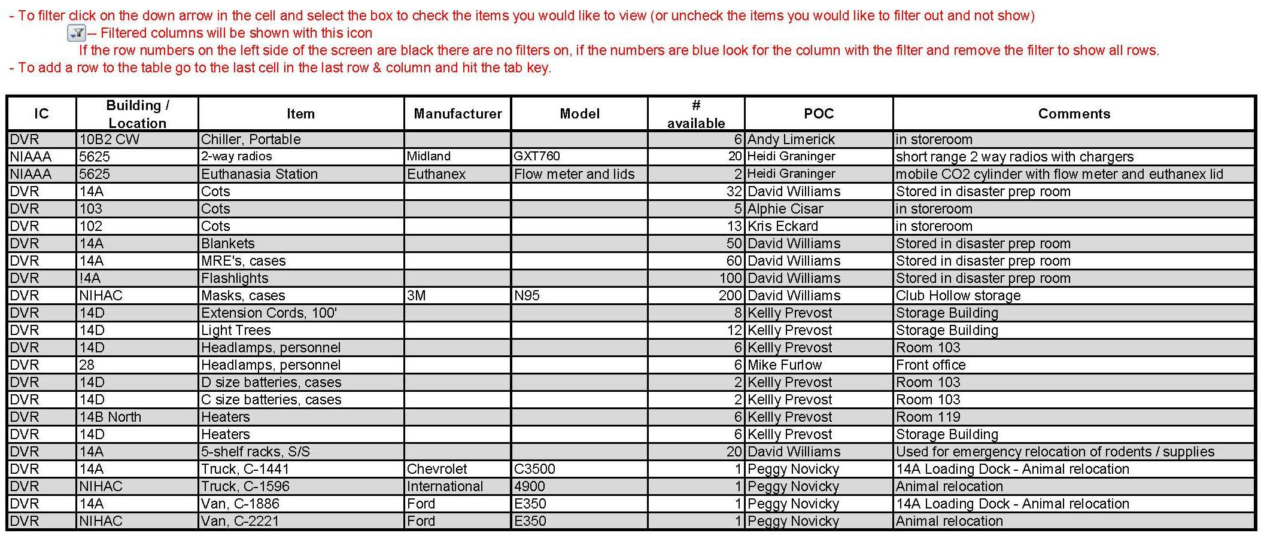

Instructions for Updating NIH Enterprise Directory Information
& AlertNIH Status

AlertNIH is the electronic system that NIH utilizes to disseminate information to various emergency response groups such as the NIH Continuity of Operations Emergency Support Teams, (including the Animal Resources Team), and other key animal program staff. Messages are disseminated via email and phone. Individuals must be added to the alert list and they must also “opt-in” through the NIH Enterprise Directory (NED) (https://ned.nih.gov/search/) in order to receive messages on their personal devices. Submit alert list membership changes to the NIH Office of Animal Care & Use.

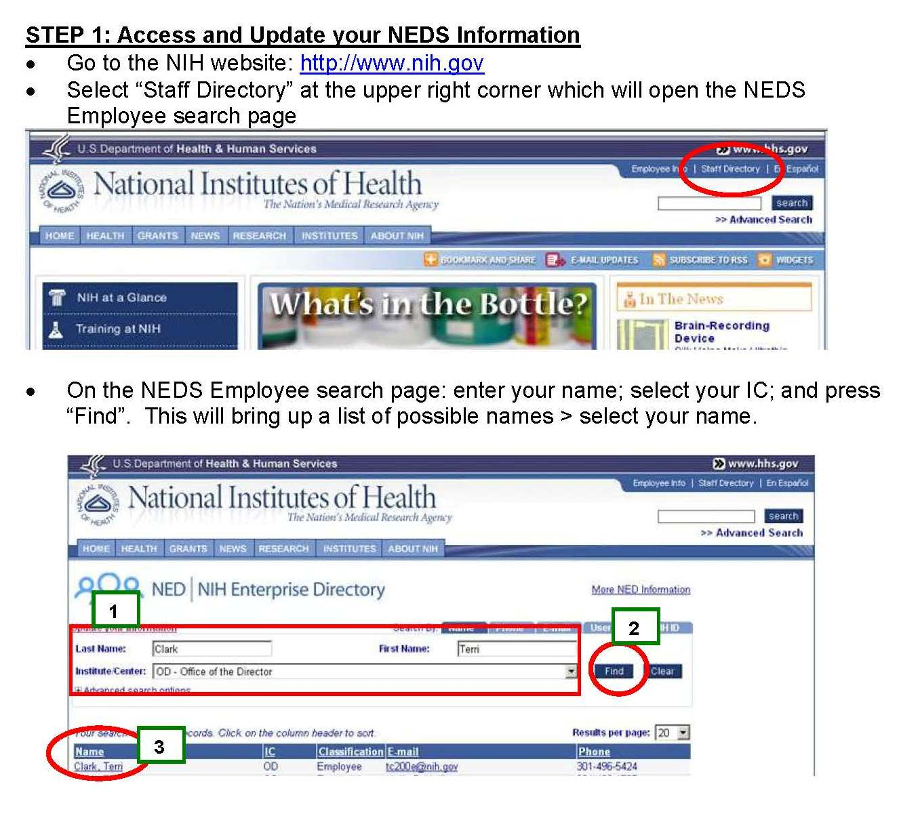
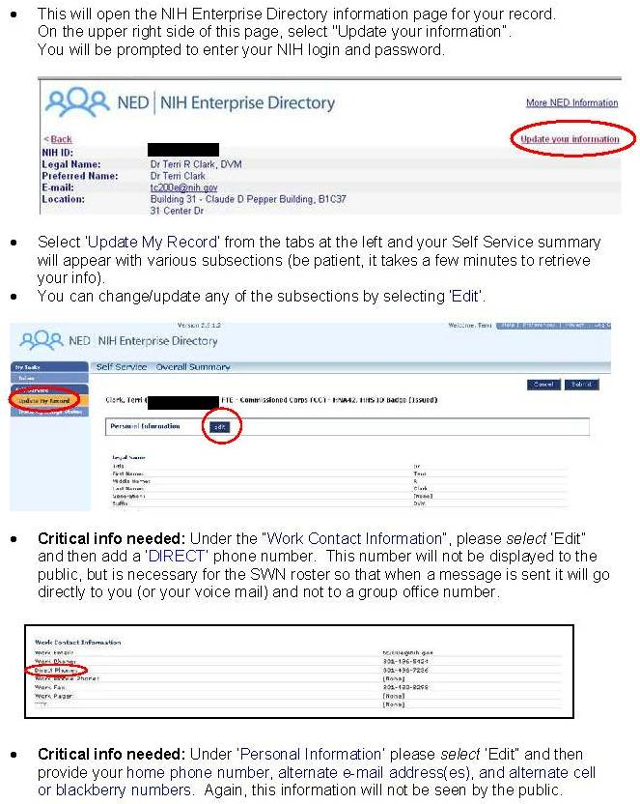

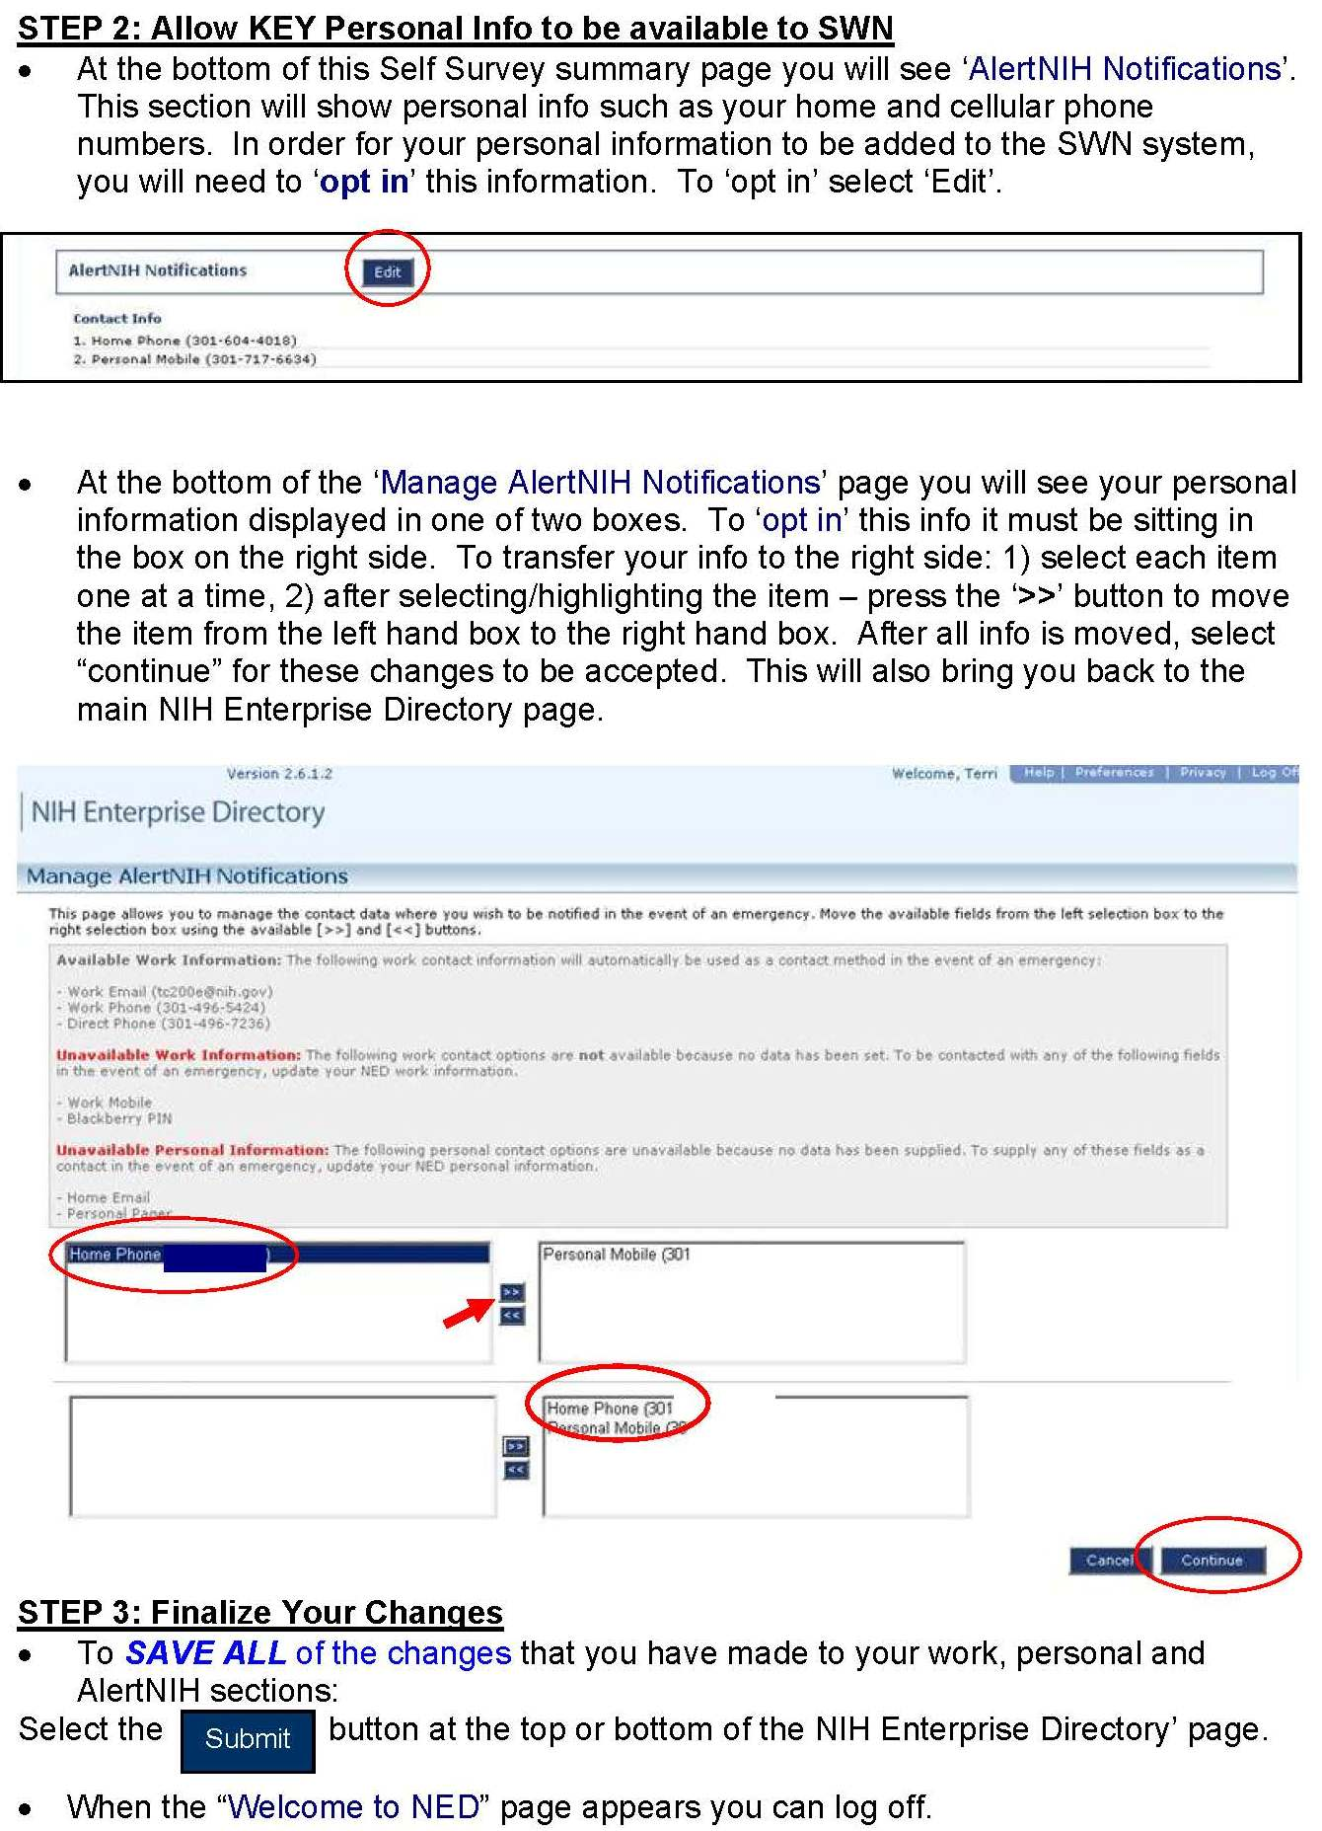
Media and FOIA Inquiries

Preparedness:
Phone call inquiries about any NIH employee or scientific project should be directed to the facility manager or veterinarian.
Facility personnel should not answer any questions which are inflammatory in nature. Refer these questions immediately to the IC Media Contacts & Information Officer. A list can be found at: http://www.nih.gov/news/media_contacts.htm.
Keep a list of IC contact numbers by the phone such as Facility Manager, Facility Veterinarian, IC Animal Program Director, IC Information Officer (http://www.nih.gov/news/media_contacts.htm), and General NIH Inquiry contact information.
Ensure all facility personnel are familiar with the above procedures.
Be certain that all individuals who answer the facility phone and admit personnel into the facility are aware of any impending problems.

Response:
Do not answer any media inquiries or general questions concerning scientific projects, individual staff members, or Freedom of Information Act (FOIA) inquiries.

Threatening or Inflammatory Inquiries –
Do not be rushed or provoked into making a wrongful statement.
Calmly refer the caller to the IC Media Contacts & Information Officer. A list can be found at: http://www.nih.gov/news/media_contacts.htm.
Perform the following steps to trace the call:
- After the caller disconnects the call, do not hang up the phone.
- Press *57 and then hang up the phone. (This procedure will "capture" the phone line so that the phone company can trace it),
- Report the incident to the IC Animal Program Director and to the NIH Police at 301-496-5685 or 311.

FOIA (Freedom of Information Act) Inquiries –
- IC Media Contacts & Information Officer (http://www.nih.gov/news/media_contacts.htm)

General Inquiries - callers may be directed to:
- 301-496-4000,
TTY 301-402-9612
- NIHinfo@od.nih.gov
- http://www.nih.gov/about/contact.htm

Notify Facility Manager, Facility Veterinarian, or IC Animal Program Director of any inquiries.

NIH Animal Facility Alarm Set Points & Tiered Response System
The NIH Animal Program Directors and the Office of Research Facilities (ORF) developed the following list of standardized animal facility alarm set points for animal room temperatures, humidity, and air changes. During normal animal facility hours (Monday – Friday, 7:00am – 4:00pm) the animal facility personnel are responsible for monitoring and reporting any abnormal animal room parameters. ORF is responsible for monitoring these parameters after-hours, and on weekends and holidays.

ORF has instituted a two-tiered alarm response system.
- Tier 1 Warning Alarm - requires that ORF personnel respond within 15 minutes. Within two hours of a Tier 1 response, ORF will notify the appropriate animal facility personnel of the Tier 1 warning alarm and provide a summary of the event and resolution.
- Tier 2 Critical Response Alarm – requires that ORF personnel be on-site of the alarm within 15 minutes to mitigate and resolve the issue and will contact the appropriate animal facility personnel within 15 minutes to notify them of the issue. ORF will notify the animal facility personnel using the contact information posted on the red Emergency Signs, so it is critical that this information be kept current and accurate.

NIH Animal Facility Alarm Set Points:
Parameter | Set Point | Tier 1:  Warning Range | Tier 2:  Critical Response Range
Temperatures: (°F)
Rodents | 72° | <69° or >75° | <64° or >79°
Rabbits | 65° | <62° or >68° | <61° or >72°
Ferrets | 66° | <63° or >69° | <58° or >72°
Nonhuman Primates | New World – 80° Old World – 76° | <77° or >82°  <73° or >79° | <70° or >84°  <64° or >84°
Carnivores | 72° | <69° or >75° | <64° or >84°
Large Animals | 72° | <69° or >75° | <64° or >84°
Poultry | 72° | <69° or >75° | <64° or >84°
Aquatics | See below
Humidity | 50% | >70%
Air Changes | 10-15 ach | <5 ach

Aquatics: The general NIH standard of 82 deg F (+/- 2degF) is used in most zebrafish rooms and 68 deg F (+/- 2 deg F) in Xenopus laevis rooms, unless an adjustment in temperature is needed to meet the water temperature requirements of the species being held. As these are aquatic species and systems, we do not consider room humidity levels below 30% or air exchange rates below 10 ach to have an adverse health effect on the animals. Air changes should be adequate to prevent condensation on room equipment and surfaces. Sufficient air changes are required to remove the heat load to maintain the lower temperature requirements of some aquatic species such as Xenopus laevis. More air changes than necessary cause increased evaporation of system water which increases the amount of replacement water added to the system and can decrease stability of the system; as well as over-ventilating aquatic areas with higher temperature requirements such as zebrafish rooms.

Non-standard set points and alarm ranges for individual rooms are only established with approval of the IC Animal Program Director and ORF.

CRITICAL CONCERNS FOLLOWING AN ANIMAL FACILITY CLOSURE
HOURS AFTER ANIMAL FACILITY CLOSURE: | Zero hour  (Initial Building Closure) | 6 hrs | 12 hrs | 18 hrs | 24 hrs | 48 hrs
CRITICAL CONCERNS:  (These concerns are cumulative over time until full staff access to the facility is re-established and the impact of the closure event is determined.) | CONCERNS LISTED AT PREVIOUS TIMEPOINTS PLUS:
 | ROOM ACCESS TO TREAT INJURIES AND EVACUATE ANIMALS IF NEEDED  AIR QUALITY  ROOM AND CAGE SECURITY  BIOSECURITY | ROOM ACCESS TO ASSESS ANIMAL HEALTH  CAGE TEMPERATURES  ELECTRICITY TO VENTILATED CAGES/ISOLATORS | ROOM ACCESS TO TREAT CLINICAL AND SURGERY PATIENTS  ROOM LIGHT CONTROL | ROOM ACCESS TO PROVIDE LIMITED HUSBANDRY CARE  FOOD AND WATER AVAILABILITY  STUDY INTEGRITY | ROOM ACCESS TO PROVIDE FULL HUSBANDRY CARE AND MONITOR ANIMAL HEALTH  CAGE SANITATION | CONCERNS LISTED AT PREVIOUS TIMEPOINTS
FACTORS  MODIFYING  CRITICALITY OF ANIMAL PROGRAM CONCERNS: | EMERGENCY or DISASTER EVENT - (Fire, flood, weather, criminal activity, explosion ...)  WEATHER CONDITIONS- (Snow, sleet, rainstorm, hurricane, tornado, seasonal temperature ...)  TIME OF DAY – (Normal operating hours, morning, afternoon, evening, weekend, holiday...)  SPECIES AND STRAINS HOUSED – (Nonhuman primate, swine, aquatic, rare mouse strain, gnotobiotic …)  TYPE OF RESEARCH PROGRAM – (Infectious disease, surgery, cancer, aging, drug toxicity ...)  OPERATIONAL PROCEDURES of the ANIMAL PROGRAM– (Contractor, facility footpaths, cage wash, weekend staffing level …)  ANIMAL CAGING SYSTEMS – (Open rack, wall-mounted, ventilated racks, Horsfall, cubicles, specialty, isolators…)  FACILITY DESIGN – (Multi-floor/story, biohazard, chemical hazard, barrier containment, elevators …)  RELOCATION RESOURCES – (Transportation, crating, loading dock access, relocation space availability …)  INSTITUTE MUTUAL AID AGREEMENTS – (Animal relocation space, communication, access, security, personnel …)  PERSONNEL AVAILABILITY – (Contract specifications, temporary housing, technical qualifications, communications …)  PUBLIC RELATIONS – (NIH Public Information emergency support team involvement, public awareness, public concerns ...)  NIH COOP STATUS – (COOP activation level, concurrent emergency events, event response plan detail, reserve assets …)  COMMUNITY ROAD NETWORKS - (Clogged access roads, temporary/permanent closures …)  SUPPLIES—(Reserve levels, delivery schedules, storage spaces, security requirements, accounting systems…)

NIH Emergency Response Contact Information

Emergency:
Police – Fire – Rescue – Hazmat – On-campus 911
Police – Fire – Rescue – Hazmat - Off-campus 9-911
TTY Telephone Line 301-496-0063
Emergency Maintenance Services (24/7) 301-435-8000
Building 10 Critical Medical Services 111

NIH Emergency Operations Plan:
Division of Emergency Management 301-496-1985
Animal Resources Team 301-496-5424 (OACU main number)
Dr. Evan Shukan (ART-L): 413-427-9448 (cell), shukanet@mail.nih.gov
Hana Bao: 781-929-2836 (cell), hana.bao@nih.gov

Non-Emergency:
Emergency Communications Center (24/7) 301-496-5685 or 311
Division of Police (Non-Emergency) 301-496-2387
Division of Fire and Rescue Services (Non-Emergency) 301-496-2372
Division of the Fire Marshall 301-496-0487
Division of Emergency Management 301-496-1985
Division of Occupational Health and Safety 301-496-2346
Division of Physical Security Management 301-496-9109
Occupational Medical Service 301-496-4411
NIH Page Operator 301-496-1211
Employee Transportation Services 301-402-RIDE

NIH IRP ‘Animal Research Facility Emergency Points-of-Contact Roster’ SharePoint Website:
This SharePoint site provides emergency contact information for use by IC, Office of Research Facilities, and ART personnel. Approval for access to the website is granted by the IC Animal Program Directors and their designees. Each IC has an individual designated with contributor rights on the website so that their information can be updated in real time as personnel changes occur. Additionally, the NIH Office of Animal Care and Use sends quarterly update reminders to the IC animal programs.
https://nih.sharepoint.com/sites/OD-OACUAnimalProgramEmergencyPointsofContact/Lists/Animal%20Program%20Emergency%20Points%20of%20Contact/AllItems.aspx?as=json

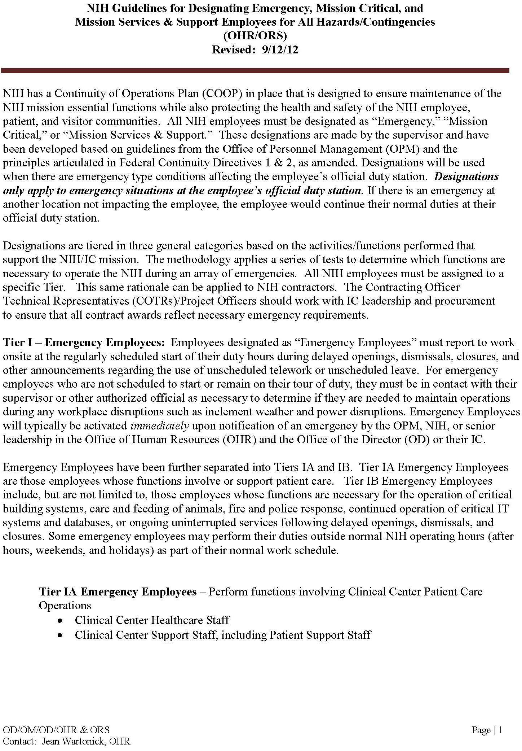
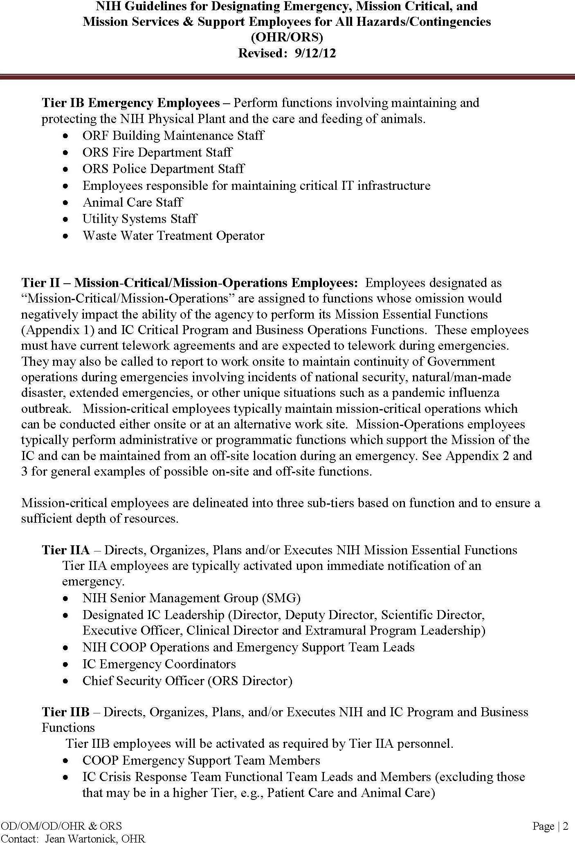
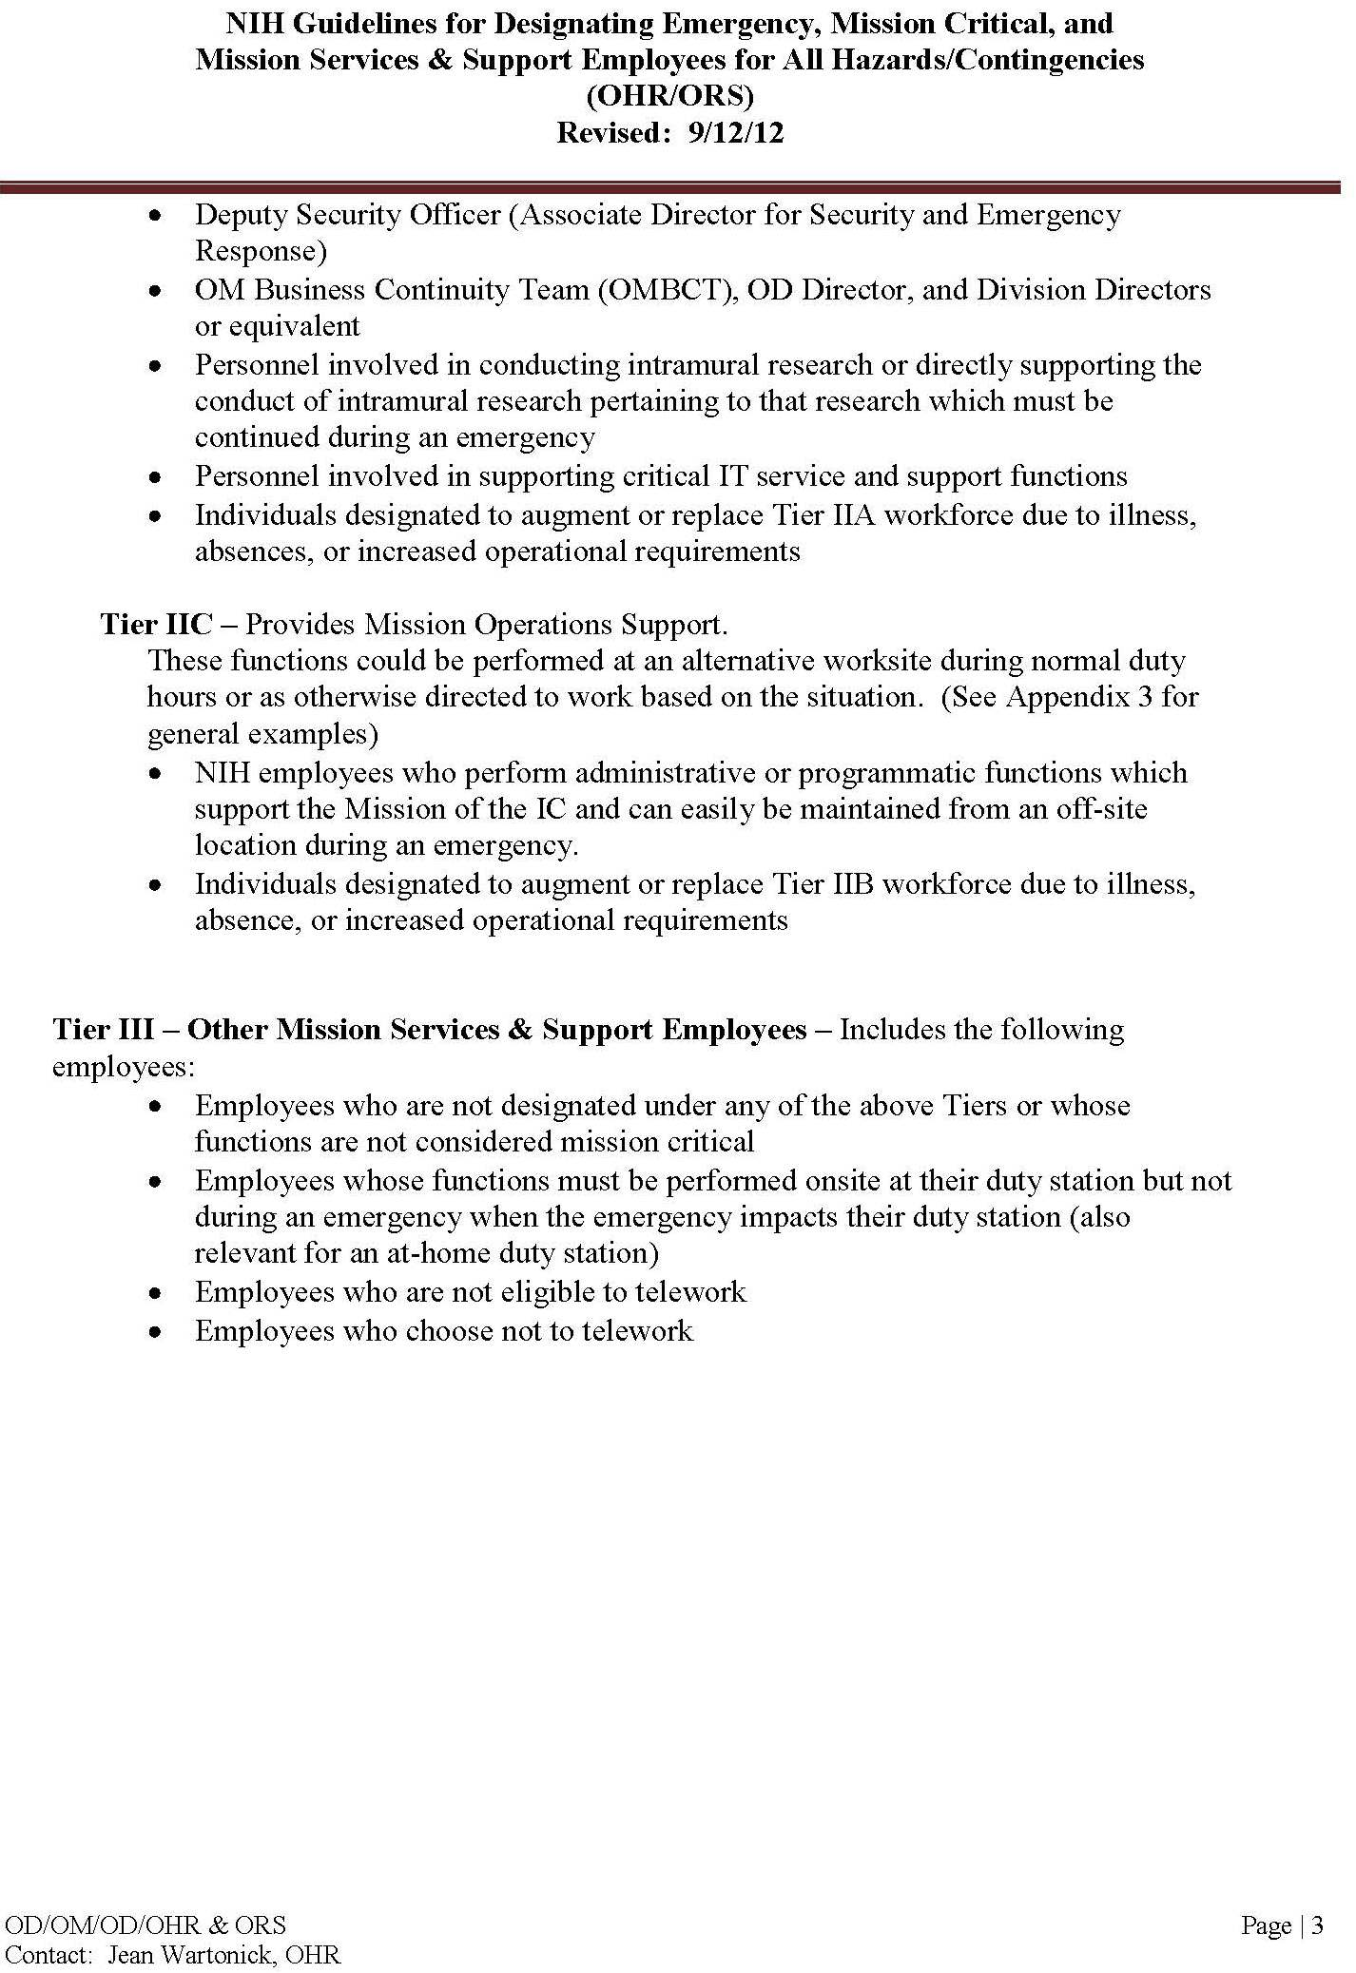
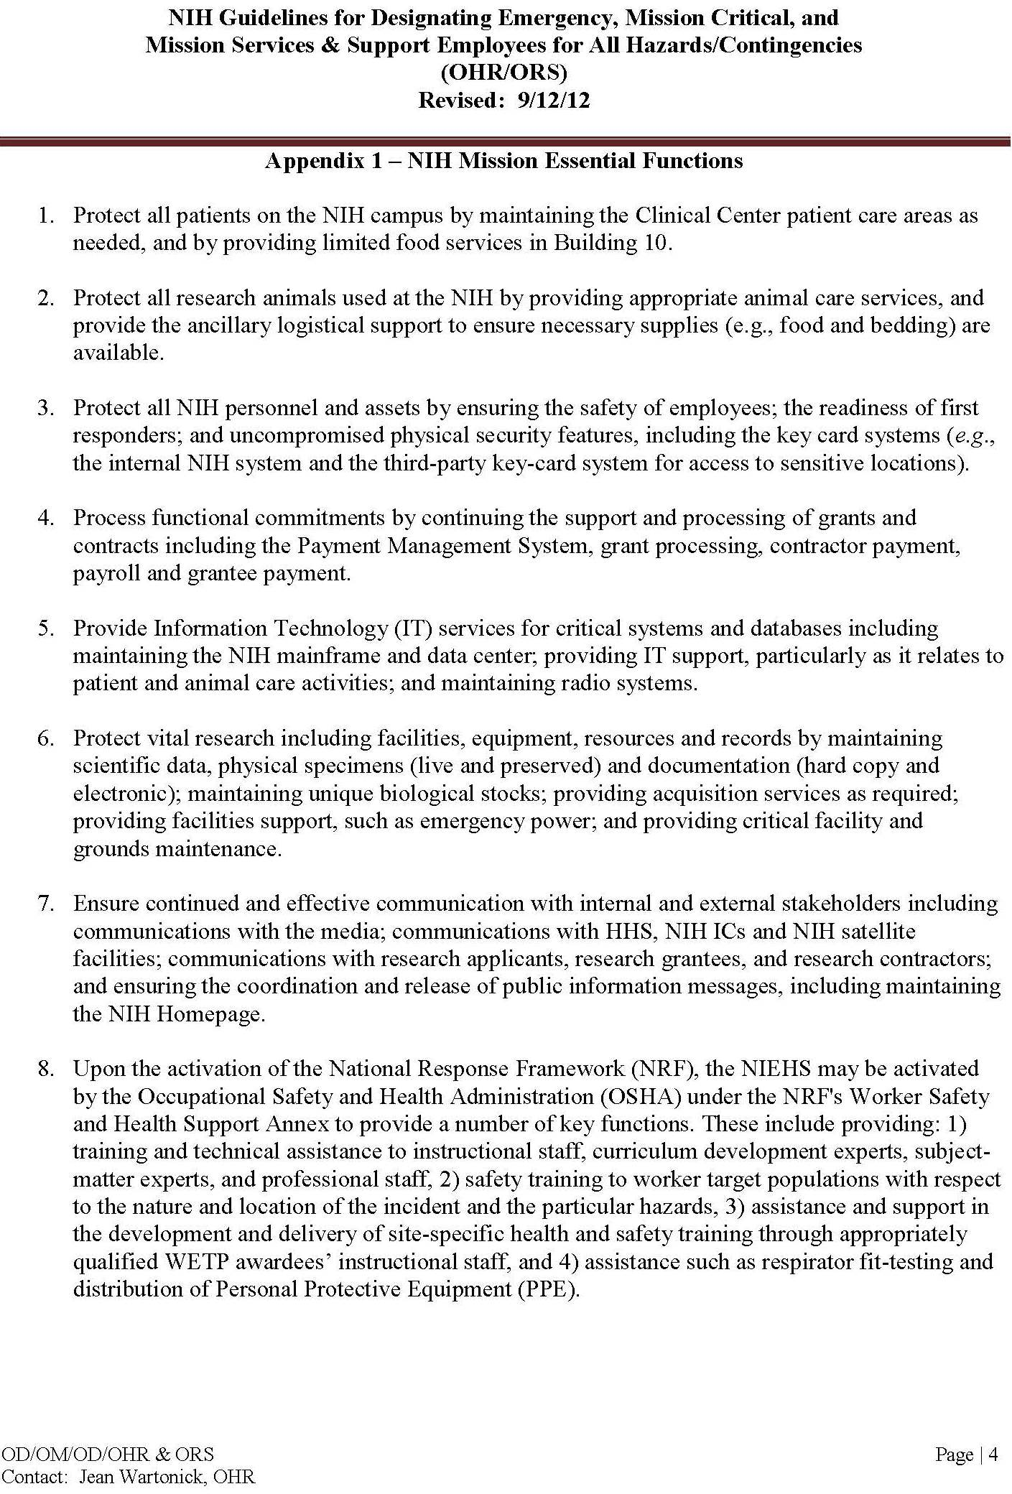
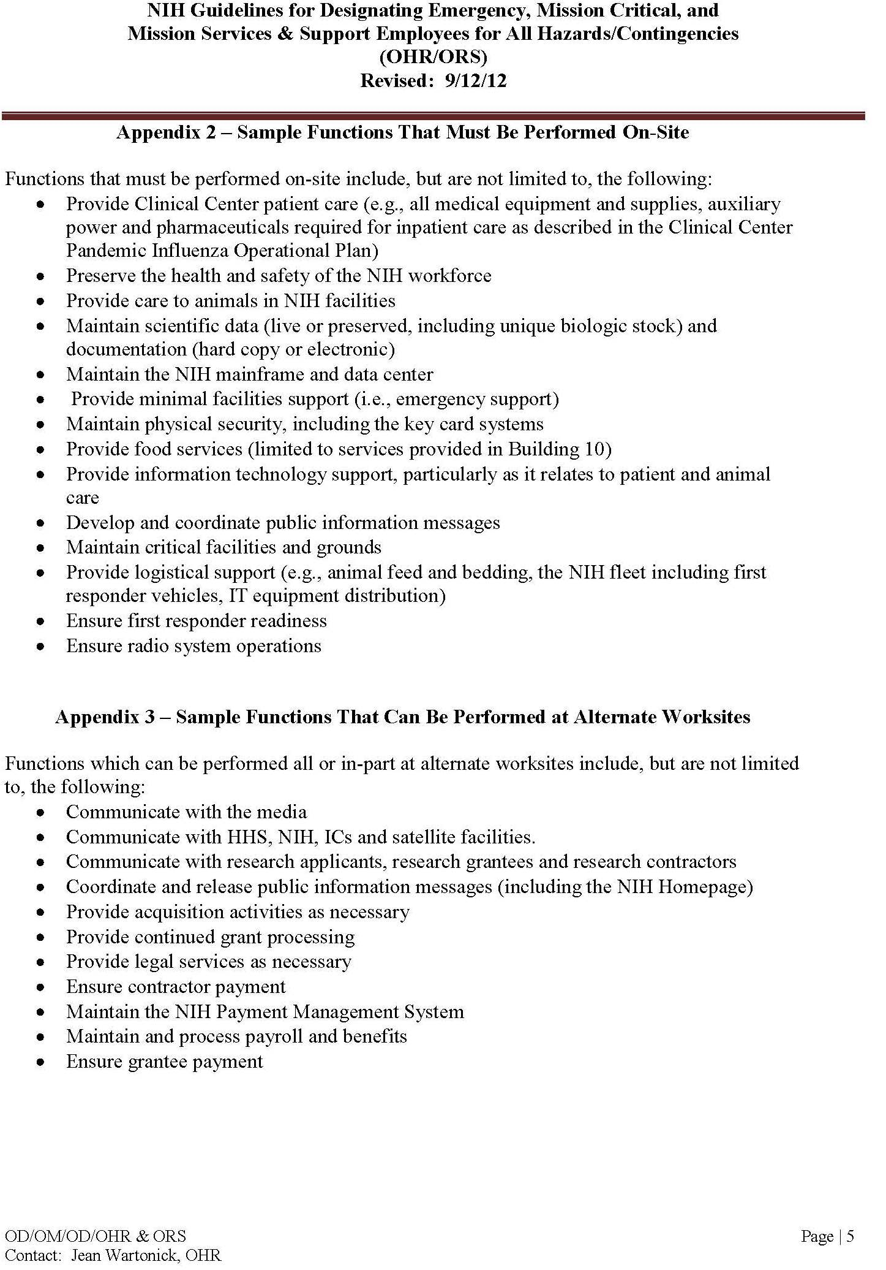
Telecommunications Systems

During large or regional disaster/emergency events, the landline and cellular phone systems may be impacted due to damage or overwhelming call volume activity. Limit use of landline and cellular services, and maximize use of systems that require minimal bandwidth, such as Short Message Service (SMS text), Blackberry PIN, Instant Messaging, email, etc.

The National Communications Systems provides two telecommunication systems that can be used by national security and emergency response personnel to make priority landline and cellular calls. To register for one or both of these services, contact the NIH Division of Emergency Managementat 301-496-1985 (POC: Jordan Southers; Alternate POC: Foram Pathak).

Government Emergency Telecommunications Service (GETS) can be used on various types of phones by dialing a universal access number. Individuals must be registered to use GETS, and there is a charge per minute for each call. See the NCS GETS website for more information: http://gets.ncs.gov/program_info.html)

Wireless Priority System (WPS) is for cellular phones. It requires that the cell phone be registered and the feature added by the cellular service provider. There are fees associated with this service such as an activation fee, monthly subscription cost, and additional per minute fees. See the NCS WEP website for more information. (http://wps.ncs.gov/)

The NIH Integrated Services Digital Network (ISDN) telephones require electricity to function, therefore electrical outages may impact them. The following NIH Analog Phone Systems should function even if the main digital phone network is out of order:

Blue Light Emergency Phone System
http://cit.nih.gov/ServiceCatalog/BlueLight.htm

Red Emergency Back-Up System
http://cit.nih.gov/ServiceCatalog/BackupSystem.htm

Online Resources & Links
The following list contains NIH resources, institutional documents, and web sites that may be useful during emergency/disaster preparedness and response.

ANIMAL BITES AND SCRATCHES
CDC National Center for Infectious Diseases – B virus Information
http://www.cdc.gov/herpesbvirus/index.html

NIH APD Guideline for the Development of Bite, Scratch, Splash Instructions for Employees Handling Macaques
http://oacu.od.nih.gov/UsefulResources/resources/APDGuideline_BiteScratchSplash.pdf

EVACUATION – ANIMALS
USDA Animal Care Emergency Programs
http://www.aphis.usda.gov/animal_welfare/ep/index.shtml

EVACUATION - PERSONNEL
Building 10 Emergency Evacuation Program
http://www.ors.od.nih.gov/ser/depc/evac/Documents/building10evactraining.pptx

NIH Building Evacuation & Shelter Training
www.ors.od.nih.gov/ser/depc/documents/evac_training.ppt

NIH CC Emergency Management Plan
http://intranet.cc.nih.gov/od/emergencyplan/

NIH DEM Evacuation & Shelter in Place (includes NIH OEC List)
http://www.ors.od.nih.gov/ser/depc/evac/Pages/Evacuation-and-Shelter-in-Place.aspx

PM1430 - NIH Occupant Evacuation Plan
http://oma.od.nih.gov/manualchapters/management/1430/

BIOHAZARDS
Biosafety in Microbiological & Biomedical Laboratories, 5th Ed. (BMBL)
http://www.cdc.gov/biosafety/

NIH Exposure Control Program for Non-NIH Personnel
http://www.ors.od.nih.gov/sr/dohs/Documents/NIH%20Exposure%20Control%20Plan.pdf

CHEMICAL HAZARDS
General Chemical Storage Compatibility
http://www.ors.od.nih.gov/sr/dohs/Documents/General_Chemical_Storage_Compatibility_Chart.pdf

Material Safety Data Sheets
http://www.ors.od.nih.gov/sr/dohs/labservices/msds/pages/material_safety_data_main.aspx

NIH Chemical Hygiene Plan
http://www.ors.od.nih.gov/sr/dohs/Documents/NIH-CHP.pdf

NIH Division of Occupational Safety and Health – Chemical Spill Procedure
http://www.ors.od.nih.gov/sr/dohs/BioSafety/incidents/Pages/chemicalspill_procedure.aspx

NIH Waste Disposal Guide
http://orf.od.nih.gov/Environmental+Protection/Waste+Disposal/

FIRE
NIH Division of Fire and Rescue Services
http://ser.ors.od.nih.gov/fire_rescue.htm

NIH Division of the Fire Marshall
http://ser.ors.od.nih.gov/fire_marshal.htm

NIH Division of the Fire Marshall Safety Links - Fire Prevention
http://www.ors.od.nih.gov/ser/dfm/Pages/Links.aspx

FIRST AID
Automated External Defibrillator (AED) and Cardiopulmonary Resuscitation (CPR) Training – NIH
http://www.ors.od.nih.gov/sr/dohs/HealthAndSafety/aed/Pages/AED-and-CPR-Training-.aspx

Automated External Defibrillators (AED) Locations at NIH
http://www.ors.od.nih.gov/sr/dohs/HealthAndSafety/aed/Pages/aedlocations.aspx

Blood Pressure Monitoring Stations – NIH
http://www.ors.od.nih.gov/sr/dohs/HealthAndSafety/BP/Pages/blood_pressure.aspx

How to Use an Automated External Defibrillator (AED) – NHLBI
http://www.nhlbi.nih.gov/health/health-topics/topics/aed/howtouse.html

Survival Center First Aid Tutorial
http://www.survival-center.com/firstaid/book.htm

EMERGENCY MANAGEMENT AGENCIES
DC: http://hsema.dc.gov/
Delaware: http://dema.delaware.gov/
FEMA: http://www.fema.gov/
Maryland: http://www.mema.state.md.us/MEMA/index.jsp
Montana: http://dma.mt.gov/des/
North Carolina: http://www.nccrimecontrol.org/Index2.cfm?a=000003,000010
Pennsylvania: http://www.pema.state.pa.us/
Virginia: http://www.vaemergency.com/
West Virginia: http://www.dhsem.wv.gov/Pages/default.aspx

NATURAL DISASTERS
Centers for Disease Control – Natural Disasters Preparedness Guide
http://www.bt.cdc.gov/disasters/index.asp

Federal Emergency Management Agency
http://www.ready.gov/natural-disasters

PREPAREDNESS
APD Development of Bite, Scratch, and Splash Care Instructions for Employees Handling Macaques
http://oacu.od.nih.gov/UsefulResources/resources/APDGuideline_BiteScratchSplash.pdf

Centers for Disease Control – Natural Disasters Preparedness Guide
http://www.bt.cdc.gov/disasters/index.asp

Disaster Planning and Response Resources – OLAW
http://grants.nih.gov/grants/olaw/disaster_planning.htm

Emergency Procedures for NIH Personnel
www.ors.od.nih.gov/ser/depc/documents/EmerProcPersonnel.doc
Guidelines for Standards of Care in Animal Shelters
http://oacu.od.nih.gov/disaster/ShelterGuide.pdf

NIH CC Emergency Management Plan
http://intranet.cc.nih.gov/od/emergencyplan/

NIH Division of Emergency Management (DEM)
http://ser.ors.od.nih.gov/emergency_prep.htm

NIH DEM Disaster & Emergency Planning
http://www.ors.od.nih.gov/ser/depc/info/Pages/Planning.aspx

NIH Emergency Preparedness Handbook – DEM
https://www.ors.od.nih.gov/ser/dem/info/Documents/NIH%20DEM%20Emergency%20Preparedness%20Handbook.pdf

NIH Emergency Preparedness Information - DEM
http://ser.ors.od.nih.gov/preparedness.htm

NIH Office of Laboratory Animal Welfare (OLAW) Disaster Planning & Response
http://grants.nih.gov/grants/olaw/disaster_planning.htm

NIH Pandemic Flu Resources
https://sis.nlm.nih.gov/dimrc/pan_influenza.html

NIH Waste Disposal Guide
http://orf.od.nih.gov/Environmental+Protection/Waste+Disposal/default.htm

Pandemic Flu Planning
http://www.flu.gov/

USDA Emergency Preparedness & Response Factsheet
http://www.aphis.usda.gov/publications/aphis_general/content/printable_version/fs_emerpre..pdf

PREPAREDNESS AT HOME
Are You Ready? In-depth Guide to Citizen Preparedness – FEMA
http://www.ready.gov/document/are-you-ready-depth-guide-citizen-preparedness

Emergency Financial First Aid Kit - FEMA
http://www.operationhope.org/images/uploads/Files/effak2.pdf

Family Communication Tips - FEMA
http://www.ready.gov/family-communications

Food and Water in an Emergency – FEMA
http://www.fema.gov/pdf/library/f%26web.pdf

Information for Pet Owners – FEMA
http://www.fema.gov/plan/prepare/animals.shtm

NIH Child Care Centers: Emergency Guide for Parents
www.ors.od.nih.gov/ser/depc/.../EmergencyGuideParents.doc

Preparing for Disaster – FEMA
http://www.redcross.org/images/pdfs/preparedness/A4600.pdf

Prepare for Emergencies Now: Information for People with Disabilities - FEMA
http://www.ready.gov/sites/default/files/FEMA_Disabilities_R-6_web_june2012.pdf

Preparing your Pets for Emergencies - FEMA
http://www.ready.gov/sites/default/files/documents/files/pets_brochure.pdf

RECOVERY

NIH Civil
https://hr.nih.gov/working-nih/civil

NIH Employee Assistance Program
http://www.ors.od.nih.gov/sr/dohs/EAP/Pages/eap_contact.aspx

ReUnite (reunite with missing people after disaster event) Smart Phone Application– NIH NLM
http://itunes.apple.com/us/app/reunite/id368052994?mt=8

SAFETY
NIH DOHS Safety & Health Specialist
http://www.ors.od.nih.gov/sr/dohs/HealthAndSafety/Pages/safety_health_specialists.aspx

Reporting Unsafe or Unhealthful Conditions or Hazards – NIH
http://www.ors.od.nih.gov/sr/dohs/HealthAndSafety/Pages/Report-of-Unsafe-Condition.aspx

NIH Policy Manual 3035 - Working Safely with Hazardous Biological Materials
http://www1.od.nih.gov/oma/manualchapters/intramural/3035/

SECURITY BREACH
NIH Police Services
http://ser.ors.od.nih.gov/police.htm

NIH Security and Emergency Response
http://ser.ors.od.nih.gov/

Montgomery County Department of Police
http://www.montgomerycountymd.gov/poltmpl.asp?url=/Content/POL/index.asp

Maryland State Police Department
http://www.mdsp.org/

SMART PHONE APPLICATIONS
Radiation Emergency Medical Management (REMM) – NIH NLM
http://www.remm.nlm.gov/downloadmremm.htm

ReUnite (reunite with missing people after disaster event) – NIH NLM
http://itunes.apple.com/us/app/reunite/id368052994?mt=8

Wireless Information System for Emergency Responders (WISER) - NIH NLM
http://wiser.nlm.nih.gov/

TELECOMMUNICATIONS FAILURE
NIH Blue Light Emergency Phone System
http://cit.nih.gov/ServiceCatalog/BlueLight.htm

NIH Center for Information Technology Service Desk (301)496-4357 or 1-866-319-4357
http://tsr.cit.nih.gov/

NIH Red Emergency Back-Up System
http://cit.nih.gov/ServiceCatalog/BackupSystem.htm

NIH Voice Mobility (online voicemail access)
https://vm.hhs.gov/subscriber/

TERRORIST HAZARDS
Department of Homeland Security Preparedness, Response, & Recovery
http://www.dhs.gov/files/prepresprecovery.shtm

FEMA Terrorist Hazard Preparedness
http://www.ready.gov/terrorism

FEMA Terrorist Response
http://www.fema.gov/news/newsrelease.fema?id=5697

National Terrorism Advisory System
http://www.dhs.gov/files/programs/ntas.shtm

UTILITY FAILURE
NIH Office of Research Facilities (ORF) – Building Manager List
http://orf2.od.nih.gov/PropertyManagement/FacilityManagement.asp

NIH ORF – Service Requests
http://orf.od.nih.gov/58000/

NIH ORF Public Notices of Utility Outages
http://orf2.od.nih.gov/utilityshutdown/scripts/index.asp

NIH ORF Operations and Maintenance
http://orf.od.nih.gov/PropertyManagement/Operations/

Operating Instructions for the MovinCool® Office Pro Spot Cooler

NOTE: The use of Spot Coolers may present a biosecurity risk to an animal housing area if the Spot Cooler has been previously used in other animal rooms and/or facilities. As of 2013 an acceptable process to decontaminate the inside of these spot coolers has not been identified. The OfficePro 18 is rated to remove 16,800 BTUs/hour from a space.

- PRIOR TO OPERATION
- Insure that the wheels are locked prior to operation. The maximum weight of the unit (when the drain tank is full of water) is ~252 lb. so it must be on a level surface and capable of holding this weight.
- Ensure that the air inlets (~ 18” of space) and outlets are not blocked.
- Ideally, the exhaust from the spot chiller should be aimed at the facility exhaust (this could be a ceiling or wall vent). If this is not possible, the exhaust from the chiller should be directed to the interstitial space (mechanical space above the ceiling level) or as a last resort, outside or away from the area targeted for cooling.
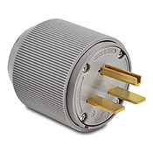
  - If the interstitial space must be used and the facility has drop-in ceiling panels, then an exhaust hose connected to the exhaust port on the top of the unit can be attached to a 2’x2’ panel and the 2’x2’ panel can be placed in the ceiling grid to allow the warmer exhaust air to vent into the interstitial space. Directing the warm exhaust air into the interstitial space may affect temperature sensors if the sensors are located in the ductwork within the interstitial space.
  - If the unit is in a facility area with a solid ceiling, then the exhaust hose should be directed away from the area that needs to be cooled.
- The power source should be a dedicated single outlet with a ground fault protective breaker. The minimum power supply is 115 V single phase 20 A, for the Office Pro 12/18 models, the 24 model requires 208/230V. Units are equipped with a NEMA plug (pictured right) and an appropriate outlet must be used for this plug type.
- The unit should not be used when the temperature is > 95°F or > 60% RH.
- The unit will automatically shut off when the drain tank is full, unless the unit is hard plumbed into the building.
- The unit will automatically restart when power is lost and regained. The unit will return to its prior operating mode.
- A box or barn fan can be used to increase the area covered by the chiller if the fan intake is placed in front of the chilled air outlets.

- OPERATION
- Units stored outside of the vivarium where they will be used, should be started and allowed to run for at least five (5) minutes outside the vivarium.
- The unit can be operated in two modes (FAN ONLY and COOL).
  - The FAN ONLY mode will only circulate the surrounding air. The fan speed and power to the unit can be changed by pressing the HI/LO button.
  - To operate in COOL mode, the ON/OFF button should be pressed and “COOL ON“ should be displayed on the LCD. The fan will continue to operate when the unit is in COOL mode. The fan’s speed can be changed. The COOL mode will engage the compressor and start cooling the air.
- Change the temperature set point by using the SET TEMP buttons (Δ and ∇). The temperature range of the unit is 65°F – 90°F.
- Condensate water accumulates in the drain tank when operating in the COOL mode. Once the drain tank is full the “TANK FULL” LED will flash and the LCD will display “TANK FL”.
- To empty the drain tank open the door on the front of the unit.
- Remove the drain tank from the unit, remove the cap and empty the drain tank.
- Replace the cap and then replace the drain tank in the unit.
- Press either the ON/OFF or the HI/LO buttons to restart the unit.
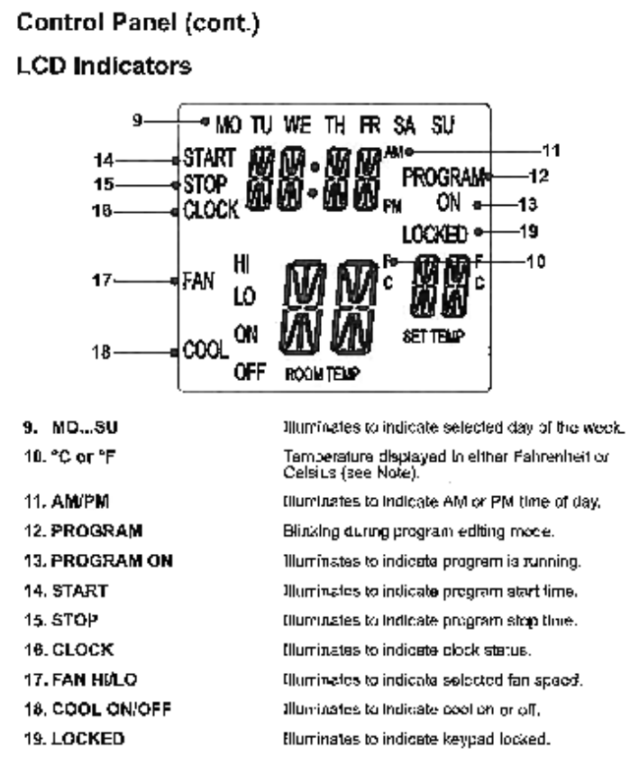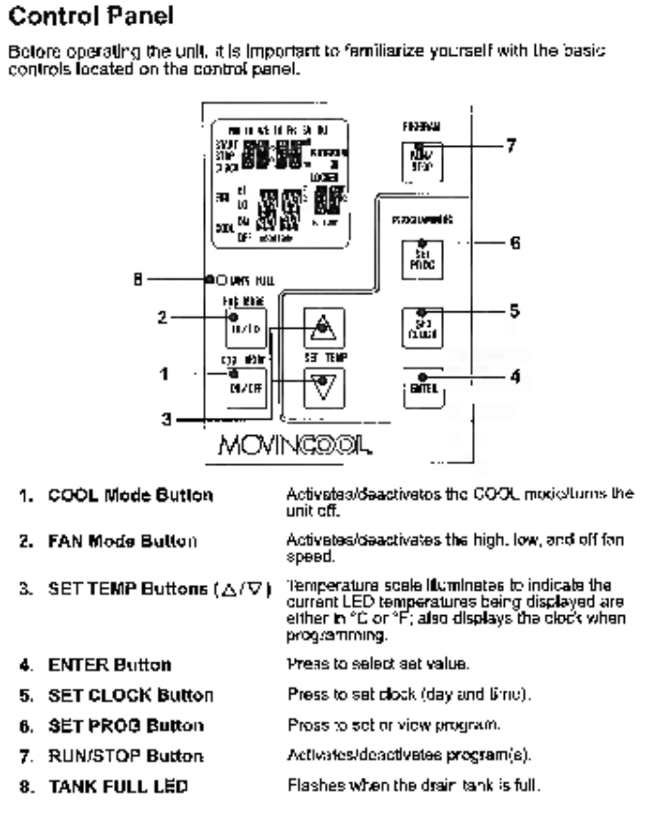

- Setting the Clock
- Press and hold the SET CLOCK button for 3 seconds until the unit beeps.
- Using the SET TEMP buttons (Δ and ∇), scroll through to the correct day of the week as displayed on the LCD and press the ENTER button.
- Using the SET TEMP buttons (Δ and ∇), select the correct hour as displayed on the LCD and press the ENTER button.
- Using the SET TEMP buttons (Δ and ∇), select the correct minute as displayed on the LCD and press the SET CLOCK button to exit clock mode.

- PROGRAMMING
- Press and hold the SET PROG button for 3 seconds until the unit beeps.
- Using the SET TEMP buttons (Δ and ∇), scroll through to the correct day of the week as displayed on the LCD and press the ENTER button.
- Using the SET TEMP buttons (Δ and ∇), select the correct hour as displayed on the LCD and press the ENTER button. Using the SET TEMP buttons (Δ and ∇), select the correct minute as displayed on the LCD and press the ENTER button.
- Repeat steps 2-5 to set the Stop Time.
- Use the SET TEMP buttons (Δ and ∇), to set the desired fan speed.
- Use the SET TEMP buttons (Δ and ∇), to set the desired temperature.
- Press the SET PROG button to exit program editing mode.

- MONITORING AND MAINTENANCE
- Once the unit is operating it should be periodically monitored. The frequency of monitoring should be increased the closer the environmental parameters are to the limits for the unit listed in Section A.5.
- When operating in COOL mode the drain tank should be checked and drained daily. The drain tank should only be removed and emptied when the unit is not in operation.
- The unit has two air filters that should be cleaned at least weekly. This may need to occur more frequently in dusty environments. To clean the filter elements:
- Open the front panel door and carefully remove the filter element by pulling on the retainer clips (opposite side of the hinges).
- Open the side panel filter door and carefully remove the filter element from the wire frame.
- Filter elements can be cleaned with a vacuum cleaner or rinsed in cold to lukewarm water.
- Once cleaned, rinse the filter element in running water and allow it to dry before reinstalling in the unit.
- The facility where the cooler is stored will be responsible for annually starting each unit to verify that it is operational.
- Maintenance, beyond what is outlined in this section, will be the responsibility of the Office of Research Facilities division (http://58000.nih.gov/ ).

- SANITATION
- Prior to storing a spot cooler, the unit must undergo external surface decontamination using a freshly prepared 10% bleach solution.
- Any gross debris should be removed prior to disinfection. Using a cloth/towel moist with disinfectant, wipe down exterior surfaces of the unit; including the drain tank, drain tank bin, diffuser plate, and the interior of the exhaust tube (as much as can be practically reached).
- The filter elements should be cleaned with a vacuum cleaner (a HEPA vacuum is recommended), moistened with facility disinfectant, removed and then rinsed in the facility disinfectant. Once cleaned, rinse the filter element in potable running water and allow it to dry before reinstalling in the unit.
- Once the external surfaces of the spot cooler have been decontaminated the unit should be wrapped in plastic shrink wrap. Prior to wrapping a spot cooler, ensure the drain tank is empty and dry; and that the filter elements have dried and been placed back in the unit.
- A Form 2683 (http://oma.od.nih.gov/public/MS/forms/NIHE-Forms/NH2683.PDF ) with the date of sanitization, initials of the sanitizer, and a telephone number for the unit’s point of contact within the facility should be shrink wrapped to the unit.

- Reviewed and accepted by the Animal Program Directors Committee on 26 August 2013.

